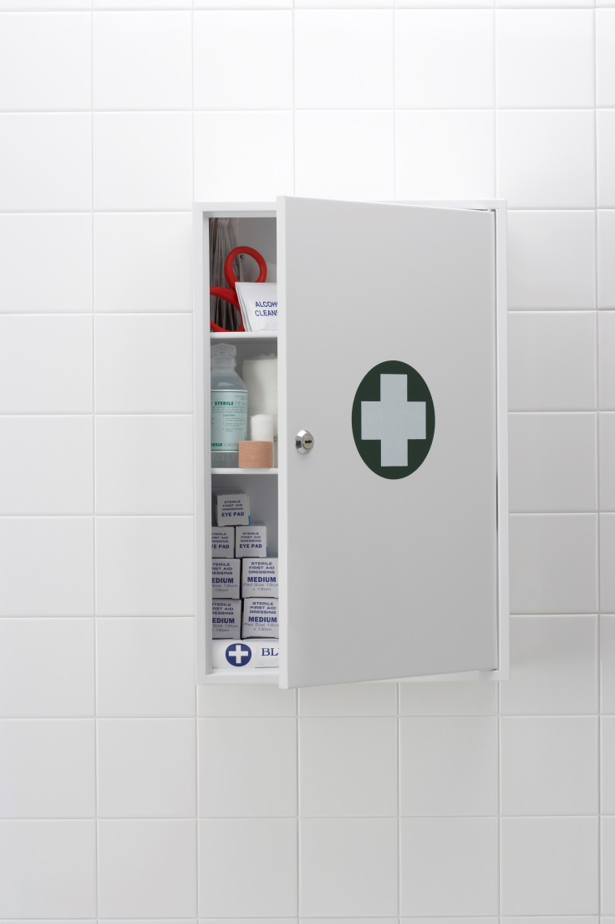
Example Policy and Procedures: Implementing and maintaining a palliative care medicines imprest system within a Queensland residential aged care facility

June 2021 V1.0
Acknowledgements
This Example Policy and Procedures document was developed as part of palliPHARM, a project funded by Queensland Health, to establish processes that ensure residents of residential aged care facilities and all other community-based palliative patients have timely access to palliative care medicines, if needed.
palliPHARM would like to acknowledge the many organisations and committees that have contributed time and expertise in the development, review and endorsement of this document including:
- Queensland Department of Health, Healthcare Approvals and Regulation Unit, Prevention Division
- palliPHARM Steering Committee consisting of:
  - Consumer Representative with lived experience
  - Director, Brisbane South Palliative Care Collaborative
  - General Manager Care and Clinical Governance, Residential Care Community Services Blue Care, UnitingCare
  - General Manager Policy and Engagement, and State Manager (QLD), Pharmaceutical Society of Australia
  - General Practitioner Representative
  - Program Manager, Brisbane South Primary Health Network
- Bolton Clarke, Clinical Quality Team
palliPHARM also acknowledges the many individuals who have contributed their time and expertise in the development of this document, in particular:
- Julie Normoyle, Governance and Care Advisor, Aspect Health Pharmacy Group
- Megan Tremlett, Senior Pharmacist – Consulting, Pharmaceutical Society of Australia
Suggested reference
Brisbane South Palliative Care Collaborative. Example Policy and Procedures: Implementing and maintaining a palliative care medicines imprest system within a Queensland residential aged care facility. Brisbane: Brisbane South Palliative Care Collaborative; 2021.
Enquiries
All enquiries about this document should be directed to:
Brisbane South Palliative Care Collaborative
E: pallipharm@health.qld.gov.au
Disclaimer
The Example Policy and Procedures: Implementing and maintaining a palliative care medicines imprest system within a Queensland residential aged care facility is intended to assist Queensland residential aged care facilities to develop or review their own policy and procedures document regarding palliative care medicines imprest systems.
While Brisbane South Palliative Care Collaborative has exercised due care in ensuring the accuracy of the material (at the date of publication) contained in this example policy and procedures document. The document is only a general guide. Brisbane South Palliative Care Collaborative does not accept any liability for any injury, loss, or damage incurred by use of, or reliance upon, the information provided within this example policy and procedures document. It is recommended that facilities adapting this document seek independent legal advice to ensure compliance with relevant legislation.

Contents
Overview 5
Purpose of this document 5
How to use this document 5
How was this document developed? 5
PART ONE: POLICY 6
Purpose 6
Policy statement 6
Guiding Principles 6
Organisational principles 7
Health professional principles 7
Terms/ definitions 7
PART TWO: PROCEDURES 10
Section 1: Implementation of a Palliative Care Medicines Imprest System 10
1.1 Medicines Advisory Committee 10
1.2 Treatment Room Location and Features 11
1.3 Storage of Schedule 8 Medicines 12
1.4 Layout and Storage of Scheduled Medicines 12
Section 2: Ordering Medicines for the Palliative Care Medicines Imprest System 13
2.1 Purchase Orders 13
2.2 Receipt of Medicine Purchase Orders 13
2.3 Ad hoc Purchase Orders 14
2.4 Possession and Administration of Imprest Medicines 15
Section 3: Recording Movement of Imprest Medicines within the Facility 16
3.1 Recording movement of schedule 4 medicines (S4s) 16
3.2 General principles of recording schedule 8 medicines (S8s) 17
3.3 Details to be recorded when S8s are received from a pharmacy 17
3.4 Details to be recorded when S8s are administered to a resident 18
3.5 Details to be recorded when S8s are removed from a facility 18
3.6 Audits and record keeping of S8s within a facility 18
Section 4: Maintenance of Palliative Care Medicines Imprest System 19
4.1 Imprest Officer Tasks and Responsibilities 19
4.2 Maintenance of Imprest medicines 21
4.3 Maintenance of Imprest Schedule 8 medicines (S8s) 21
4.4 Imprest Review 21
4.5 Return of Imprest Medicines 22
4.6 Management of Medicine Recalls 23
PART THREE: APPENDICES 25
APPENDIX 1: Medicine Scheduling 25
APPENDIX 2: Minimum requirements for S8 receptacles 26
APPENDIX 3: Example list of medicines to be held in a palliative care medicines imprest system 30
APPENDIX 4: Sample purchase order that complies with Queensland legislative requirements 31
APPENDIX 5: Sealed Tamper Evident Bag 32
APPENDIX 6: Sample Delivery Advice Form 33
APPENDIX 7: Sample Invoice for Schedule 8 medicines provided by Supplying Pharmacy 34
APPENDIX 8: Sample Imprest Medicine Movement Record Form 35
APPENDIX 9: Example layout of a S8 Register with example entries 36
APPENDIX 10: Sample Shift Change Check Page in the S8 Register 37
APPENDIX 11: Sample Schedule 8 Return Request Form 38
REFERENCES 39

Abbreviations
DoN Director of nursing
EN Enrolled nurse
GP General Practitioner
MAC Medicines Advisory Committee
NP Nurse practitioner
POMs Patient’s own medicines
RACF Residential aged care facility
RN Registered nurse
S2s Schedule 2 medicines also known as ‘Pharmacy only’ medicines
S3s Schedule 3 medicines also known as ‘Pharmacist only’ medicines
S4s Schedule 4 medicines also known as restricted drugs
S8s Schedule 8 medicines also known as controlled drugs

Overview

Purpose of this document
The purpose of this document is to provide an example policy and procedures document on how to set up and maintain a palliative care medicines imprest system within a residential aged care facility (RACF).
A palliative care medicines imprest system serves as a stock management process to enable timely access to end-of-life medicines by clinical staff at a facility. Medicines contained in the palliative care medicines imprest system are purchased by the RACF and are not supplied on prescription or for a specific person. They are obtained by a RACF in accordance with legislative requirements.
This document encourages the establishment of a well-controlled, well-managed, well-stocked palliative care medicines imprest system. It supports high-quality palliative care for residents in RACFs by enabling timely access to medicines required for management of emergent end-of-life symptoms, thus alleviating suffering.
This policy and procedures document does not include aspects related to prescribing, preparation or administration of palliative care medicines, or the storage, handling, or disposal of patients’ own medicines.

How to use this document
This document is a resource for RACF staff to inform the basis of the development or update of local policy and procedures for setting up and maintaining a palliative care medicines imprest system within their facility. It should be used in conjunction with the contractual agreement already established between the pharmacy and facility which determines the arrangements surrounding medicine supply and stock delivery.
Facilities should adapt the content of this document to meet individual facility and organisational needs.

How was this document developed?
This document was developed with consideration of Queensland legislative requirements and best-practice resources for medicine management within RACFs. Resources included:
- Guide to the Pharmacological Management of End Of Life (Terminal) Symptoms in Residential Aged Care Residents 2015 (Brisbane South Palliative Care Collaborative)¹
- Guidelines for the handling of palliative care medicines in community services 2020 (Brisbane South Palliative Care Collaborative and NPS MedicineWise)²
- Guiding principles for medication management in residential aged care facilities 2012 (Australian Government Department of Health)³
- Health (Drugs and Poisons) Regulation 1996 (Queensland Government)⁴
- National Palliative Care Standards 5th Edition 2018 (Palliative Care Australia)⁵
- Standard for the Uniform Scheduling of Medicines and Poisons No. 29 June 2020 (Australian Government)⁶
- The Aged Care Quality Standards 2020 (Australian Government Aged Care Quality and Safety Commission)⁷
- The National Safety and Quality Health Service (NSQHS) Standards 2021 (Australian Commission on Safety and Quality in Health Care)⁸
- Therapeutic Guidelines: Palliative Care, Version 4 (2016)⁹

PART ONE: POLICY
[Name of facility] is committed to supporting the provision of quality palliative care with the establishment of a palliative care medicines imprest system within the facility to facilitate timely access to palliative care medicines for residents, if required, to relieve distressing end-of-life symptoms.

Purpose
This policy facilitates the safe and effective implementation and maintenance of a palliative care medicines imprest system (hereafter used interchangeably with the term ‘imprest’ and ‘imprest system’) within this RACF. The policy has been written in accordance with Queensland legislative requirements and best-practice guidance on how to implement and maintain a palliative care medicines imprest system.

Policy statement
The aim of palliative care is to optimise quality of life for patients with life-limiting illnesses, through the prevention and relief of suffering by early identification, assessment and treatment of pain and other distressing symptoms. High-quality palliative care in RACFs allows more older Australians to receive the right care and to die in their place of choice and ensure their families and carers are better supported during the dying and bereavement process.¹⁰
Anticipatory prescribing is important to ensure effective control of new or worsening symptoms, especially within the terminal phase of a palliative resident’s illness. It refers to prescribing medicines in advance for problems that are anticipated which can help avoid a crisis or urgent transfer to hospital.^{9,11} Anticipatory prescribing includes ensuring medicines that are likely to be needed are readily available, with prescriptions and medication charts written in advance.⁹
If a prescription is not written for anticipatory medicines or a pharmacy service is unavailable to supply the medicines at short notice, an imprest system embedded within a RACF can allow timely access to these medicines until a prescription is written and/or medicines can be dispensed. An imprest system, in conjunction with appropriate prescribing, can prevent unnecessary transfer of a resident to an acute facility for symptom management. It allows for immediate on-site care to be available, especially after-hours.^{9,12}

Guiding Principles
- The goals and preferences of residents nearing the end of life should be recognised and respected, their comfort maximized, and their dignity preserved.
- People have a right to be supported, cared for and to die in the place of their choice.
- All Australians receiving palliative care must be able to access necessary medicines, including opioids, to manage and prevent suffering from uncontrolled symptoms.
- Medicines are prescribed, obtained, charted, and administered according to the Australian National Medicines Policy and in accordance with regional jurisdictional requirements and local facility policies and procedures. ^{3,13,14}
- A good quality of life and death may require proactive pharmacological management of distressing symptoms by the most effective route possible.
- The RACF should ensure adequate medicine supply is maintained for residents during changed clinical circumstances to reduce disruption of their access to required medicines.
- The RACF should stock appropriate palliative care medicines in accordance with state legislation.
- The RACF should ensure all medicines are stored safely and securely and in a manner that maintains the quality of the medicine.
- The RACF should ensure that the handling and disposal of all medicines is compliant with state legislation.
- Practices that have high potential for harm to the resident, especially those that impact on how clinical care is delivered, should be discouraged.⁷

Organisational principles
The [name of facility]:
- will provide a workplace which has clear, best-practice procedures concerning medicine management, including guidance regarding anticipatory medicines to treat emergent end-of-life symptoms
- will establish a Medicines Advisory Committee (MAC) to maintain safety and quality requirements within the facility
- will adhere to legislative requirements for procurement, maintenance, recording and access of stocked palliative care medicines
- will ensure the facility stores and disposes medicines in compliance with state legislation and best-practice guidelines
- will ensure that palliative care medicines are securely stored yet readily accessible and administered in a timely manner
- will maintain quality use of imprest medicines within the RACF through regular imprest reviews to assess the safety, appropriateness, effectiveness and judicious use of available palliative care medicines for clinical staff to administer to residents
- will ensure staff are aware of, and adhere to, the policy and procedures outlined in this document.

Health professional principles
It is the health professional’s responsibility to:
- be familiar with the policy and procedures outlined in this document prior to implementation of the imprest system
- comply with the legislative requirements surrounding the procurement, possession, recording and administration of medicines and poisons.

Terms/ definitions
Authorised person | An authorised person refers to a person who is endorsed to buy and obtain scheduled medicines according to Queensland legislation. In a RACF, relevant personnel include:  - the Director of Nursing (DoN) for the facility  - the medical superintendent (e.g. visiting GP)  - registered nurse (RN) in charge of the facility
Checker | A checker is a term used in legislation that defines person(s) responsible for an institution, or a doctor, pharmacist or RN nominated in writing by the person in charge of the institution, or RN in charge of the facility.⁴ One important role of the checker is to check the stock on hand of schedule 8 medicines (S8s) and inspect the records for any discrepancies or suspicion of misappropriation.⁴ In a RACF relevant personnel include:  - The RN in charge of the facility  - Person in charge of the facility  - RN(s) as nominated in writing by the RN in charge of the facility or person in charge of the facility
Clinical consumables | Clinical consumables is a term that refers to consumable items that clinical staff might use such as syringes, needles, medicine cups, gloves, dressings, tapes, alcohol wipes, etc.
Controlled drugs | Controlled drugs is another term for S8s.⁴ S8s require special handling, recording and storage according to Queensland legislation.⁴
Enrolled nurse (EN) | An enrolled nurse is a person registered under the Health Practitioner Regulation National Law to practise in the nursing profession, other than as a student; and in the enrolled nurses division of that profession.^{4,15}
Imprest officer | An imprest officer is a nominated employee as agreed by facility management to service and maintain the palliative care medicines imprest system. Imprest officer(s) are registered staff member(s). The imprest officer is responsible for ordering, receiving, unpacking, replenishing and generally tidying the palliative care medicines imprest system*.  *Imprest officer(s) are exempt from performing any duties pertaining to S8s unless they are a RN employed by this facility.
Medical practitioner | A medical practitioner is a person with who is registered under the Health Practitioner Regulation National Law in the medical profession. ^{4,15}
Medicines advisory committee (MAC) | A medicines advisory committee is a locally based committee established by RACF management to support the safe and effective management and quality use of medicines within the facility.
Nominated registered nurse (RN) | A registered nurse who has been nominated by an authorised person to be responsible for the scheduled medicines and, if available, hold the keys to the treatment room, locked cupboard and S8 receptacle when an authorised person is unavailable.
Non-registered staff | Non-registered staff is a term that refers to employees of the facility who are NOT endorsed to possess schedule 4 or schedule 8 medicines according to Queensland legislation. An example of a non-registered staff member is a personal care worker or assistant in nursing (AIN).
Nurse practitioner (NP) | A nurse practitioner is a registered nurse whose registration is endorsed under the Health Practitioner Regulation National Law as being qualified to practise as a nurse practitioner. ^{4,15}
Palliative care medicines imprest list or  ‘imprest list’ | A palliative care medicines imprest list refers to the list of items to be held on the palliative care medicines imprest system. This list is determined by the facility’s medicines advisory committee and should specify a description of the medicines to be held on imprest (including medicine name, strength and formulation), and the minimum and maximum quantities to be held of each item at all times.
Palliative care imprest medicines or  ‘imprest medicines’ | Palliative care imprest medicines refers to medicines contained within the palliative care medicines imprest system that are purchased by the RACF and are not supplied on prescription or for a specific person. They are obtained by a RACF in accordance with legislative requirements.
Palliative care | Palliative care is care provided for a person of any age who has a life-limiting illness, with little or no prospect of cure, and for whom the primary treatment goal is quality of life.
Palliative care medicines imprest system or  ‘imprest’ | A palliative care medicines imprest system is a stock management method that allows timely access to palliative care medicines by clinical staff at a facility. Medicines located in the imprest are not supplied on prescription or for a specific person but are obtained by the facility according to legislative requirements.
Patient’s own medicines (POMs) | Patient’s own medicines is a term which refers to medicines that have been dispensed by a pharmacy for a specific patient/resident according to a prescription written by a prescriber.
Pharmacist | A pharmacist is a person registered under the Health Practitioner Regulation National Law to practise in the pharmacy profession. ^{4,15}
Pharmacy | A pharmacy means a community pharmacy or a place in a relevant institution where medicines are supplied by a pharmacist to the public.
Prescriber | A person who, under the Health (Drugs and Poisons) Regulation 1996, is endorsed to prescribe a controlled or restricted drug or a stated poison.⁴
Registered nurse (RN) | A registered nurse is a person registered under the Health Practitioner Regulation National Law to practise in the nursing profession, other than as a student, and in the registered nurse’s division of that profession. ^{4,15}
Registered staff | Registered staff is a term which refers to employees of the facility who are endorsed to possess medicines according to Queensland legislation i.e. employees who practice under one of the following professions:  - EN  - RN  - NP  - Medical Practitioner  - Pharmacist
Resident | A resident of a RACF is a person living at the facility.
Restricted drugs | Restricted drugs is a term used in Queensland legislation to refer to S4s.⁴
Scheduled medicines | Scheduled medicines are medicines that are classified into one or more of the nine scheduled categories in accordance with the Australian Government Standard for the Uniform Scheduling of Medicines and Poisons (SUSMP).⁶ In this document, the scheduled medicines are categorised into one or more of the four schedules: S2, S3, S4 or S8 (Appendix 1)
Schedule 8 (S8) receptacle | A schedule 8 receptacle is a receptable that is compliant with the minimum legislative requirements for the storage of schedule 8 medicines in an institution e.g. a S8 receptacle.⁴ Refer to Appendix 2 for the comprehensive list of minimum requirements for this receptacle.
Schedule 8 (S8) register | A schedule 8 register is a book that records the transactions of S8 medicines within a facility from the S8 receptacle.⁴ This is a bound book with consecutively numbered pages and formatted in such a way that, when filled in completely, is compliant with Queensland legislative requirements.⁴
Second check witness | A second check witness is an appropriate person as determined by facility management to serve as a witness when dealing with S8s. The role of the witness is to sight and confirm that the correct S8 has been selected and that the S8 count in the S8 receptacle matches the remaining quantity in the respective S8 register. A second check witness should be a facility staff member; pharmacy staff are not authorised to witness S8 movement within a facility.
Supplying pharmacy | The supplying pharmacy is a pharmacy that has an established contractual agreement with the facility for provision of a pharmacy service. This includes supplying medicines to all/majority of the residents, supplying medicines on imprest, disposing of obsolete (including expired) medicines and other medicine related support such as medicine recalls.
Treatment room | A treatment room is a locked room within the facility that is designated to store medicines, the S8 receptacle, the locked cupboard and other relevant administration equipment such as clinical consumables. This room must not be accessible to the general public.

PART TWO: PROCEDURES

Section 1: Implementation of a Palliative Care Medicines Imprest System
RACF management and the facility’s Medicines Advisory Committee (MAC) will collaborate on the establishment of an imprest system and ongoing imprest management. Facility management is involved in higher-level decision making on imprest implementation.
RACF management will make decisions on:
- Management of the imprest system
  - Establishing a MAC
  - Ordering schedule
  - Delivery service
  - Approved staff/roles including nominating imprest officer(s) and second check witness(es)
  - Frequency of S8 audits, imprest reviews and MAC meetings
- Treatment room location and features
  - Location of palliative care medicines imprest system within the treatment room including locked cupboard and S8 receptacle
- Imprest layout
  - Shelving and product allocation within the locked cupboard and S8 receptacle of the palliative care medicines imprest system
- Security
  - Locking mechanism e.g. key-lock, combination-lock, swipe access
  - Staff access

1.1 Medicines Advisory Committee
The facility will establish a MAC. The purpose of the MAC is to support the safe and effective management and quality use of medicines within the facility. At a minimum, the committee will comprise of representatives from each of the following disciplines:
- Facility management
- Medical Practitioner
- Nurse
- Pharmacist
A primary role of the MAC, regarding imprest implementation, is to determine the list of palliative care medicines to be held on imprest. The palliative care medicines imprest list (hereby used interchangeably with ‘imprest list’) should incorporate medicines from the Core Palliative Care Medicines List for Queensland Community Patients (Table 1) which includes medicines as endorsed by the Australian & New Zealand Society of Palliative Medicine.¹⁶ A MAC meeting will be conducted prior to imprest implementation to discuss the imprest list. Refer to Appendix 1 for details on medicine scheduling and Appendix 3 for an example imprest list.
To have a well-stocked palliative care medicines imprest system, the MAC will ensure that the imprest list includes at least one medicine from each of five medicine categories included in Table 1.¹⁷ The choice of which medicine from each medicine category will be included in the imprest list, is based on local prescribing practices. Minimum and maximum quantities of each medicine to be held on the palliative care medicines imprest system will be predetermined by the MAC.
Table 1: Core Palliative Care Medicines List for Queensland Community Patients
Medicine Category | Medicines |  | Minimum recommended stock | Indication/(s) for use in terminal phase patients
 | First Line | Second Line
Analgesic  (High potency opioid) | Morphine (sulfate or hydrochloride) 10mg/mL and/or 30mg/mL Injection | Fentanyl citrate 100µg/2mL Injection  Hydromorphone 2mg/mL Injection | 5 ampoules | Dyspnoea  Pain
Anticholinergic | Hyoscine butylbromide 20mg/mL Injection |  | 5 ampoules | Respiratory tract secretions
Antiemetic | Metoclopramide 10mg/2mL Injection | Haloperidol 5mg/mL Injection | 10 ampoules | Nausea, vomiting
Antipsychotic | Haloperidol 5mg/mL Injection |  | 10 ampoules | Agitation  Nausea, vomiting  Refractory distress
Anxiolytic | Midazolam 5mg/mL Injection | Clonazepam 1mg/mL Injection  Clonazepam 2.5mg/mL (0.1mg/drop) Oral Liquid | 5 or 10 ampoules  10mL bottle | Agitation  Dyspnoea  Refractory distress  Seizure

Refer to Appendix 3 for an example imprest list detailing medicines to be held on a palliative care medicines imprest system for a Queensland RACF. A printed copy of the most up to date imprest list should be displayed on the locked cupboard and/or S8 receptacle within the treatment room.
The frequency of the MAC meetings at this facility occur [once every ________________ months].

1.2 Treatment Room Location and Features
The imprest system will be located in the treatment room.
Treatment room features must align with legislative requirements on the storage of scheduled medicines and adhere to best-practice principles, including:
- Treatment room must not be accessible to the general public
- Treatment room should be centrally located for quick accessibility by clinical staff and close to the nurse’s station allowing close supervision by the RN in charge
- Treatment room should contain clinical consumables
- Treatment room must always be locked, and access granted (swipe access, pin code entry or key entry) to RACF employees only
- Treatment room must contain a locked cupboard and a S8 receptacle to store imprest S4s and S8s, respectively
- Imprest medicines must be separated from other medicines (e.g. POMs) that may be stored within the treatment room, locked cupboard or S8 receptacle
- Keys to the treatment room, locked cupboard and S8 receptacle are to be held by an authorised person or nominated RN only
The location of the treatment room within this facility is [ _______________________________________ ].
It is the imprest officer’s responsibility to help with palliative care imprest set up and organising the layout of medicines within this room. However, imprest officer(s) are exempt from performing any duties pertaining to S8s unless they are a RN employed by this facility. Palliative care imprest set-up tasks include generation of shelf labels, allocated section labels and the organisation of shelving. (Refer to Section 4.1 for a comprehensive list of imprest officer tasks and responsibilities).

1.3 Storage of Schedule 8 Medicines
The palliative care medicines imprest system includes a S8 receptacle as opioids are a prerequisite medicine of the imprest list. (The minimum legislative requirements for a compliant S8 receptacle can be found in Appendix 2).
This S8 receptacle is used to store all schedule 8 medicines within the facility. However, within the S8 receptacle, imprest S8s will be stored separately to other S8s (e.g. POMs). Movement of imprest S8s will be recorded in the facility’s S8 register and comply with legislative requirements of recording S8s, as detailed in Section 3. Movement records of each imprest S8 will be documented on a separate page of the S8 register.
Facility managers will ensure:
- S8s are kept within the S8 receptacle inside the treatment room (refer to Appendix 2 for the minimum legislative requirements for a compliant S8 receptacle)
- The key, or combination to, or other way used to personally access the S8 receptacle cannot be provided to any other person(s) aside from an authorised person or nominated RN*.
* Other personnel who are allowed to possess a S8 within the facility e.g. EN(s), RN(s), pharmacist(s), medical practitioner(s) must access the S8 receptacle only under the supervision of the authorised person or nominated RN.

1.4 Layout and Storage of Scheduled Medicines
Palliative care imprest S4s are stored within a locked cupboard, and the keys to the locked cupboard are only to be held by an authorised person or nominated RN. However, access to the locked cupboard can be granted to all registered staff without direct supervision by an authorised person or nominated RN. Other scheduled imprest medicines (S2s and S3s) will be stored on shelving within the treatment room.
The supplying pharmacy was consulted during imprest set-up for advice on imprest layout and medicine storage requirements. Medicines contained within the locked cupboard are organised in a logical layout which makes it easy for clinical staff to find the required medicine at the time of need, reducing the occurrence of medication errors and allowing for easy stock re-ordering. (For basic principles on medicine storage refer to Section 4.2).

Section 2: Ordering Medicines for the Palliative Care Medicines Imprest System
The ordering schedule and delivery arrangements for imprest medicines are detailed in the contractual agreement established between this facility and the supplying pharmacy. (Refer to Section 4 for details on the ordering schedule).
Overall, it is the responsibility of the authorised person to purchase and obtain imprest scheduled medicines for the facility. However, the imprest officer assists by monitoring the stock levels of imprest medicines and identifying which medicines require re-order from the pharmacy. Nonetheless, all facility staff members have the responsibility of notifying the imprest officer or authorised person when medicines reach the minimum stock levels.
Imprest officer(s) and other staff are exempt from ordering and receiving of S8s unless they are a RN employed by this facility. Determining S8s that require re-order is done during the S8 count conducted at each shift change. The staff members performing the count will take note of all movements of S8s and the S8s reaching minimum stock levels and prompt the imprest officer and/or authorised person to re-order accordingly.

2.1 Purchase Orders
To meet the requirements of Queensland legislation, S4s and S8s for imprest use are only obtained by an authorised person via a purchase order, which is an order for supply. The facility will complete separate purchase orders for S4s and S8s.
The purchase order has all the following on its front:
- The date it is written; and
- The name and address of the person placing the order; and
- The description and quantity or volume of the medicine to be supplied; and
- A number that allows the purchase order to be distinguished from other purchase orders used by the person ordering the medicines
- A signature of the authorised person who places the purchase order.
Refer to Appendix 4 for a sample purchase order. A purchase order must be provided to the supplying pharmacy prior to, or at, the time of supply.
The purchase order is sent to the supplying pharmacy, with a copy retained at the facility. The imprest officer is responsible for submitting the purchase order once it has been completed and signed by the authorised person. Regular purchase orders are submitted to the supplying pharmacy via secure email or facsimile on the scheduled order days as established by facility management. (Refer to Section 4 for details on the ordering schedule).
Ad hoc purchase orders may be submitted to the supplying pharmacy to meet emergent needs. (Refer to Section 2.3 for further information on ad hoc purchase orders).
Our supplying pharmacy as of [(date) is _____________________________________________________ ].

2.2 Receipt of Medicine Purchase Orders
Printed invoice(s) detailing the scheduled medicines being delivered will be accompanied with the order received from the supplying pharmacy. If S8s are included in the order, a separate invoice detailing only the S8s being delivered will be provided by the supplying pharmacy. Details of other scheduled medicines being delivered will be listed on separate invoices. S8s will be packaged separately to the other medicines ordered from the supplying pharmacy, in a sealed tamper evident bag (Appendix 5) All invoices will be affixed securely to the tamper evident bag (Appendix 5) containing S8s or enclosed in a package marked “Invoice Enclosed”.
Purchased medicines will be delivered directly from the supplying pharmacy to the facility by one of the following methods:
- an employee of the supplying pharmacy
- a carrier/transport service.
Upon delivery of the order, only a registered staff member of the facility will receive the order and sign for the delivery advice provided by the carrier/transport service or supplying pharmacy employee (See Appendix 6 for a sample delivery advice). Completed delivery advice(s) will be returned to the supplying pharmacy.
Once the order is received, all packages will not be left unattended and will remain in possession of a registered staff member until the authorised person or nominated RN can fulfill his/her responsibilities, which include:
- locating the invoice
- unpacking the contents of all packages received
- conducting an audit of the stock received against the invoice
- if there are S8s in the order:
  - putting S8s received inside the S8 receptacle and completing the required details in the respective S8 register together with a second check witness (refer to Section 3.3)
  - completing the ‘acknowledgement of receipt’ section of the S8 invoice, then sending this notice to the supplying pharmacy by secure email or facsimile on the same day the order is delivered to the facility. See Appendix 7 for a sample copy of an invoice for S8s sent by the supplying pharmacy
- filing the invoice(s) appropriately according to the facility’s standard record keeping procedures.
Once the audit of the stock received has been conducted by an authorised person or nominated RN, the imprest officer will put away scheduled medicines (excluding S8s) in the designated area(s) within the treatment room and/or locked cupboard and complete ‘imprest medicine movement record’ forms where appropriate (see Appendix 8 for a sample copy of the ‘imprest medicine movement record’ form).

2.3 Ad hoc Purchase Orders
Ad hoc purchase orders refer to purchase orders that are placed outside of the allocated order days/times in order to meet emergent needs. For ad hoc orders, a purchase order must be completed and signed by an authorised person, a copy retained by the facility and a copy sent to the supplying pharmacy by secure email or facsimile. Verbal notification to the pharmacist at the supplying pharmacy is required to alert them of the urgent need of the purchase order.
Compliance with Queensland regulations for ordering, receipting, and recording the medicines must be met as per standard processes as outlined in Section 2.1 and 2.2. Delivery arrangements of the ad hoc purchase order are to be negotiated between the RN in charge and community pharmacist. This may include engaging with a carrier or arranging for a staff member to deliver the order.
[NB: This policy and procedure does not include aspects related to obtaining medicines after hours. It is recommended that separate policies and procedures are developed between the supplying pharmacy and facility detailing these arrangements or included here as per local processes.]

2.4 Possession and Administration of Imprest Medicines
Possession of a medicine is defined as having custody or control of the medicine and the ability or right to obtain custody or control of the medicine. Registered staff are the only people who can possess S4 and S8 imprest medicines within this facility.
Administration of a medicine means to give a resident a single treatment dose of the medicine, which is then taken by the resident immediately. Prior to administration of an imprest medicine, the registered staff member must ensure there is a valid order (verbal or written) from the prescriber. Administration of S4 and S8 imprest medicines to residents of a facility must only occur by one of the following staff employed by the facility:
- EN(s) – can administer a S4 on the oral or written instruction, or a S8 on the written instruction of a medical practitioner or NP whilst under the supervision of a medical practitioner, NP, or RN.
- RN(s) – can administer a S4 or S8 on the oral or written instruction of a medical practitioner or NP, using clinical judgement to confirm appropriateness.
- NP(s) – can administer a S4 or S8 provided these medicines are within the scope of practice of the NP. When administering, the NP needs to be reasonably satisfied that the resident requires the medicine as part of their medical treatment plan. Additionally, an NP can administer a s4 or S8 on the oral or written instruction of a medical practitioner; and provide oral or written instruction to an EN or RN to administer a S4 or S8*.
- Medical practitioner(s) – can administer a medicine provided the medical practitioner is reasonably satisfied that the resident requires the medicine as part of their medical treatment plan. A medical practitioner can also provide oral or written instruction to an EN, RN or NP to administer a s4 or S8*.
NB: A second check witness should be present upon the administration of an imprest S8 medicine.
* ENs can only act on an administration order of a S8 if there is a written instruction from a NP or medical practitioner.

Section 3: Recording Movement of Imprest Medicines within the Facility
S4s and S8s are prescription medicines and so require a valid order from a prescriber before they can be administered to a resident. To meet legislative requirements, the facility will keep a record of all S8 transactions that occur within the facility. Refer to Sections 3.2 to 3.6 for further information on S8 record keeping.
For safety and accountability purposes, movement of imprest S4s in and out of the imprest system will be recorded by registered staff who deal with these medicines. Refer to Section 2.4 for details on facility staff who can administer imprest medicines.
Recording usage or removal of imprest medicines within the facility will also prompt re-order by the imprest officer and/or authorised person when conducting imprest maintenance duties.

3.1 Recording movement of schedule 4 medicines (S4s)
Each imprest S4 will have an ‘imprest medicine movement record’ form (Appendix 8) that will always remain next to the respective imprest S4. The purpose of this form is to record the movement of the medicine in and out of the imprest system, and monitor medicine usage. Completion of this form is not required for patients’ own S4s.
For each S4 transaction, the registered staff member will record an entry on the corresponding ‘imprest medicine movement record’ form including:
- The date of transaction
- The resident’s name or supplier details (e.g. “received from pharmacy” or “returned to pharmacy”)
- Quantity received or removed
- Balance of stock remaining on imprest
- Necessary marginal notes e.g. invoice number, reason for return to pharmacy, other reason for removal.
All amounts recorded on the ‘imprest medicine movement record’ form will refer to the smallest unit of measurement available for each medicine e.g. tablet, capsule, sachet, ampoule, film, millilitres, patches, etc. Once all rows of the ‘imprest medicine movement record’ form for each imprest S4 has been completed, stock balances will be carried over to a new form.
Staff will complete the ‘imprest medicine movement record’ form when:
- Adding imprest S4s to the imprest system, once the stock has been received from the supplying pharmacy and an audit has been conducted by an authorised person or nominated RN
- Removing an imprest S4 for administration to a resident
- Removing an obsolete or expired imprest S4 to return to the supplying pharmacy for disposal
- Removing an imprest S4 for any other reason e.g. damage to stock, medicine recall.
‘Imprest medicine movement record’ forms that have been completed in full will be filed appropriately by an authorised person according to the facility’s standard record keeping procedures. Completed forms will be reviewed at the facility’s next imprest review.

3.2 General principles of recording schedule 8 medicines (S8s)
All transactions of S8s must be recorded in the respective S8 register. The facility must keep the S8 register(s) next to the S8 receptacle. Record of transactions must include the receiving of S8s into, administering S8s from, and removing S8s from the S8 receptacle. The facility must ensure:
- The S8 register is bound with sequentially numbered pages
- Each page of the register relates to only one medicine, strength, and formulation of S8
- All amounts recorded refer to the smallest unit of measurement available for each medicine e.g. tablet, capsule, sachet, ampoule, film, millilitres, patches, etc.
- All records must be made on the day of transaction
- All entries must be recorded by an authorised person or a nominated RN
- All entries must have a second check witness
- All entries must be made in the order in which the transactions occur
- A person must not cancel, change or obliterate any entry in the register. However, a correction can be made by the same person who made the entry but must include the following:
  - The date the correction was made
  - Signature of the person who made the entry and the correction
  - A marginal note or footnote giving the correct particulars
- S8 register(s) must be kept for a minimum of two years after the last entry was made and be kept in good condition.
Refer to Appendix 9 for examples of S8 register entries.

3.3 Details to be recorded when S8s are received from a pharmacy
For each S8 medicine that the facility receives, the following must be recorded on the corresponding page of the S8 register:
- The date the medicine was received
- The name and address of the supplying pharmacy
- The description (medicine name, strength and form) of the S8 received
- The quantity or volume (using the smallest unit of measurement) of the S8 received
- The name and signature of the authorised person or nominated RN recording the entry and who accepted the order from the carrier/transport service or supplying pharmacy employee
- The name and signature of the second check witness
- The quantity or volume (using the smallest unit of measurement) of the S8 remaining
- The unique identifier (e.g. invoice number) provided by the pharmacy for the transaction in the comments section of the entry.
Recording the receipt of S8s into the S8 receptacle will be written with indelible red ink in the respective register.

3.4 Details to be recorded when S8s are administered to a resident
[Update this section as per local policies and procedures already established within the facility for recording administration of S8s to a resident.]

3.5 Details to be recorded when S8s are removed from the facility
S8 medicines will be removed from the S8 receptacle when they are no longer required for resident(s) at the facility or the medicine is expired or damaged.
For each S8 that is removed, the following must be recorded on the relevant page of the S8 register:
- The date the S8 is removed
- The name and address of the pharmacy to whom the S8 will be returned
- The description (medicine name, strength and form) and quantity or volume (using the smallest unit of measurement available) of the S8 being removed
- The name and signature of the authorised person or nominated RN recording the entry
- The name and position of the second check witness
- The quantity or volume (using the smallest unit of measurement) of the S8 remaining
- The reason for removal in the comments section of the entry.
Recording the removal of S8s from the S8 receptacle will be written with indelible red ink in the respective register.
Refer to Section 4.4 for further details on the return of imprest medicines process. The RN and second check witness who signed out the respective medicines from the facility’s S8 register, must complete the required forms as outlined in Section 4.4.

3.6 Audits and record keeping of S8s within a facility
It is the responsibility of the DoN or RN in charge to be the nominated checker, who carries out regular audits to confirm the accuracy of records at the facility, within reasonable intervals. Intervals will be no more frequently than one month apart.
The checker ensures that all records are kept of all transactions of S8s within the facility. The checking of the accuracy of these records pertains to checking that the quantity of each S8 on hand matches the records, that all entries have been recorded, all pages in the respective registers are accounted for and that the records of all transactions are inspected and appear to be clinically reasonable. In the S8 register the checker must:
- Write the date of reconciliation
- Write the results of the reconciliation; and, if necessary
  - Immediately report any of the following to the chief executive:
    - A contravention to the S8 recording regulations (e.g. entries are not filled in completely as previously outlined despite thorough investigation and consultation with staff)
    - An apparent excessive use of a S8 that cannot be clinically justified upon investigation of the resident‘s medical records*
    - Any discrepancy between the physical stock count and the stock count recorded in the S8 register, despite rigorous investigation into the reason for the discrepancy
- If the checker knows, or reasonably suspects a S8 has been lost, misappropriated or stolen, a written notice must be supplied immediately to the chief executive detailing the suspicion.
* When excessive use of a S8 is suspected, a thorough investigation should be conducted by the facility’s clinical staff including reporting to the medical practitioner involved in the resident’s care to confirm if administration of a S8 was clinically warranted.

Section 4: Maintenance of Palliative Care Medicines Imprest System
A contractual agreement between the facility and supplying pharmacy proprietors has been established to determine the:
- Ordering schedule
- Delivery service
- Arrangements for meeting emergent demands and ad hoc ordering
- Returns process of obsolete (including expired) imprest medicines back to the supplying pharmacy
- Management of medicine recalls.
During the implementation period, facility management and the MAC will establish the following in order to maintain the palliative care medicines imprest system:
- Special handling or storage conditions for medicines held on imprest
- Nomination of imprest officer(s) and defining their tasks and responsibilities
- Imprest review time frames (which may coincide with scheduled MAC meetings)
The order and delivery schedule for the [name of facility] is:
Purchase order to be submitted on | For delivery by
_______day by _________ am/pm | _______day by _________ am/pm
_______day by _________ am/pm | _______day by _________ am/pm
_______day by _________ am/pm | _______day by _________ am/pm

4.1 Imprest Officer Tasks and Responsibilities
The imprest officer is responsible for ordering, receiving, unpacking, replenishing and generally tidying the imprest system*. Imprest officer(s) are registered staff member(s).
* Imprest officer(s) are exempt from performing any duties pertaining to S8s unless they are a RN employed by this facility.
[The nominated imprest officer(s) for this facility is/are ___________________________ as at (date).]
Imprest officer(s) are required to be present at the facility on the ordering and delivery days to assist with submitting the purchase order and putting away the stock received from the supplying pharmacy. The timetable, detailing the order and delivery schedule, and the days when the imprest officer should perform his/her duties, is displayed within the treatment room. If urgent supply is required outside of the specified order days, refer to Section 2.3 for details on ad hoc purchase orders.
The duties of the imprest officer include:
Area | Tasks
Store Set Up | - Organise the layout of imprest storage locations in consultation with facility management  - Set up an imprest list for agreed medicines to be stored in the imprest system and stock levels to be maintained for each item  - Establish an ordering and delivery schedule in consultation with RACF management  - Generate shelf labels for each medicine (excluding S8s if imprest officer is not a RN) to be stored on imprest  - Affix shelf labels adjacent to stock locations (excluding areas such as the S8 receptacle if imprest officer is not a RN)  - Ensure set-up complies with layout and storage requirements as outlined in Section 1  - Ensure imprest system is maintained in an orderly manner.
Ordering* | - Perform stock count of imprest medicines  - Ensure the imprest S4 stock count matches the balance on the ‘imprest medicine movement record’ form for each imprest S4  - Review the relevant records of imprest medicines and note down medicines that require re-order (when stock level reaches minimum stock level as specified on the imprest list), including specifying quantities required  - Inform the authorised person to complete and sign the purchase order for imprest medicines that require re-order  - Ensure the purchase order is sent off in a manner that is likely to minimise fraud or tampering; and if sent electronically – ensure transmitted securely or on a secure electronic ordering system  - Once the stock audit has been conducted by the authorised person or nominated RN, place items into their respective allocated storage location, ensuring appropriate stock rotation  - Update balance of ‘imprest medicine movement record’ for each imprest S4  - Dispose of all packaging associated with the stock replenishment process.
Maintenance* | - Ensure a contemporary imprest list is displayed on the locked cupboard and/or S8 receptacle  - Identify any surplus or obsolete products for return to the pharmacy for disposal  - Identify any expired stock for return to the pharmacy for disposal  - Notify the authorised person and complete necessary forms for medicines to be returned to pharmacy  - Create a designated area within the locked cupboard where obsolete medicines will be stored until the scheduled date of return to the supplying pharmacy  - Monitor and replace any damaged or obsolete shelf labels  - Be aware of any change to requirements that may result from seasonal/clinical factors and inform an authorised person if minimum quantities of imprest medicines held need to be adjusted for this purpose  - Keep the imprest system tidy and functional to reduce the risk of medication errors or other picking errors.
Miscellaneous | - Establish a protocol for how to meet emergent demands such as ad hoc purchase orders to be submitted by an authorised person  - Identify imprest medicines that have been recalled as per notification from the supplying pharmacy and coordinate return of these medicines back to the supplying pharmacy  - Participate in planned reviews of the imprest list  - Undertake additional imprest stock counts at the end of each Financial Year (as needed).
* Imprest officers are exempt from ordering, receiving and maintaining S8s unless they are a RN employed by this facility.

4.2 Maintenance of Imprest medicines
Although it is predominantly the imprest officer’s responsibility to maintain the imprest system, all registered staff should adhere to the basic principles of medicine storage to ensure medicines are stored safely and securely. These principles include:
- Medicines held within the imprest system must not be removed from the treatment room except for the purpose of administration to a resident or for return to the supplying pharmacy for disposal
- Medicines must be retained in the manufacturer’s original packaging unless re-labelled and/or re-packaged by a pharmacy and checked by a pharmacist
- Medicines should remain within their packaging, protected from light (where appropriate) until the point of administration
- Partially used tablets or ampoules should not be returned to the medicine’s allocated shelf but instead be discarded in an appropriate manner e.g. disposed of in a sharps bin
- To maintain the integrity and storage of medicines, the specific storage requirements for each medicine should follow the instructions on the manufacturer’s packaging or medicine leaflet insert. Seek advice from a pharmacist if specific storage requirements for a medicine is unknown.

4.3 Maintenance of Imprest Schedule 8 medicines (S8s)
Maintenance of imprest S8s and stock replenishment is the responsibility of all registered staff. The S8 stock count occurs at every shift change and is conducted by the RN in charge together with a second check witness.
During S8 stock counts, a physical count of each of the imprest S8s is to be reconciled against the remaining quantity as specified in the corresponding S8 register. Recording of S8 counts at each shift change should be in the designated section at the back of the S8 register. (See Appendix 10 for an example layout of these pages). A re-order for more S8s from the supplying pharmacy will be prompted when the current stock quantity reaches the agreed minimum stock quantity to be held on imprest. Refer to Section 2 for details on ordering processes.
It is also the responsibility of the RN in charge to:
- Keep the area inside and around the S8 receptacle tidy and organised
- Organise the layout of the S8 receptacle in such a way that reduces the risk of medication selection errors
- Ensure sufficient supply of S8 registers are available within the facility
- Ensure the checker is performing regular audits and inspecting the accuracy of records.

4.4 Imprest Review
Imprest reviews will be conducted once every three months or added as a standing agenda item to the regular MAC meetings (whichever comes first). Imprest reviews must involve the imprest officer and the local MAC members. The purpose of regular imprest reviews is to improve stock turnover and efficiencies for clinical staff. The parties involved in an imprest review should identify medicines that:
- Should be removed from the imprest
- Need quantities to be adjusted, and
- Should be added to the imprest.
Imprest holdings will involve consideration of financial implications, patient/resident safety, clinical guideline changes and accessibility within the facility, especially considering after-hours medicine access. Other considerations when updating the imprest list may include:
- Frequency of ad hoc purchase orders
- Reviewing items requested in ad hoc purchase orders
- General purchase orders and quantities ordered
- Reviewing records of obsolete items previously returned to the supplying pharmacy for disposal e.g. ‘imprest medicine movement record’ form and S8 register
- Stock shortages
- Seasonal/clinical factors.

4.5 Return of Imprest Medicines
All obsolete (including expired) or surplus-to-requirements imprest medicines that are suitable for return to the supplying pharmacy will be accepted by pharmacy staff. Suitability criteria of medicines to be returned as outlined in the contractual agreement established between facility management and supplying pharmacy proprietors. The supplying pharmacy participates in a free national medicines disposal program which allows them to dispose of obsolete scheduled medicines (excluding S8s) in a secure and safe way.¹⁸
Schedule 8 medicines for disposal must be returned to Queensland Health forensic and scientific services (QHFSS) as per Queensland legislation. Facility staff will send obsolete (including expired) S8s directly to QHFSS by completing the Queensland Health Destruction Form¹⁹ and following the information outlined in this form. If this is not possible due to extenuating circumstances, the supplying pharmacy may facilitate the disposal of obsolete S8s as per the processes below.
The processes for returning obsolete imprest medicines back to the supplying pharmacy for disposal differs slightly between schedule 8 medicines and other scheduled medicines and is detailed in Table 1.
Table 1: Process for returning obsolete imprest medicines back to the supplying pharmacy in extenuating circumstances
 | Scheduled medicines  (excluding S8s) | Schedule 8 medicines
Step 1: Notify | - Verbally notify an authorised person that there are obsolete medicine(s) that need to be returned to the supplying pharmacy  - Authorised person will verbally notify the supplying pharmacy of scheduled medicines for disposal and arrange transport. | - Verbally notify an authorised person that there are obsolete S8s that will need to be returned to the supplying pharmacy  - Authorised person will verbally notify the supplying pharmacy of S8s for disposal and arrange transport.
Step 2: Record | - The registered staff member who identifies the obsolete medicine(s) will record an entry on the ‘imprest medicine movement record’ form (Appendix 8) for the respective medicine(s) and adjust the stock balance accordingly. | - A RN will be involved in the recording and removal of the obsolete S8s  - An entry will be recorded in the respective S8 register for each S8 that will be removed from the S8 receptacle. See Section 3.5 for details on what to record when S8s are removed from a facility  - In addition to recording required details in the S8 register, the RN and second check witness will complete Section 1 of the ‘Schedule 8 return request’ form (Appendix 11). Upon completion of Section 1, a copy will be faxed/emailed to the supplying pharmacy. This ensures the pharmacist receives written notification from the facility, alerting them of the expected S8 medicines and quantities to be returned.
Step 3: Remove | - Obsolete medicine(s) will be removed from their designated allocation within the imprest system | - Obsolete S8s that have been written out of the respective S8 register will be removed from their designated allocation within the S8 receptacle immediately.
Step 4: Package | - Obsolete medicines will be packaged in such a way that the contents of the package cannot be identified by its exterior  - The package will be sealed in a secure manner so that it is tamperproof. | - Obsolete S8s will be packaged in a sealable tamper evident bag (Appendix 5) and sealed  - The partially completed ‘Schedule 8 return request’ form (Appendix 11) will be affixed to the outside of the sealed tamper evident bag.
Step 5: Store | - Packaged obsolete medicine(s) will be stored in the designated obsolete medicines area within the locked cupboard until transport to the supplying pharmacy can be arranged. | - The sealed tamper evident bag with the affixed ‘Schedule 8 return request’ form will be stored in the S8 receptacle until transport to the supplying pharmacy can be arranged. *
Step 6: Transport | - Packaged obsolete medicines will be transported to the supplying pharmacy by an employee from the supplying pharmacy or RACF  - If transportation by an employee is unable to be arranged, a transport or carrier company can be engaged with appropriate steps in place to ensure package contents can be accounted for and the package can be tracked. | - The RN who retrieves the sealed tamper evident bag from the S8 receptacle and the employee transporting the medicines to the supplying pharmacy will complete Section 2 of the ‘Schedule 8 return request’ form (Appendix 11)  - The sealed tamper evident bag containing S8s with the affixed ‘Schedule 8 return request’ form will be transported to the supplying pharmacy via an employee from the supplying pharmacy or RACF.
* Where possible, obsolete S8s should be returned to the supplying pharmacy as soon as possible to minimise confusion amongst staff and to ensure that space within the S8 receptacle is not compromised.
The facility can obtain blank copies of the ‘Schedule 8 return request’ form from the supplying pharmacy.
The pharmacist who receives the sealed tamper evident bag containing S8s will complete Section 3 of the ‘Schedule 8 return request’ form and send a copy back to the facility via secure email or facsimile for record keeping by the RACF.

4.6 Management of Medicine Recalls
While it is predominantly the responsibility of the imprest officer to maintain medicines within the imprest system, a medicine recall event requires all facility staff members on shift to participate in medicine recall procedures.
The supplying pharmacy will notify facility staff of medicines requiring recall, coordinate return of affected medicines back to the supplying pharmacy and organise credit and/or replacement of affected medicines, where appropriate. Upon notification of a medicine recall, facility staff* will immediately action medicine recall procedures to ensure affected medicines do not remain in circulation within the facility, at risk of being administered to a resident.
* Imprest medicines should only be handled by registered staff.
[Update this section as per local policies and procedures already established within the facility for management of medicine recalls.]

PART THREE: APPENDICES

APPENDIX 1: Medicine Scheduling
The Standard for the Uniform Scheduling of Medicines and Poisons (SUSMP) is an Australian Government Standard that classifies all drugs and poisons into one of nine schedules.⁶ This listing is determined according to the degree of control recommended to be exercised over their availability to the public and guides state legislation on their management.
Pharmaceuticals for internal human use are generally found in one of the four schedules:
Schedule 2 (S2) | ‘Pharmacy Medicines’ are available over-the-counter in pharmacies without a prescription. The safe use of these medicines may require advice from a pharmacist or from a licensed person, where a pharmacy service is not available.
Schedule 3 (S3) | ‘Pharmacist Only Medicines’ are also available over-the-counter from pharmacies without a prescription. However, a pharmacist is required to be involved in the sale of these medicines through the provision of professional advice to the consumer, to ensure the medicine is used safely and effectively.
Schedule 4 (S4) | ‘Prescription Only Medicines’ are only available with a valid prescription or order from a prescriber, to be supplied by another authorised person according to Queensland legislation or dispensed by a pharmacist.
Schedule 8 (S8) | ‘Controlled Drug’ or ‘CD’ medicines are substances which should be available for use but require restriction of manufacture, supply, distribution, possession, storage and use to reduce abuse, misuse and physical or psychological dependence. Staff should be familiar with the drugs listed in Schedule 8 of the current SUSMP. These include (but are not limited to), all forms of:  Alfentanil Methadone  Alprazolam Morphine  Fentanyl Oxycodone  Hydromorphone Remifentanil  Ketamine Sufentanil  Note: This is a NOT an exhaustive list of S8 medicines; consult the SUSMP for a complete list.

APPENDIX 2: Minimum requirements for S8 receptacles
Extracts from Appendix 6 of Health (Drugs and Poisons) Regulation 1996 (the Regulation)
NB: Reference to ‘Part’ or ‘Section’ in Appendix 2 of this document refers to the relevant Part or Section of the Regulation.
Part 1: CABINETS
Definitions
Cabinet | Includes a safe that can be mounted to a wall but does not include an above-ground safe that is taken, under Section 12, to be a secure place
Alarm Cabinet | Metal cabinet that is fitted with an alarm that is activated if a person attempting to open the door of the cabinet does not open it in a particular way, including for example, by using a combination

Section | Description | Applicable to
1 | Body Requirements  - The body of a cabinet must be constructed of a single layer of mild steel plate at least 10mm thick and with continuous welding of all joints.  - The cabinet body must—  - incorporate—  - a full-length steel lock keeper bar welded to the inside of the cabinet on the lock side; and  - a full-length steel bar welded to the inside of the cabinet on the hinge side that acts as a tamper-proof recess for a dog bar; and  - have, for installation—  - four suitably sized holes in the back plate; or  - two suitably sized holes in the back plate and two suitably sized holes in the base of the cabinet. | Cabinets
2 | Door requirements  - The door of a cabinet must be constructed of mild steel plate at least 10mm thick.  - When the cabinet door is closed, the door must—  - fit flush with the body of the cabinet; and  - have a clearance around the door of not more than 1.5mm.  - The cabinet door must incorporate—  - hardened steel plate, at the site of attachment of the lock, of an area that protects all parts of the lock from drilling; and  - a solid, full length dog bar, down the inside of the door on the hinge side, that recesses behind the bar mentioned in Section 1(2)(a)(ii). | Cabinets
3 | Lock requirements  - A cabinet lock must be—  - a 6-lever pick-proof lock; or  - a lock mechanism of a level of security equal to, or greater than a 6-lever pick-proof lock; or  - a tamper-proof combination lock of, or at least equivalent to, the ‘Sergeant & Greenleaf’ type.  - The cabinet lock must—  - be continuous welded to the inside face of the door; and  - incorporate a steel saddle around the lock, welded to the inside face of the door; and  - be fitted with a steel guard around the bolt of the lock, welded to the inside face of the door. | Cabinets
4 | Hinge requirements  The hinges on the door of a cabinet must be—  - constructed of heavy-duty steel; and  - continuous welded to the door and the body of the receptacle; and  - tamper-proof; and  - concealed on the inside of the cabinet if possible. | Cabinets
5 | Mounting requirements  - The cabinet must be mounted by one of the methods mentioned in Sections 6, 7, 8 and 9.  - The methods are called, in order, Type 1, 2, 3 and 4 mountings.  - The chief executive may certify another way of mounting that is of equal or greater security. | Cabinets and  Alarm cabinets
6 | Type 1 mounting  - For type 1 mounting, a cabinet must be mounted to a concrete, brick or timber wall by four bolts made from heavy-duty galvanised steel or equivalent quality bolts, of at least 12mm diameter, that are passed through the wall and fastened inside the rear of the cabinet by steel ‘cyclone’ type washers and suitable nuts.  - However, for a timber wall, the bolts must pass through studs or noggings in the wall. | Cabinets and  Alarm cabinets
7 | Type 2 mounting  - If Type 1 mounting is not appropriate, a cabinet must be fixed to a concrete or brick wall by four dynabolts or other similar expanding type bolts.  - The bolts must—  - be heavy-duty galvanised steel bolts, or an equivalent quality bolt, of at least 12mm diameter; and  - be fixed as far into the concrete or brickwork as is practicable. | Cabinets and  Alarm cabinets
8 | Type 3 mounting  - If the wall is of timber construction but the floor is of brick or concrete, the cabinet must, if possible, be mounted—  - to the floor—by two dynabolts or other similar expanding type bolts; and  - to the wall—by four coach screws into the studs or noggings in the wall.  - The bolts must be of at least 12mm diameter and the screws must be of at least 12.5mm diameter. | Cabinets and  Alarm cabinets
9 | Type 4 mounting  - If there is no brick or concrete floor or wall to which a cabinet may be mounted—  - but there is a wall and a floor to which the cabinet may be mounted—the cabinet must be mounted by four coach screws into the studs or noggings of one wall and two coach screws through the base of the cabinet into the framework of the floor; or  - but there are two walls to which the cabinet may be mounted—the cabinet must be mounted by four coach screws into the studs or noggings of the rear wall and two coach screws through the side of the cabinet into the studs or noggings of the second wall.  - The screws must be of at least 12.5mm diameter. | Cabinets and  Alarm cabinets
Part 2: IN-FLOOR SAFES
Section | Description
10 | Application of part  - If an in-floor safe has a door system like that described in Part 1: Cabinets, the door, lock, and hinge must comply with Sections 2, 3 and 4.  - If subsection (1) does not apply, the safe must comply with Section 11.
11 | In-floor safe  An in-floor safe must—  - have a body constructed—  - of mild steel plate that is continuously welded to prevent moisture penetration; and  - in a way that incorporates protective recesses on the locking and non-locking sides that accommodate lock bolts and dog bars when the safe is closed; and  - have—  - a 6-lever pick-proof lock; or  - a lock mechanism that gives a level of security equal to, or greater than a 6-lever pick-proof lock; or  - a tamper-proof combination lock; and  - be embedded in reinforced concrete at least 100mm thick.

Part 3: ABOVE-GROUND SAFES
Section | Description
12 | Certain safes taken to be a secure place  - An above-ground safe with the space between the inner and outer shell filled with concrete or another material that gives equal or better security than concrete, and weighing at least 305kg, is taken to be a secure place if—  - the safe door complies with Section 14; and  - the safe lock complies with Section 15.  - An above-ground safe weighing less than 305kg is taken to be a secure place only if it complies with this part.
13 | Body of safe  - The body of an above-ground safe must—  - have at least 2 anchoring holes in its base, of a diameter large enough to firmly accommodate 12mm bolts; and  - incorporate recesses provided by welded steel bars down both sides inside the safe to give protection to lock bolts and dog bars when the safe is closed.  - The space between the inner and outer shell of the safe must be filled with concrete or another material that gives equal or better security than concrete.
14 | Safe door  The door of an above-ground safe must—  - be constructed of steel plate at least 10mm thick; and  - be fitted with dog bars or lock bars on the inside of the door, and tamper-proof steel hinges continuously welded to the door and the body of the safe.
15 | Safe lock  The lock of an above-ground safe—  - must be –  - a 6-lever pick-proof lock; or  - a lock mechanism that gives a level of security equal to, or greater than a 6-lever pick-proof lock; or  - a tamper-proof combination lock of, or equivalent to, the ‘Sergeant and Greenleaf’ type; and  - must be fitted with a steel saddle, continuously welded to the door, covering the lock mechanism.
16 | Anchoring  - An above-ground safe must have a facility for anchoring it flush to the floor of a building.  - If the safe has legs, the legs must be removed before the safe is installed.  - The safe must be installed with its back and at least 1 side flush with, or as close as possible to, the walls of the building.  - If the floor is a concrete or brick floor, the safe must be anchored by at least 2 dynabolts or other similar expanding type bolts of at least 12mm diameter.  - If the floor is a timber floor, the safe must be anchored by cup-head bolts of at least 12mm diameter, penetrating through the timber framework of the floor, steel cyclone type washers measuring 50mm x 50mm, and appropriate nuts located inside the safe.  - If it is not possible to comply with subsection (4) or (5), the safe must be anchored to a timber floor by at least 2 coach screws of at least 12.5mm diameter secured into the timber framework of the floor.

APPENDIX 3: Example list of medicines to be held in a palliative care medicines imprest system
The list of medicines determined to be held on a palliative care medicines imprest system should be at the discretion of the local MAC. Below is a recommended imprest list for a palliative care medicines imprest system, which facilities may adapt to meet individual facility needs and scope of practice of the clinical staff:
Area within the treatment room | Allocated Section | Product Description  (Generic name, strength and formulation) | Minimum Qty to be stocked | Maximum Qty to be stocked | Ordered from
Locked Cupboard | Orals
 | Injectables | Haloperidol 5mg/mL Ampoules | 10 ampoules | 20 ampoules | Supplying Pharmacy
 |  | Hyoscine butylbromide 20mg/mL Ampoules | 10 ampoules | 20 ampoules | Supplying Pharmacy
 |  | Metoclopramide 10mg/2mL Ampoules | 10 ampoules | 20 ampoules | Supplying Pharmacy
 |  | Midazolam 5mg/mL Ampoules | 10 ampoules | 20 ampoules | Supplying Pharmacy
S8 Receptacle | Orals
 | Injectables | Morphine 10mg/mL Ampoules | 10 ampoules | 20 ampoules | Supplying Pharmacy

APPENDIX 4: Sample purchase order that complies with Queensland legislative requirements
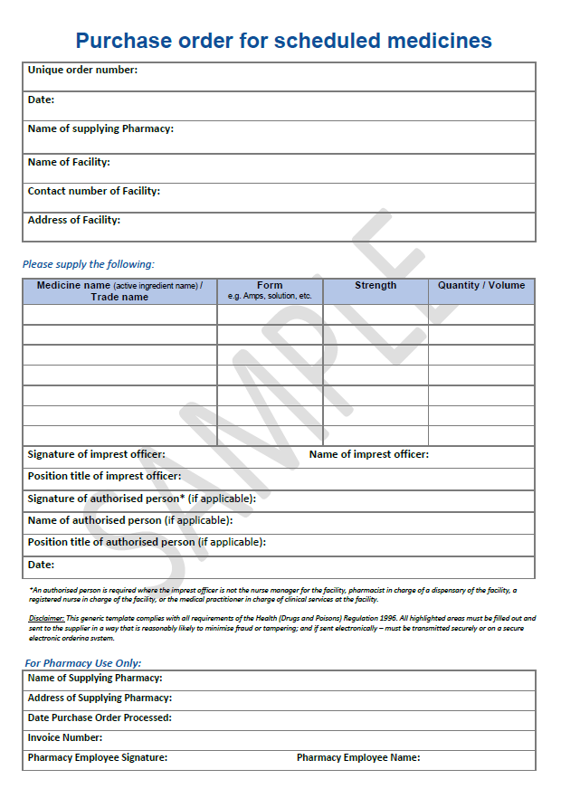

APPENDIX 5: Sealed Tamper Evident Bag
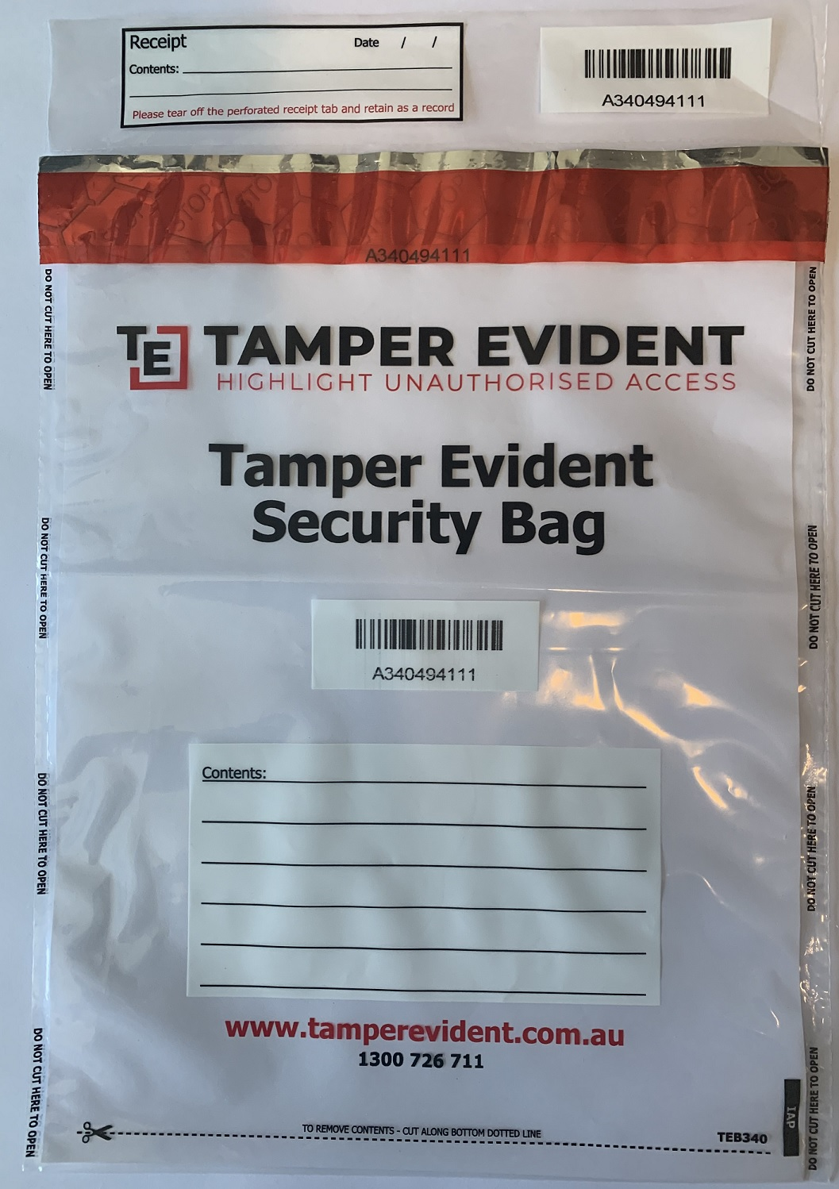

APPENDIX 6: Sample Delivery Advice Form
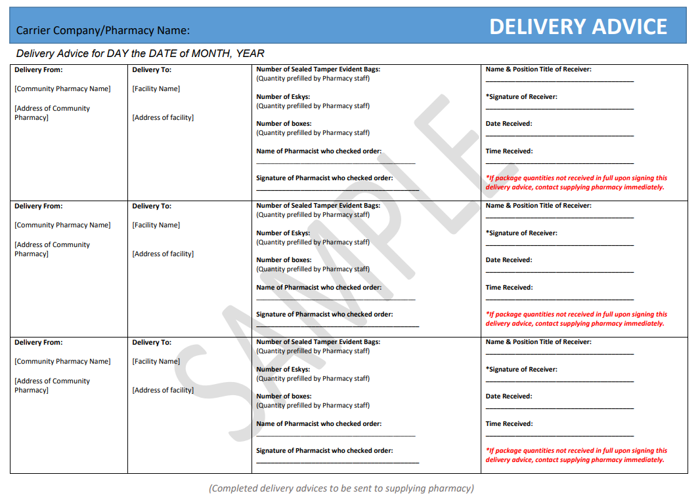

APPENDIX 7: Sample Invoice for Schedule 8 medicines provided by Supplying Pharmacy
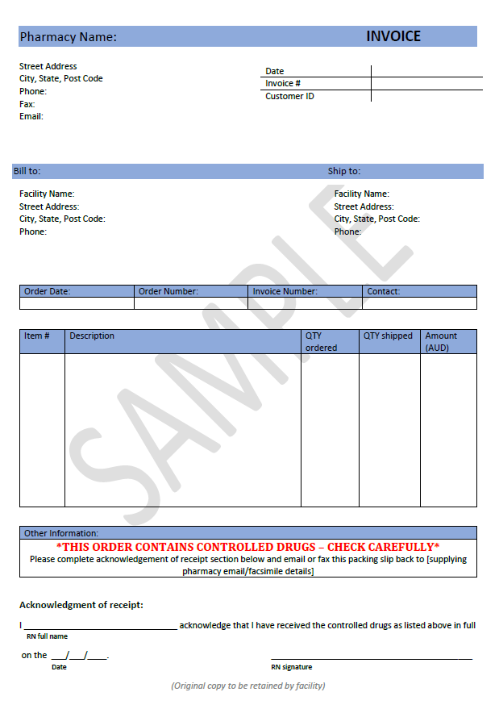

APPENDIX 8: Sample Imprest Medicine Movement Record Form
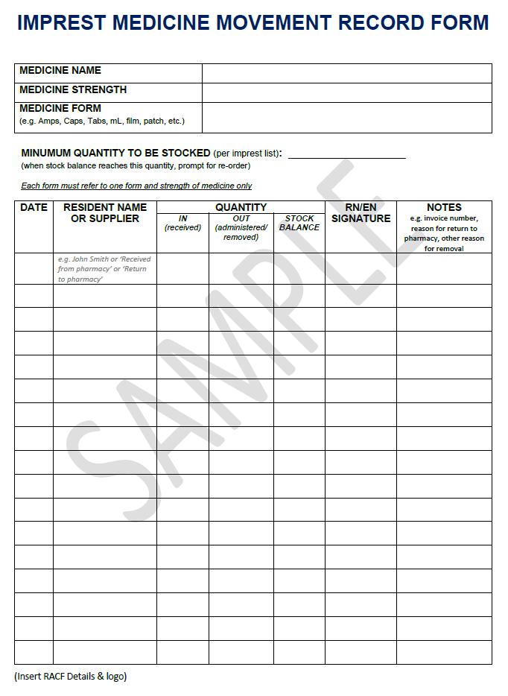

APPENDIX 9: Example layout of a S8 Register with example entries
RACF: _________ [NAME OF FACILITY] ________________ YEAR: ______2020________________ Page No. XXXX XXXX
DRUG NAME: ____MORPHINE_______________________ FORM: _____AMPs________________ STRENGTH: _______10mg/1mL______
Each page must refer to one form and strength of drug only

DATE DRUG GIVEN OR RECEIVED | PATIENT’S NAME OR SUPPLIER |  | AMOUNT GIVEN OR RECEIVED | No. USED | TIME GIVEN/  RECEIVED | BY WHOM GIVEN OR RECEIVED |  | CHECKED BY |  | No. REMAINING | WEEKLY CHECK, INVOICE NUMBER AND COMMENT (INITIALLED)
 | SURNAME | GIVEN NAME/S |  |  |  | PRINT | SIGN | PRINT | SIGN
Balance carried Forward from Book No ………………………. Page …………………….
10/07/2020 | Received from The Pharmacy 1 Pharmacy Rd Brisbane |  | Morphine 10mg/mL Amps x  20 Amps |  | 10:30 | Anna Smith |  | Tim Jones |  | 21 Amps | Inv # 12345
13/07/2020 | Bloggs | Joe | Morphine subcut 5mg | 1 Amp | 12:30 | Anna Smith |  | Tim Jones |  | 20 Amps | Patient dose = 5mg (0.5mL discarded), AS TJ
22/07/2020 | Returned to The Pharmacy 1 Pharmacy Rd Brisbane |  | Morphine 10mg/mL x 5 Amps |  | 09:30 | Anna Smith |  | Tim Jones |  | 15 Amps | Expired Stock sent to pharmacy
28/07/2020 | Bloggs | Joe | Morphine subcut 5mg | 1 Amp | 10:15 | Anna Smith |  | Tim Jones |  | 14 Amps | Patient dose = 5mg (0.5mL discarded), AS TJ
01/08/2020 | All entries checked and correct |  |  |  | 08:30 | Ben Rogers |  | - | - | 14 Amps | Monthly audit

APPENDIX 10: Sample Shift Change Check Page in the S8 Register
SHIFT CHANGE CHECK
Date | Time | Signature  OFF duty | Signature  ON duty | Date | Time | Signature  OFF duty | Signature  ON duty | Date | Time | Signature  OFF duty | Signature  ON duty
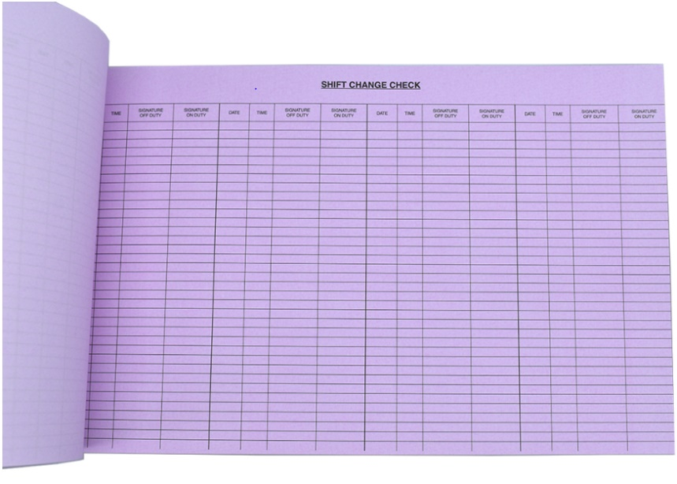

APPENDIX 11: Sample Schedule 8 Return Request Form
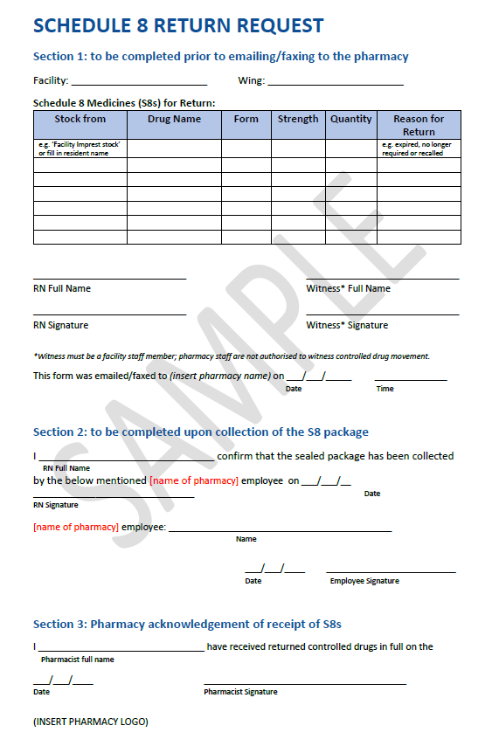

REFERENCES
- Brisbane South Palliative Care Collaborative. Guide to the Pharmacological Management of End of Life (Terminal) Symptoms in Residential Aged Care Residents: A Resource for General Practitioners. Brisbane: State of Queensland (Queensland Health); 2015.
- Brisbane South Palliative Care Collaborative (BSPCC) and NPS MedicineWise. Guidelines for the handling of palliative care medicines in community services. Version 2. Sydney: BSPCC and NPS MedicineWise; 2020. Available from: https://www.caringathomeproject.com.au/tabid/5161/Default.aspx. [Accessed 12 November 2020].
- Commonwealth of Australia. Guiding principles for medication management in residential aged care facilities. Canberra: Australian Government; 2012. Available from: https://www1.health.gov.au/internet/main/publishing.nsf/Content/guide-med-mgmt-aged-care [Accessed 4 November 2020]
- State of Queensland (Queensland Health). Health (Drugs and Poisons) Regulation 1996. Brisbane: Queensland Government; 2020. Available from: https://www.legislation.qld.gov.au/view/html/inforce/current/sl-1996-0414 [Accessed 27 April 2021].
- Palliative Care Australia (PCA). National Palliative Care Standards 5th edn. Canberra: PCA; 2018.
- Therapeutic Goods Administration. Standard for the Uniform Scheduling of Medicines and Poisons. No. 29, June 2020. Canberra: Australian Government; 2020. Available from: https://www.tga.gov.au/publication/poisons-standard-susmp [Accessed 27 April 2021]
- Aged Care Quality and Safety Commission. Guidance and Resources for Providers to support the Aged Care Quality Standards. Canberra: Australian Government; 2019. Available from: https://www.agedcarequality.gov.au/sites/default/files/media/Guidance_%26_Resource_V11.pdf [Accessed 27 September 2020]
- Australian Commission on Safety and Quality in Health Care. The National Safety and Quality Health Service (NSQHS) Standards. Australian Government; 2021. Available from: https://www.safetyandquality.gov.au/standards/nsqhs-standards
- Palliative Care Expert Group. Therapeutic Guidelines: Palliative Care. Version 4. Melbourne: Therapeutic Guidelines Limited; 2016.
- Palliative Care Australia. Palliative Care in Aged Care. Available from: https://palliativecare.org.au/palliative-care-in-aged-care [Accessed 4 November 2020].
- National Prescribing Service Limited. palliMEDS [Mobile application software]. Version 2. Sydney: National Prescribing Service Limited; 2020. Available from: https://apps.apple.com/au/app/pallimeds/id1412581448. [Accessed 12 November 2020].
- Pharmaceutical Society of Australia. Palliative Care Essential CPE. New South Wales: Pharmaceutical Society of Australia Limited; 2019.
- Commonwealth of Australia. Guidelines for a Palliative Approach in Residential Aged Care – Enhanced Version. National Health and Medical Research Council. Canberra: Australian Government; 2006. Available from: https://www.apcp.com.pt/uploads/guideall.pdf [Accessed 27 April 2021]
- Commonwealth of Australia. National Medicines Policy 2000. Canberra: Australian Government; 1999. Available from: http://www.health.gov.au/internet/main/publishing.nsf/Content/national-medicines-policy [Accessed 27 April 2021]
- State of Queensland (Queensland Health). Health Practitioner Regulation National Law Act 2009. Brisbane: Queensland Government; 2020. Available from: https://www.legislation.qld.gov.au/view/pdf/inforce/current/act-2009-045 [Accessed 5 February 2021]
- ANZSPM Limited. The Australian & New Zealand Society of Palliative Medicine. Available from: https://www.anzspm.org.au/c/anzspm [Accessed 11 November 2020]
- State of Queensland (Queensland Health). COVID-19 Response: Investigating the challenges regarding access to End of Life Medications in Residential Aged Care Facilities. Version 1.0. Brisbane: Clinical Excellence Queensland; 2020.
- The National Return & Disposal of Unwanted Medicines Limited. Return Unwanted Medicines (RUM). Available from: https://returnmed.com.au/ [Accessed 11 November 2020]
- State of Queensland (Queensland Health). Forensic and Scientific Services – controlled drug destruction form - July 2020. Available from: https://www.health.qld.gov.au/__data/assets/pdf_file/0022/443614/drug-destruction-fm.pdf [Accessed 30 March 2021].

