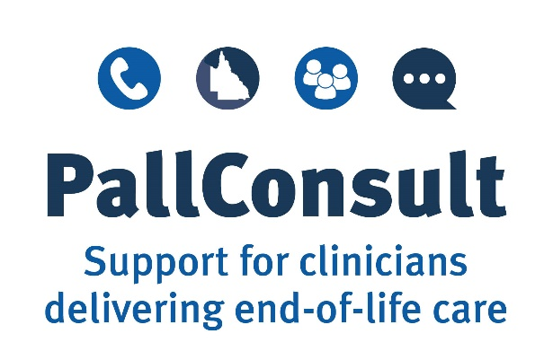

Example Policy and Procedures:

Using the NIKI T34TM, T34TM or BodyGuardTM T syringe pump for palliative patients

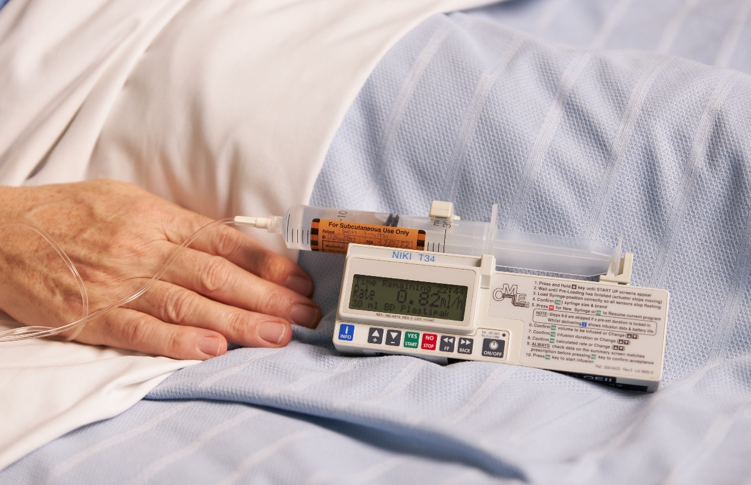

  - February 2022 v4.0

Acknowledgements
This example Policy and Procedures document was developed as part of PallConsult, a project designed to boost the ability of local healthcare teams to deliver patient-centred palliative care across Queensland.
Suggested reference
Brisbane South Palliative Care Collaborative. Example Policy and Procedures: Using the NIKI T34TM, T34TM or BodyGuardTM T syringe pump for palliative patients. Brisbane: Brisbane South Palliative Care Collaborative; 2020.
Enquiries
All enquiries about this document should be directed to:
Brisbane South Palliative Care Collaborative
E: pallconsult@health.qld.gov.au
Disclaimer
The Example Policy and Procedures: Using the NIKI T34TM, T34TM or BodyGuardTM T syringe pump for palliative patients is intended as a guide for health care organisations to help them develop or review their own policy and procedures.
While Brisbane South Palliative Care Collaborative has exercised due care in ensuring the accuracy of the material (at the date of publication) contained in the example policy and procedures document, the document is only a general guide to developing appropriate policies and procedures.
Brisbane South Palliative Care Collaborative does not accept any liability for any injury, loss, or damage incurred by use of, or reliance upon, the information provided within this example policy and procedures document.
IMPORTANT INFORMATION
This document is relevant for use with the NIKI T34TM, T34TM and BodyGuardTM T syringe pumps as the operation of these syringe pumps is very similar.
For the purposes of this document, when NIKI T34TM is written in the text, the information is relevant for NIKI T34TM, T34TM and BodyGuardTM T syringe pumps and infusions.

Table of Contents
Overview 4
Purpose of this document 4
How to use this document 4
How was this document developed? 4
PART ONE: POLICY 6
Purpose 6
Policy statement 6
Guiding principles 6
Organisational principles 7
Health professional principles 7
Patient and family education principles 7
Relevant resources 7
Terms/definitions 8
PART TWO: PROCEDURES 9
Organisational instructions 9
Prescription Guidelines 9
Medicine administration management 9
Equipment supply 10
Training for health professionals 11
Components of the PallConsult NIKI T34TM syringe pump learning package: 12
Use of the NIKI T34TM syringe pump 12
Suitable patients 12
Site selection for the subcutaneous cannula: 12
Setting up the NIKI T34TM syringe pump 14
Symptom assessment 20
Symptom assessment scores 20
NIKI T34TM syringe pump infusion checklist 20
Precipitation 20
Subcutaneous site check 20
Patient/family education related to the NIKI T34TM syringe pump 21
Patient/family education 21
At home: 21
Quality improvement 21
Servicing and maintenance 22
Pump storage 22
References 23

Overview

Purpose of this document
The purpose of this document is to provide an example policy and procedures concerning the use of the NIKI T34TM syringe pump for palliative patients.
Health care services can use this document to develop, or review, their own policy and procedures for use of the NIKI T34TM syringe pump.
The document contributes to the delivery of high-quality palliative care by enabling health professionals to competently use NIKI T34TM syringe pump infusions to help manage pain and other distressing symptoms experienced by palliative patients.
The document is one component of a suite of resources developed as part of the Queensland Health PallConsult project. These resources are available at www.pallconsult.com.au. PallConsult aims to boost the ability of local health care teams to deliver patient-centred palliative care by providing resources and support to health professionals who care for palliative patients.

How to use this document
This document is a resource for health care services to inform the development of policy and procedures for the use of NIKI T34TM syringe pump infusions within an individual service, according to the jurisdictional requirements of that service. Services may adapt the content of this document to meet individual service needs. When adapting the content of this document please insert the correct name for type of syringe pump (NIKI T34TM, T34TM or BodyGuardTM T) your organisation uses i.e. you may have both NIKI T34TM and BodyGuardTM T infusion pumps or you may have only use NIKI T34TM infusion pumps.

How was this document developed?
The document was developed using best-practice resources regarding palliative care symptom management. Resources included:
- A practical handbook for health professionals: How to safely set up, commence and provide necessary documentation for NIKI T34TM, T34TM and BodyGuard TM T syringe pump infusions (2020) (PallConsult)
- BD BodyGuardTM T Syringe Pump Directions for Use (2021). (Caesarea Medical Electronics Ltd (manufacturer))
- Guidelines for Subcutaneous Infusion Device Management in Palliative Care. 2nd ed. (2010) (Centre for Palliative Care Research and Education [CPCRE])
- National Palliative Care Standards. 5th ed. (2018) (Palliative Care Australia)
- Palliative Care (Queensland Government)
- Professional Standards for Practice (Nursing and Midwifery Board of Australia)
- Safer Care Victoria. February 2021. Syringe driver compatibility guidance document.
- State-wide strategy for end-of-life care (2015) (Queensland Health)
- Syringe driver Online Learning Package (2015) (Centre for Palliative Care Research and Education [CPCRE])
- T34TM Syringe Pump: Directions For Use. 3rd ed. (2019) (Caesarea Medical Electronics Ltd (manufacturer))
- The Syringe Driver: Continuous subcutaneous infusions in palliative care. 4th ed. 2016. (Dickman A, Schneider J. Oxford University Press)
- Therapeutic Guidelines: Palliative Care, Version 4 (2016)

PART ONE: POLICY
[Name of service provider] is committed to providing quality palliative care, including supporting the delivery of best-practice symptom management with the use of NIKI T34TM syringe pump infusions for the relief of distressing symptoms in palliative care patients.

Purpose
This policy facilitates the safe and effective use of the NIKI T34TM syringe pump for the palliative management of patients’ symptoms. This policy has been written to provide health professionals with best-practice guidance on the safe use of NIKI T34TM syringe pump infusions.

Policy statement
The aim of palliative care is to support palliative patients to live and die well in the setting of their choice. This support improves the patient’s quality of life through the prevention and relief of suffering, by impeccable assessment and treatment of pain and other problems.
In the terminal phase of a palliative patient’s illness, subcutaneous administration of medicine is common practice to manage distressing symptoms as other routes are often inappropriate or ineffective. Subcutaneous infusions, using syringe pumps, have become an integral part of care to ensure the comfort of many palliative patients. The NIKI T34TM syringe pump delivers medicines subcutaneously at a controlled rate over a pre-programmed period of twenty-four hours. Management of subcutaneous infusions using NIKI T34TM syringe pumps must ensure patient safety and comfort and accord with best practice medicine guidelines.
This policy aligns with the Queensland Health PallConsult project that specifically aims to enhance the ability of local health care teams to deliver patient-centred palliative care, especially in rural and remote parts of Queensland. PallConsult includes the development of a suite of resources to educate clinicians about aspects of end-of-life care. PallConsult supports people in the last year of their life to access the right care, at the right time and in the setting of their choice.

Guiding principles
- People have a right to be supported, cared for and to die in the place of their choice
- To ensure a good quality of life and death, people may require proactive pharmacological management of distressing symptoms by the most effective route possible
- Subcutaneous delivery of medicine is a safe and effective way to administer medicines for the management of palliative symptoms
- The use of the NIKI T34TM syringe pump to administer medicines must be openly discussed with the person (if appropriate) and the family in the context of death and dying, respecting the person’s specific spiritual, religious and cultural needs
- Medicines must be prescribed, obtained, charted and administered according to the Australian National Medicines Policy and in accordance with regional jurisdictional requirements and local facility policy and procedures
- All Australians receiving palliative care must be able to access necessary medicines, including opioids, to manage and prevent suffering from uncontrolled symptoms
- To ensure a consistent baseline competency in pain and symptom management for palliative patients, health professionals should engage in palliative care and NIKI T34TM syringe pump education and training.

Organisational principles
The [Name of service provider]:
- is responsible for providing a workplace which has clear, best-practice procedures concerning medicine management, including guidance regarding anticipatory prescribing for emergent palliative care symptoms
- will supply the workplace with the appropriate resources to safely and competently use the NIKI T34TM syringe pump
- will provide guidance for best-practice assessment of symptoms and documentation of actions when using the NIKI T34TM syringe pump
- will provide support for the delivery of patient and family education concerning syringe driver infusions
- will implement quality activities that allow for the review of practices when using NIKI T34TM syringe pump infusions
- will ensure staff are aware of, and adhere to, the policy and procedures outlined in this document.

Health professional principles
It is the health professional’s responsibility to:
- be familiar with the policy and procedures outlined in this document prior to administering medicines using a NIKI T34TM syringe pump
- recognise any gaps in their competency with NIKI T34TM syringe pump infusions, and complete any training required.

Patient and family education principles
- Patient and family education promotes safety and acceptance of the syringe driver as a means to providing improved symptom control.
- Careful explanation and education about NIKI T34TM syringe pump infusions and associated advantages and possible disadvantages is required for patients with syringe drivers and their families

Relevant resources
- The PallConsult NIKI T34 TM syringe pump learning package, that includes:
Target Audience | Resource | Use of resource
Organisations | Example Policy and Procedures: Using the NIKI T34TM, T34TM and BodyGuardTM T syringe pump for palliative patients | The purpose of this document is to provide an example policy and procedures about using the NIKI T34TM,T34TM and BodyGuardTM T syringe pumps for palliative patients. Health care services can use this document to develop or review their own policy and procedures.
Health professionals | Online education module | The online education module aims to educate health professionals about how to safely use the T34TM, T34TM and BodyGuardTM T syringe pumps.
Health professionals | A practical handbook for health professionals: How to safely set-up, commence and provide necessary documentation for NIKI T34TM, T34TM and BodyGuardTM T syringe pump infusions | This handbook contains the essential information the clinician needs to know to safely set up, commence and provide necessary documentation for NIKI T34TM, T34TM and BodyGuardTM T syringe pump infusions.
Health professionals | Setting up and commencing a NIKI T34^{TM,} T34TM and BodyGuardTM T syringe pump infusion with a new syringe: A step-by-step guide | This illustrated guide explains how to start a NIKI T34TM, T34TM and BodyGuardTM T syringe pump infusion using a step-by-step approach.
Health professionals | Short training videos | Three videos illustrate some of the essential elements for ensuring safe delivery of NIKI T34TM, T34TM and BodyGuardTM T syringe pump infusions:  Video 1 - Using syringe pumps in the clinical environment  Video 2 - Getting to know the NIKI T34TM syringe pump  Video 3 - Starting and subsequent day set up of NIKI T34TM syringe pump infusions.
Health professionals | A competency checklist | This checklist describes the requirements for ongoing demonstration of competency for safe and effective use of NIKI T34TM, T34TM and BodyGuardTM T syringe pump.
Families | Information sheet for families | This information sheet provides information for families about the NIKI T34TM, T34TM and BodyGuardTM T syringe pumps. It includes what a syringe pump is; how it works; why it is used and special considerations if the person has one at home.
- caring@home Project
- PallConsult
- Safer Care Victoria. February 2021. Syringe driver compatibility guidance document.
- National Palliative Care Standards 5th ed, 2018
- palliMEDS (download for free from Google Play or from App Store)
- Therapeutic Guidelines: Palliative Care - Subcutaneous drug administration in palliative care.
Online (subscription required): eTG complete, 2016. Appendix 10.1.
Print copy: Version 4, 2016. Appendix 1, page 387.

Terms/definitions
Palliative care | Care provided for a person of any age who has a life-limiting illness, with little or no prospect of cure, and for whom the primary treatment goal is quality of life.
NIKI T34TM syringe pump  T34TM syringe pump  BodyGuardTM T syringe pump | The NIKI T34TM syringe pump is a portable battery-operated device. It holds a syringe containing the medicine as prescribed by a doctor or nurse practitioner. The syringe pump is used to give medicines subcutaneously, over a 24-hour period and will deliver medicine at a rate set by the health professional.  The three versions of the syringe pump work in the same way. Differences in relation to the battery requirements can be found on page 12 of the Practical Handbook for Health Professionals.
Registered nurse | A registered nurse is a person with appropriate educational preparation and competence for practice, who is registered with the Australian Health Practitioner Regulation Agency (AHPRA) to practise nursing in Australia.
Subcutaneous medicine | Subcutaneous medicine is medicine given via a small plastic tube placed under the person’s skin.
Subcutaneous cannula | A subcutaneous cannula is a thin plastic tube that is inserted under the person’s skin by a health care professional.
Prescriber | A health professional authorised to write prescriptions and medicine orders and give directions (verbal or written) about administration and supply of prescription-only medicines.

PART TWO: PROCEDURES

Organisational instructions
All medicines given via a syringe pump should be correctly prescribed and clearly documented in an order written by a Doctor or a Nurse Practitioner in Palliative Care.
Examples of order forms:
- Hospitals
Form – Subcutaneous Medication Infusion Device Chart
Video – Documenting a Niki T34TM Syringe Pump on MAR
Video – Ordering continuous infusion on MAR.

- Community and Residential Aged Care Facilities (RACFs)
Form – NIKI T34TM, T34TM and BodyGuardTM T subcutaneous medication infusion chart

The NIKI T34TM syringe pump should only be operated by, or under the supervision of, appropriately trained personnel and in accordance with each local site Work Instructions and Procedures. Prior to setting up or using a syringe pump, staff must familiarise themselves with the manufacturer’s instruction booklet and locally developed clinical guidelines.

Prescription Guidelines
All prescriptions completed by a Doctor or Nurse Practitioner must comply with the Medicines and Poisons Act 2019.
Often when commencing a NIKI T34TM syringe pump, oral or transdermal medicine doses need to be converted to equivalent subcutaneous doses of the same or a different medicine.
For opioid conversion information see:
palliMEDS - The palliMEDS app, developed by NPS MedicineWise for caring@home, familiarises primary care prescribers with eight palliative care medicines that have been endorsed by the Australian & New Zealand Society of Palliative Medicine (ANZSPM) for management of terminal phase symptoms in community-based palliative care patients. These medicines can be used to manage common emergent symptoms in home-based palliative care patients in the last few days of life when people often have problems swallowing.

Medicine administration management
When managing a NIKI T34TM syringe pump infusion the primary responsibilities of the registered nurse are to:
- Recognise limitations in their knowledge and competence and must decline duties they do not feel able to perform in a skilled and safe manner in accordance with the Nursing and Midwifery Board of Australia’s Registered Nurse Standards for Practice - effective 1 June 2016
- Regularly assess patient comfort levels and symptom management requirements
- Administer medicine, assist with administration or support carers to give medicines. They must exercise professional judgement, apply knowledge and recognise their professional accountability according to the organisation’s mandatory training requirements and the requirements of the Nursing and Midwifery Board of Australia’s Registered Nurse Standards for Practice - effective 1 June 2016
- Be aware of the indications for syringe pump use
- Have a knowledge of the purpose and action of medicines administered via a NIKI T34TM syringe pump
- Recognise adverse effects of medicines used in a syringe pump
- Educate patient/family (if appropriate) on the use of and function of the syringe pump
- Safely set up a syringe pump, ensuring that the syringe is clearly labelled (listing all medicines and diluent), signed and dated
- Assess subcutaneous sites and pump function at least four-hourly in inpatient units and daily in the community/RACF and change according to policy
- Document commencement, changes of infusions, and any site or extension set changes in the patient notes and care plan/local documentation.
- The appropriate battery for the syringe pump type has been selected, it has sufficient charge and is fitted correctly.

Equipment supply
Appropriate equipment required to safely and effectively set up and maintain a NIKI T34TM syringe pump infusion is essential to the delivery of timely, quality palliative care. This equipment includes:
- NIKI T34TM syringe pump – pre-programmed to deliver infusions over a 24-hour period for palliative care patients
- Syringe:
  - a 30mL Luer lock syringe should be used to prevent risk of disconnection of the syringe from the extension set
  - 20 mL is the recommended syringe volume (combined medicine and diluent) to reduce risk of adverse site reactions
- Battery –
NIKI T34TM | Any good quality 9V alkaline disposable battery (WINC battery is slightly too small for a NIKI T34TM)
T34TM | Use 9V alkaline disposable battery with IEC code 6LR61.
BodyGuardTM T | Use 9V alkaline disposable battery with IEC code 6LR61

NB. Both WINC premium alkaline 9V battery and Battery World ultra-alkaline generic batteries meet this requirement. The battery should have the 6LR61 code printed on the casing. Using the incorrect battery can cause a number of issues including end of battery messages during pre-loading, volume test fails, pressure test/calibration issues and reduced amount of infusions from the battery
- Extension set – Luer lock extension sets should be used to prevent accidental disconnection of the extension set from the syringe
- Medicine Label - The following details are required on the label:
  - Patient name
  - ID number (record number)
  - DOB
  - Medicine/s added
  - Units/mL of medicine/s added
  - Diluent added
  - Date
  - Time
  - Initials of the nurse who prepared the syringe
  - Initials of the nurse who checked the syringe
Ensure the label is flat when attached to the syringe, so it does not interfere with the barrel clamp or obscure the volume measurement scale allowing for a visual check between what is displayed on the screen and the volume remaining in the syringe
- Lockbox – the pump and labelled syringe should be accommodated in a lockbox when in use
- Stock order – maintaining a stock of the same brand of equipment is important to minimise variations when setting up NIKI T34TM syringe pump infusions

Training for health professionals
Sustainable staff training processes are implemented to ensure all registered nurses have an understanding and knowledge of the PallConsult NIKI T34TM syringe pump learning package. This package supports health professionals to safely and effectively use the NIKI T34TM syringe pump.
An educational calendar, highlighting when each staff member needs to review the learning package and the expected date of completion for their competency check, should be established.

Components of the PallConsult NIKI T34TM syringe pump learning package:
1 | Online education module | The online education module aims to educate nurses about how to safely use the NIKI T34TM, T34TM and BodyGuardTM T syringe pump.
2 | A practical handbook for health professionals: How to safely set up, commence and provide necessary documentation for NIKI T34TM, T34TM and BodyGuardTM T infusions. | This handbook contains the essential information the clinician needs to know to safely set-up, commence and provide necessary documentation for a T34TM, T34TM and BodyGuardTM T infusions.
3 | Setting up and commencing a NIKI T34TM, T34TM and BodyGuardTM T syringe pump infusion with a new syringe: A step-by-step guide | This illustrated guide explains how to start a NIKI T34TM, T34TM and BodyGuardTM T syringe pump infusion using a step-by-step approach.
4 | Short training videos | Three videos illustrate some of the essential elements for ensuring safe delivery of the NIKI T34TM, T34TM and BodyGuardTM T syringe pump infusions:  Video 1 - Using syringe pumps in the clinical environment  Video 2 - Getting to know the NIKI T34TM, T34TM and BodyGuardTM T syringe pump  Video 3 - Starting and subsequent day set up of NIKI T34TM, T34TM and BodyGuardTM T syringe pump infusions.
5 | A competency checklist | This checklist describes the requirements for ongoing demonstration of competency for safe and effective use of a NIKI T34TM, T34TM and BodyGuardTM T syringe pump.

Use of the NIKI T34TM syringe pump

Suitable patients
Health professionals should proactively identify when a person receiving palliative care may require a NIKI T34TM syringe pump infusion to deliver medicine/s.
Some indications include:
- Persistent nausea and vomiting
- Dysphagia
- Gastrointestinal obstruction
- Poor absorption of oral medicine
- Weakness and/or alteration in a patient’s level of consciousness; or
- Any other reason where the administration of oral medicines is inappropriate or likely to be ineffective.
Health professionals should:
- Provide an opportunity for the patient and family to express any fears and anxieties that they may have around the use of a syringe pump and medicines to be administered.

Site selection for the subcutaneous cannula:
- Inappropriate site selection can lead to poor medicine absorption and ineffective therapeutic effect
- Site selection should consider the patient’s choice and comfort, the patient's mobility, skin condition and ease of access
- Site selection location must be clearly documented
- The site should be assessed regularly.
- Sites to avoid:
- Any area that restricts body and limb movement (i.e. skin folds, joints)
- Breast tissue
- Areas of obvious bruising, swelling, infection, redness, inflammation, bony prominences, tumour site, ascites, scarred areas, lymphoedema, oedema and/ or hardened, broken skin.
- Irradiated skin areas
- Areas where there is little subcutaneous tissue (i.e. thin patient outer arms/ sub clavicular area).
- Additional considerations:
- For confused patients, consider a subcutaneous site position that is out of the patient's line of sight and reach (i.e. scapula, upper back)
- If a patient is being turned at regular intervals avoid the anterior upper arm
- When resiting a subcutaneous cannula, ensure adequate site rotation. When it is necessary to re-site in the same area, the new site should be at least 5 cm away from the old site
- If the patient requires subcutaneous breakthrough medicines in addition to the subcutaneous infusion, consider using two separate subcutaneous cannulas.

Setting up the NIKI T34TM syringe pump
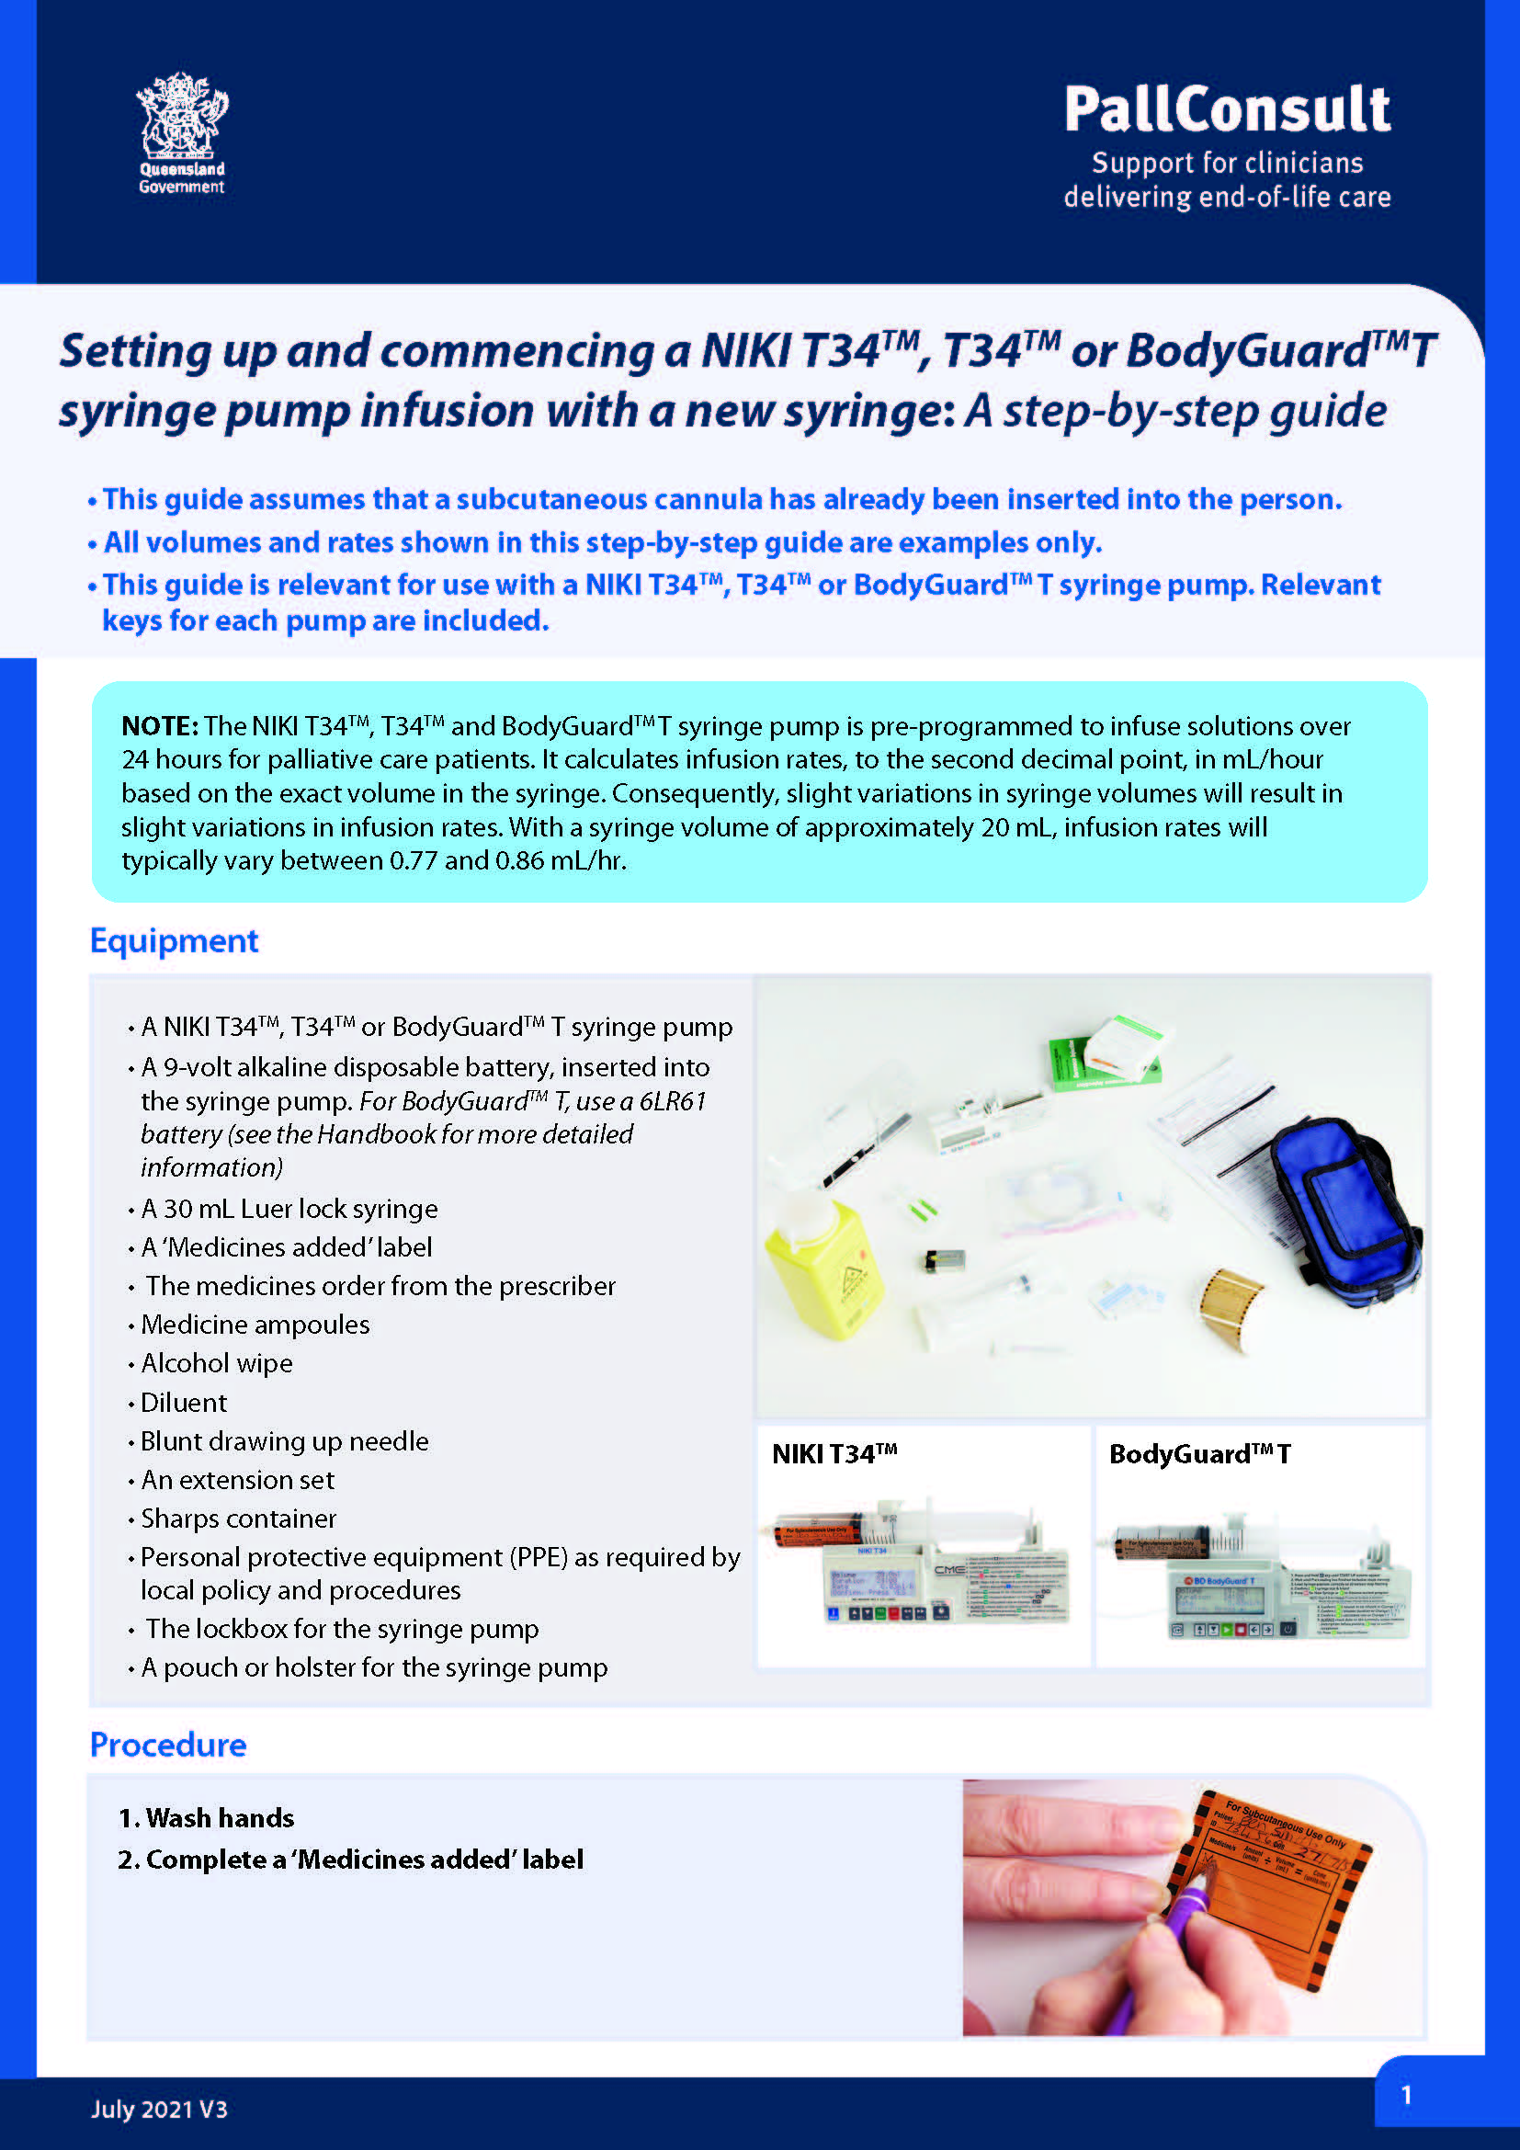
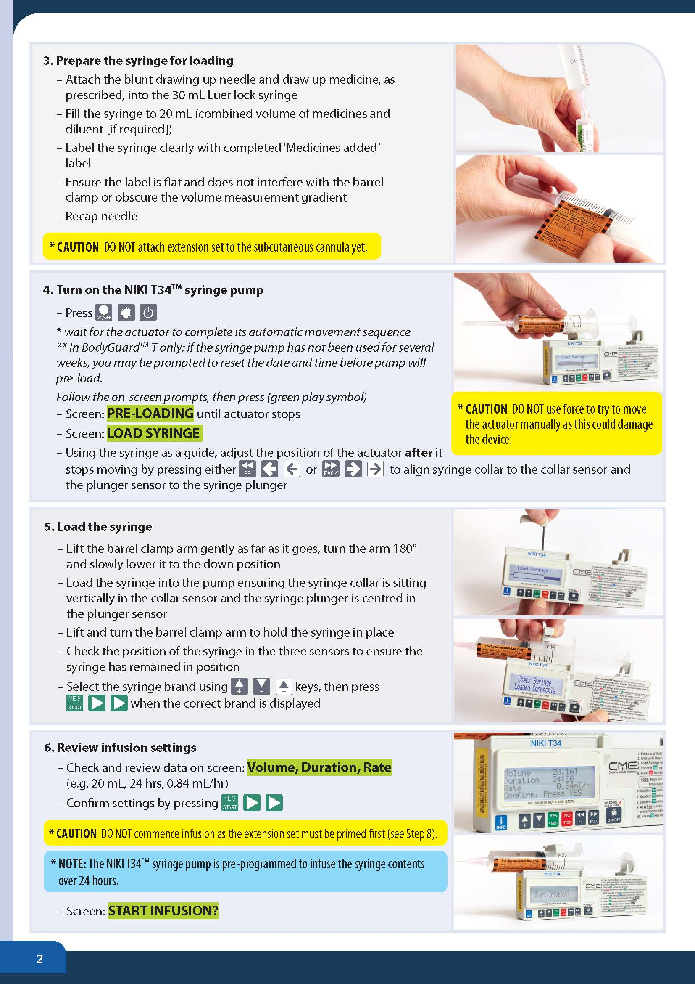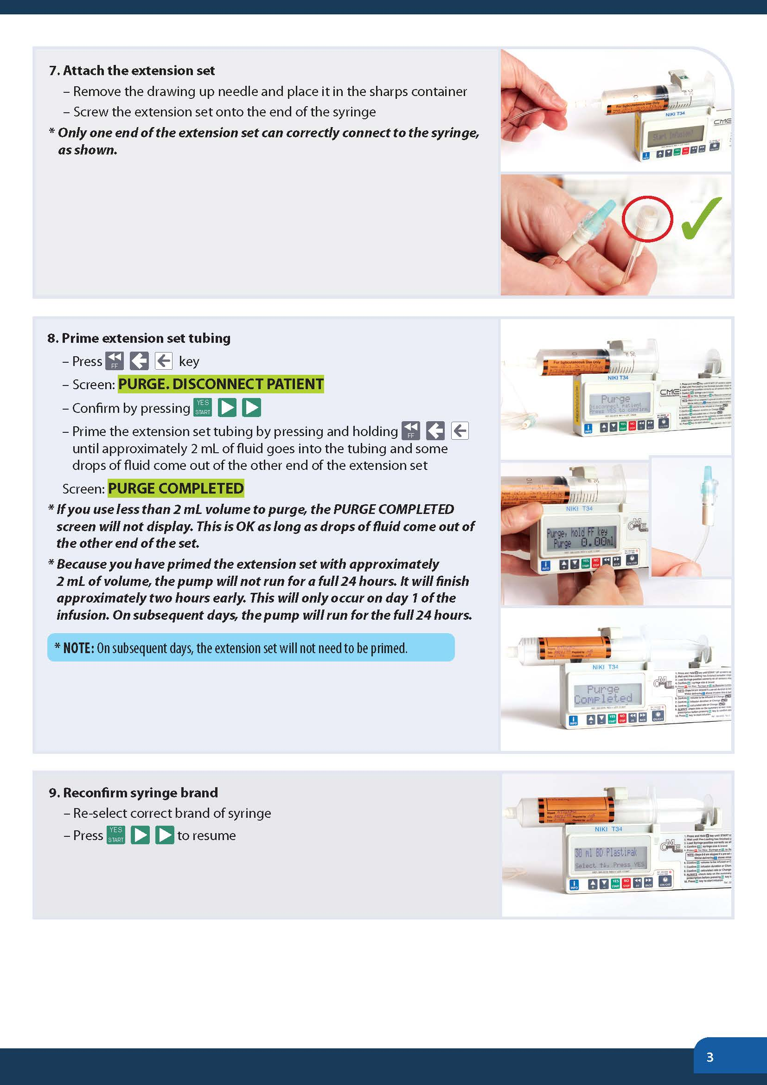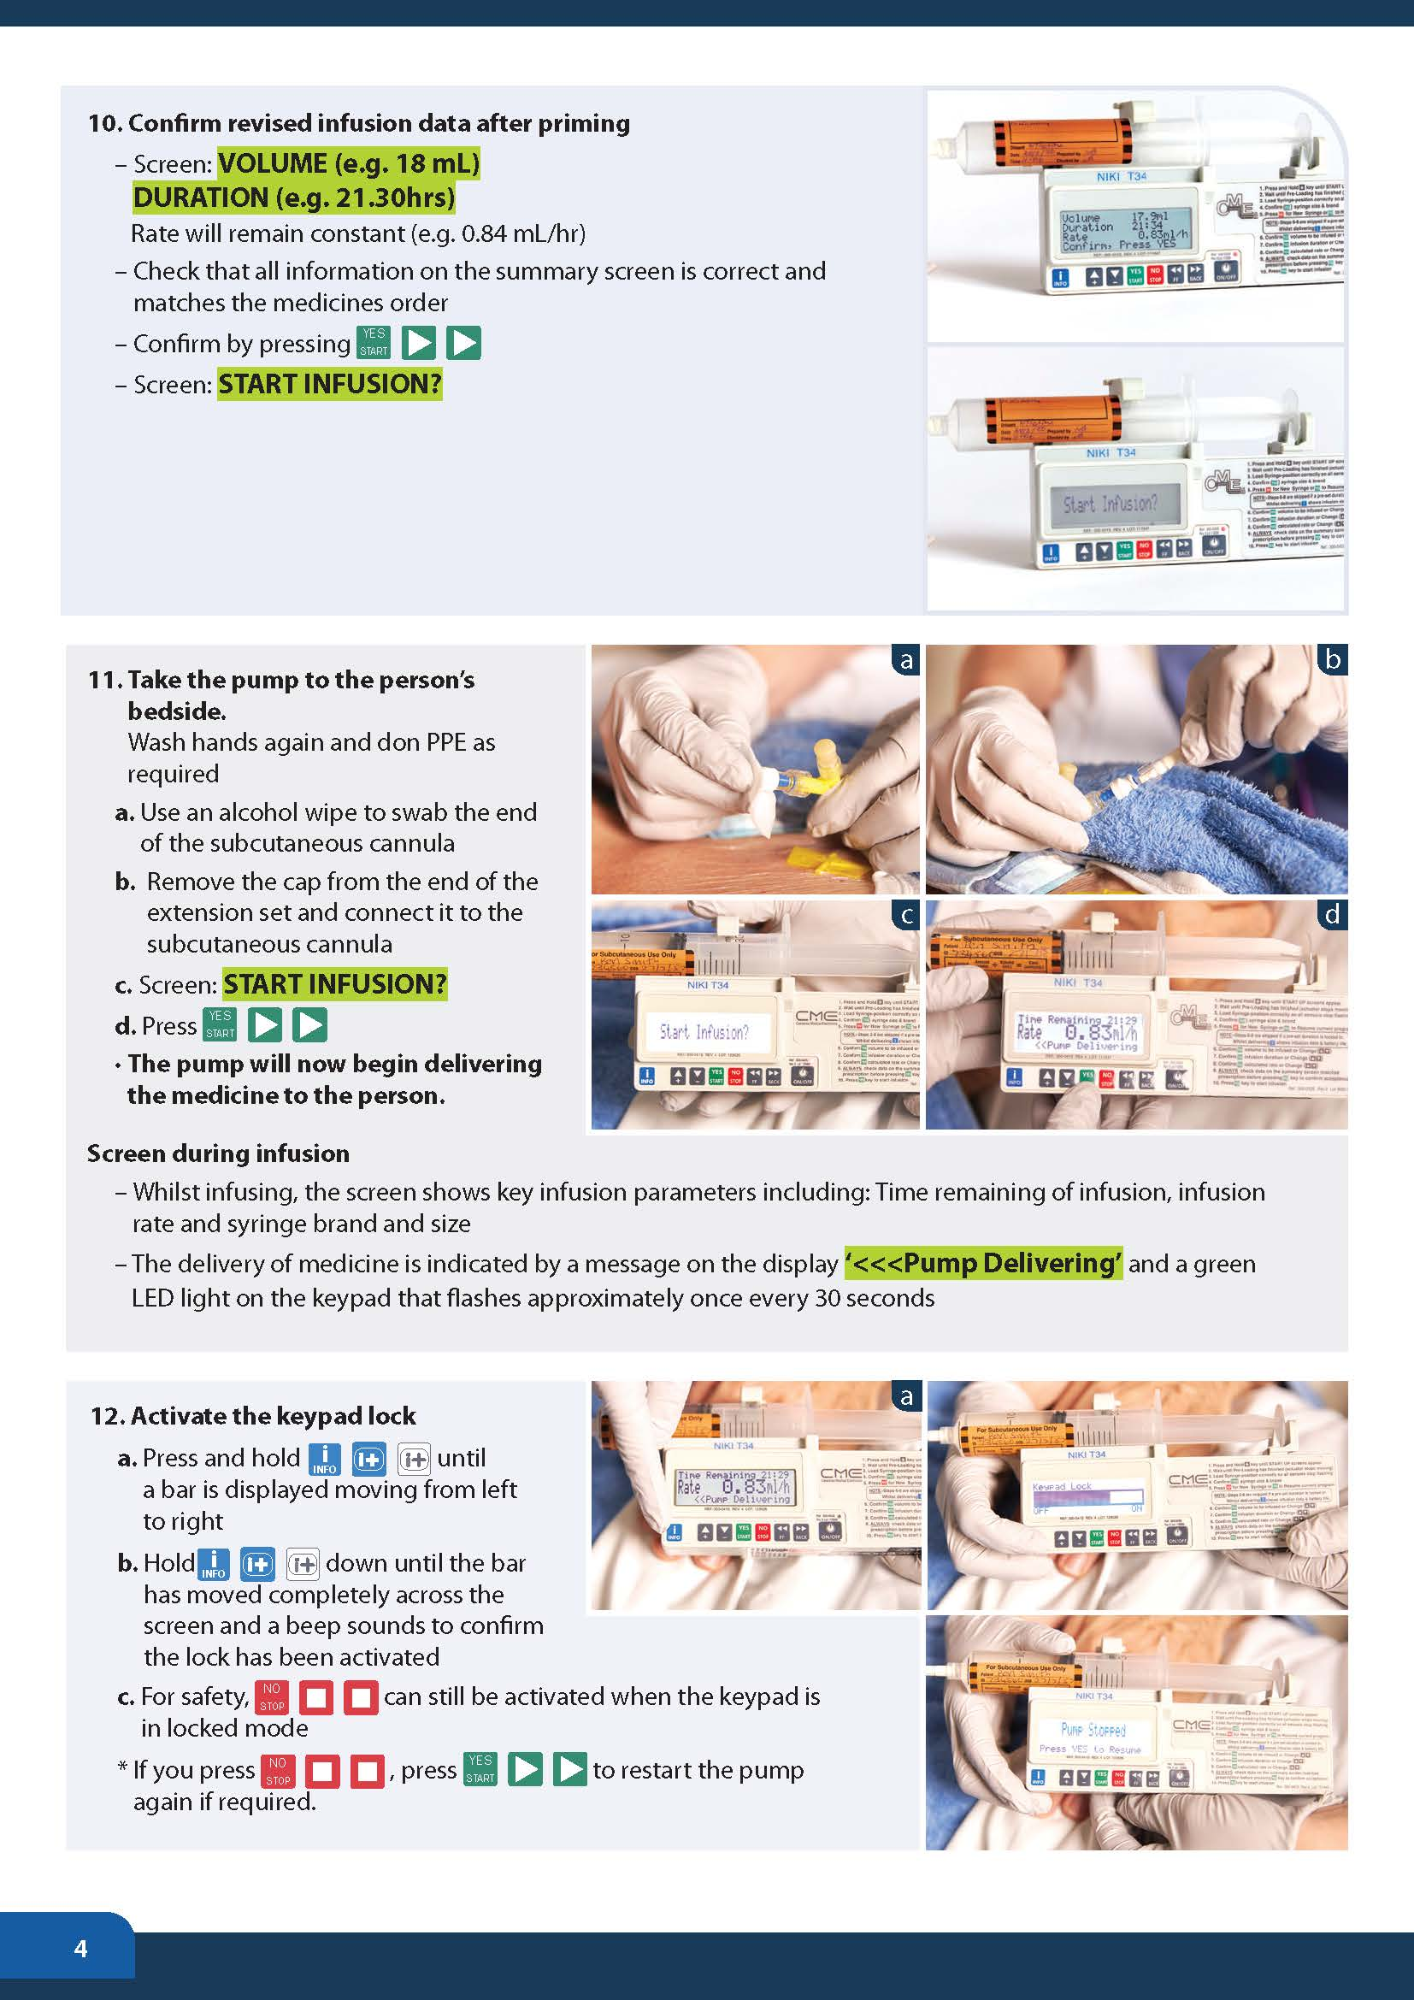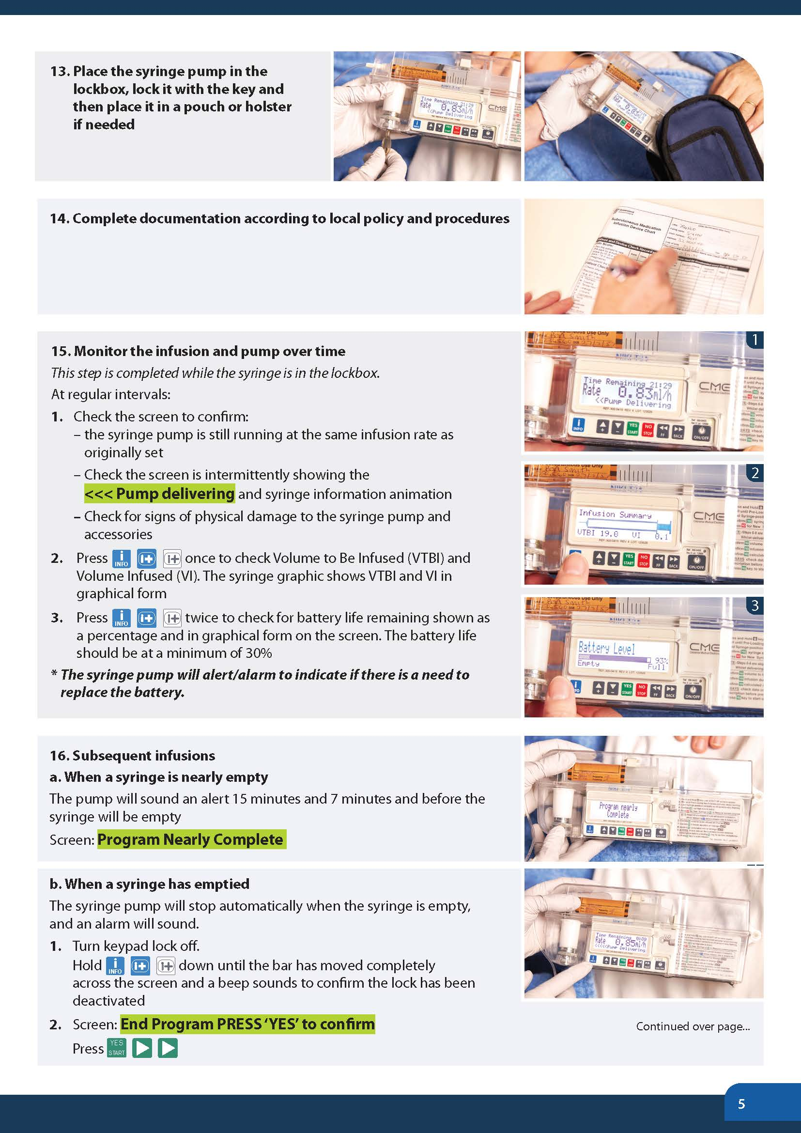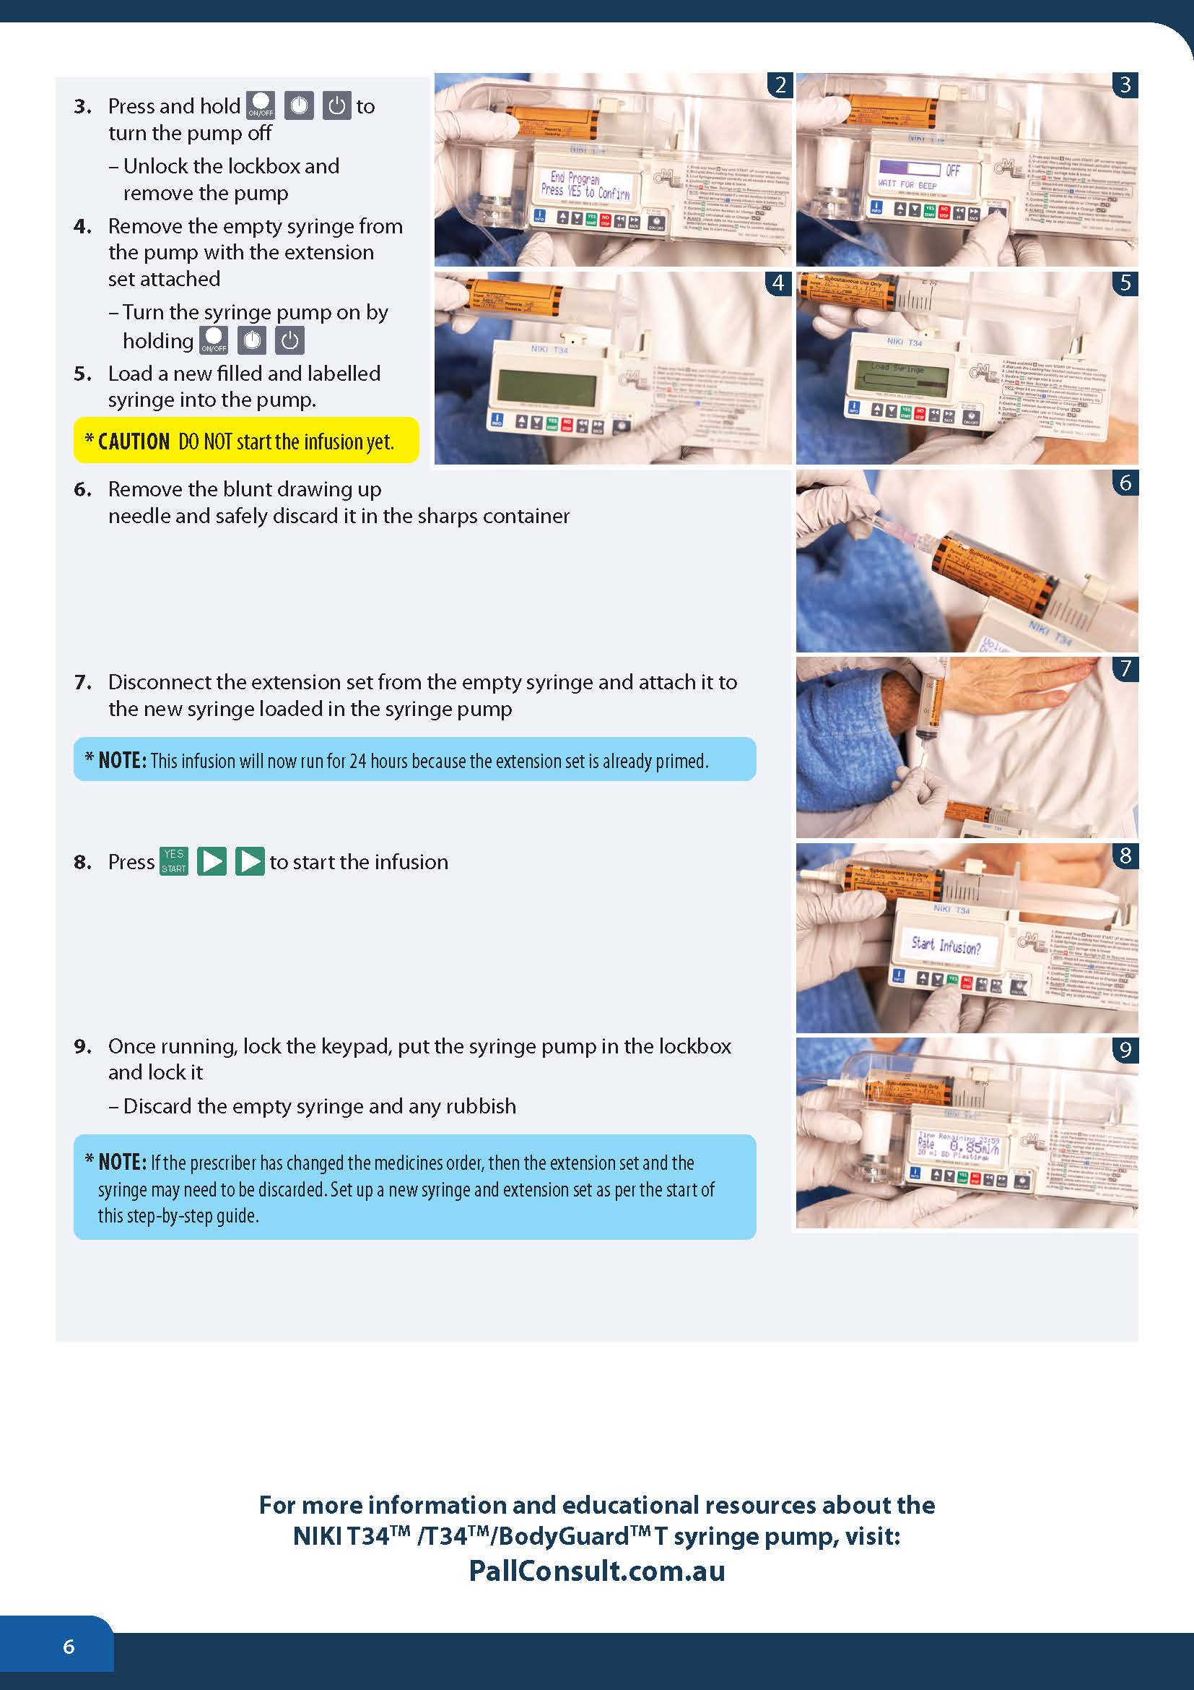

Symptom assessment
Meticulous symptom assessment and management is required when a person is receiving a NIKI T34TM syringe pump infusion

Symptom assessment scores
- Assess the person’s symptom(s) level(s) using a numerical rating scale with scores of 0 to 10 (0 = no symptom distress at all and 10 = worst imaginable symptom distress level)
- Document the score before and about thirty minutes after any intervention delivered to provide symptom relief such as a breakthrough medicine
- Provide PRN medicine as ordered and required
- Follow up with the prescriber if symptoms are not well controlled.

NIKI T34TM syringe pump infusion checklist
- Ensure the battery has sufficient charge
- Check the LED light flashes green intermittently on the NIKI T34TM syringe pump when infusing
- Check the volume remaining in the syringe and that the required volume has been delivered
- Check that the device is running to time
- Check connections are secure
- Ensure there are no leakages
- Check extension set lines are kink free
- Check solution in the syringe is clear and there is no precipitation in the syringe
- Document check and any remedial actions taken.

Precipitation
If a combination of medicines become cloudy, precipitates or crystallises in the syringe or extension set:
- Immediately stop administration of the medicines
- Contact the medical officer
- Re-site subcutaneous cannula
- Discard the syringe and extension set
- Prepare a new syringe and extension set
- Restart the syringe driver
- Document actions in the patient’s medical record and ensure that the incident is recorded in the organisation’s Incident Information Management System

Subcutaneous site check
Site inspection (at least four-hourly in inpatient units and daily in the community/RACFs) is integral to early identification and prevention of site-related complications and should be performed as part of routine care. Any site problems can potentially cause patient discomfort. They can also interfere with medicine absorption and compromise effective symptom control.
When inspecting the site, check for:
- Tenderness or hardness at the site
- Leakage at the insertion site
- Swelling
- Erythema (redness)
- Presence of blood in the tubing
- Displacement of the cannula.

Patient/family education related to the NIKI T34TM syringe pump
Patients and family require clear and simple education about the reasons the NIKI T34TM syringe pump is being considered for symptom management. Time should be provided to discuss a patient or family members’ fears about the use of a NIKI T34TM syringe pump infusion.

Patient/family education
Education should include:
- Syringe driver use including:
- An explanation about what the NIKI T34TM syringe pump does, and how it works
- Safety aspects of the NIKI T34TM syringe pump
- Ways to manage the NIKI T34TM syringe pump at home
- Site checks
- Trouble shooting tips.
- Providing written information to reinforce verbal education provided

At home:
Nursing staff must carefully assess the patient/ family for their willingness and ability to manage subcutaneous infusions in the home environment.
The patient and family should be given verbal and practical guidance about living with a NIKI T34TM syringe pump. Health professionals should be mindful that information and education given when the patient is unwell, and the family/carer is anxious may need to be repeated and reinforced. Well-timed information can prepare the family for the role they are taking on, minimising potential adverse consequences.
A 24-hour support number must be provided to families caring for patients with syringe pumps.
See: Information sheet for families (about the NIKI T34TM syringe pump) (PallConsult).

Quality improvement
As part of the continuous quality improvement process of a palliative care organisation, 12-monthly audits should be undertaken to monitor staff completion rates of the NIKI T34TM syringe pump competencies. This includes both the online education module Using the NIKI T34TM syringe pump for palliative symptom management and the competency demonstration checklist using the PallConsult NIKI T34TM syringe pump learning package resources.
A routine audit of the organisation’s incident and error register is a systematic way to review any potential issues with staff knowledge of policy and procedures of the NIKI T34TM syringe pump.
Audits need to be directly relevant to the implementation of the PallConsult: NIKI T34TM syringe pump resources.
Evaluation and monitoring should be simple, inexpensive and feasible. The processes should use routinely-collected data and data linkage where possible.

Servicing and maintenance
- Follow the manufacturer’s instructions for the cleaning of the NIKI T34TM syringe pump after each use.
- A maintenance service of the NIKI T34TM syringe pump is recommended every year, as per the manufacturer’s guidelines. A maintenance reminder alert will display on the machine when the yearly service is due.
- Servicing should be attended by a BD certified technician who will perform the following procedures:
- Clean the syringe pump thoroughly
- Visually inspect the syringe pump to verify its structural integrity
- Perform all the manual tests in the change set up menu
- Perform calibration procedures as per the technical service manual
- Run the syringe pump for several hours to make sure no abnormalities occur during infusion such as alarms, inaccurate infusion and battery inconsistencies.

Pump storage
Store in a clean, dry place at room temperature. If the syringe pump is stored for an extended period it should be cleaned and the battery removed.

References
- Brisbane South Palliative Care Collaborative. A practical handbook for health professionals: How to safely set up, commence and provide necessary documentation for NIKI T34TM, T34TM and BodyGuardTM T syringe pump infusions. Brisbane: BSPCC; 2020.
- Queensland Government (Centre for Palliative Care Research and Education). Guidelines for Subcutaneous Infusion Device Management in Palliative Care. 2nd ed. Brisbane: CPCRE; 2010.
- Palliative Care Australia. National Palliative Care Standards. 5th ed. PCA;2018.
- Queensland Government (Queensland Health). Palliative Care. Available from: https://www.qld.gov.au/health/support/end-of-life/care/palliative.
- Nursing and Midwifery Board of Australia. Professional Standards. Available from: https://www.nursingmidwiferyboard.gov.au/codes-guidelines-statements/professional-standards.aspx
- State of Queensland (Queensland Health). Statewide strategy for end-of-life care. Brisbane: 2015.
- Safer Care Victoria. February 2021. Syringe driver compatibility guidance document.
- Queensland Government (Centre for Palliative Care Research and Education). Syringe driver online learning package. CPCRE; 2015.
- Caesarea Medical Electronics Ltd. T34TM Syringe Pump: Directions For Use (3rd Edition, DFU999-103EN Rev.04). Caesarea, Israel: CME; 2019.
- BD BodyGuardTM T Syringe Pump Directions for Use (2021). (Caesarea Medical Electronics Ltd (manufacturer)
- T34TM Syringe Pump: Directions For Use. 3rd ed. (2019) (Caesarea Medical Electronics Ltd (manufacturer)
- Dickman A, Schneider J. The Syringe Driver: Continuous subcutaneous infusions in palliative care (4th ed.). Oxford, New York: Oxford University Press; 2016.
- Palliative Care Expert Group. Therapeutic Guidelines: Palliative Care. Version 4. Melbourne: Therapeutic Guidelines Limited; 2016.

