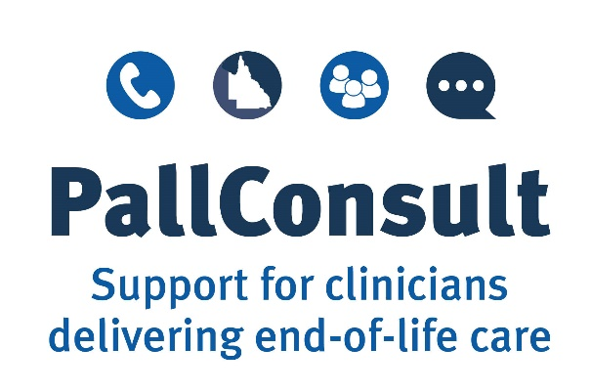

Example Policy and Procedures:

Using the SurefuserTM+ infusion device in the palliative care setting
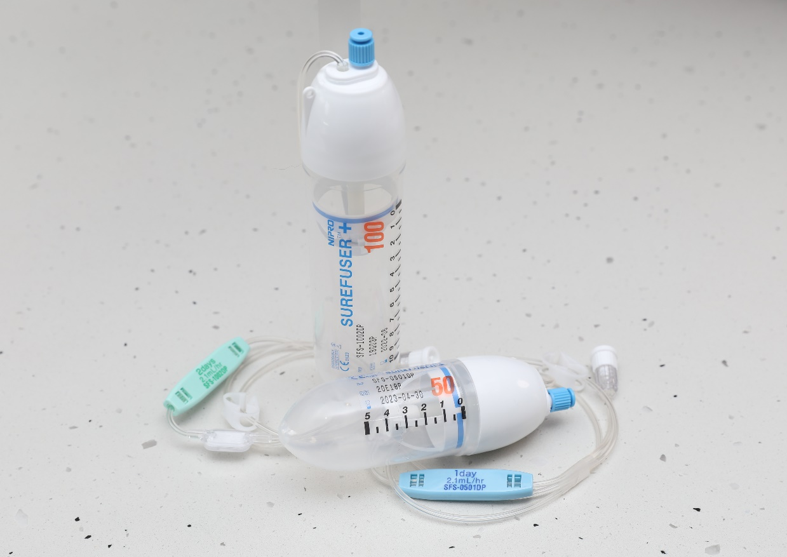

  - April 2021 V1.0

Acknowledgements
This example Policy and Procedures document was developed as part of PallConsult, a project designed to boost the ability of local health care teams to deliver patient-centred palliative care across Queensland.
Suggested reference
Brisbane South Palliative Care Collaborative. Example Policy and Procedures: Using the SurefuserTM+ infusion device in the palliative care setting. Brisbane: Brisbane South Palliative Care Collaborative; 2021.
Enquiries
All enquiries about this document should be directed to:
Brisbane South Palliative Care Collaborative
E: pallconsult@health.qld.gov.au
Disclaimer
The Example Policy and Procedures: Using the SurefuserTM+ infusion device in the palliative care setting is intended as a guide for health care organisations to help them develop or review their own policy and procedures.
While Brisbane South Palliative Care Collaborative has exercised due care in ensuring the accuracy of the material (at the date of publication) contained in the example policy and procedures document, the document is only a general guide to developing appropriate policy and procedures.
Brisbane South Palliative Care Collaborative does not accept any liability for any injury, loss, or damage incurred by use of, or reliance upon, the information provided within this example policy and procedures document.

Table of Contents
Overview 4
Purpose of this document 4
How to use this document 4
How has this document been developed? 4
PART ONE: POLICY 5
Purpose 5
Policy statement 5
Guiding principles 5
Organisational principles 6
Health professional principles 6
Patient and family education principles 6
Relevant resources 7
Terms/definitions 8
PART TWO: PROCEDURES 8
Organisational instructions 8
Prescription Guidelines 8
Medicine administration management 9
Equipment supply 9
Training for health professionals 10
Components of the PallConsult SurefuserTM+ learning package: 10
Use of the SurefuserTM+ 11
Suitable patients 11
Symptom assessment 11
Symptom assessment scores 11
Step-by-step guide – Setting up the SurefuserTM+ infusion device, commencing and monitoring the infusion 12
Monitoring the infusion over time 18
Managing monitoring requirements 18
Monitoring labels 18
SurefuserTM+ checklist 20
Precipitation 20
Subcutaneous cannula insertion site check 20
Patient/family education related to the SurefuserTM+ 20
Education in the home setting should include: 21
Troubleshooting 22
Quality improvement 22
SurefuserTM+ storage: 23
References 24

Overview

Purpose of this document
The purpose of this document is to provide an example policy and procedures concerning the use of the SurefuserTM+ infusion device (hereafter in the document referred to as the SurefuserTM+) in the palliative care setting. Health care services can use this document to develop, or review, their own policy and procedures for use of the SurefuserTM+.
The document contributes to the delivery of high-quality and patient-centred palliative care by enabling health professionals to competently use the SurefuserTM+ to help manage pain and other distressing symptoms experienced by palliative care patients.
The document is one component of a suite of resources developed as part of the Queensland Health PallConsult project. These resources are available at www.pallconsult.com.au. PallConsult aims to boost the ability of local health care teams to deliver patient-centred palliative care by providing resources and support to health professionals who care for palliative patients.

How to use this document
This document is a resource for health care services to inform the development of policy and procedures for the use of SurefuserTM+ within an individual service, according to the jurisdictional requirements of that service. Services may adapt the content of this document to meet individual service needs.
Health service providers should adapt the contents of this document to meet individual facility, organisations and geographical needs.

How has this document been developed?
The document has been developed using best-practice resources regarding palliative care symptom management and incorporated Queensland legislative requirements concerning medicine management. Resources included:
- A practical handbook for health professionals: How to safely set up, commence and provide necessary documentation for NIKI T34TM syringe pump (2nd and 3rd editions) infusions (2020) (PallConsult)¹
- Guidelines for Subcutaneous Infusion Device Management in Palliative Care. 2nd ed. (2010) (Centre for Palliative Care Research and Education [CPCRE])²
- Health (Drugs and Poisons) Regulation 1996 (Queensland Government)³
- National Palliative Care Standards. 5th ed. (2018) (Palliative Care Australia)⁴
- End-of-life and Palliative Care (Queensland Government)⁵
- Professional standards for practice (Nursing and Midwifery Board of Australia)⁶
- Statewide strategy for end-of-life care (2015) (Queensland Health)⁷
- Syringe driver compatibility Guidance document (2021)⁸
- Syringe Driver Online Learning Package (2015) (Centre for Palliative Care Research and Education, Queensland Health)⁹
- Step-by-step guide for filling and preparing SurefuserTM+ (NIPRO Australia Pty Ltd)¹⁰
- The National Safety and Quality Health Service (NSQHS) Standards 2021 (Australian Commission on Safety and Quality in Health Care)¹¹
- The Syringe Driver: Continuous Subcutaneous Infusions in Palliative Care. 4th ed. 2016. (Dickman A, Schneider J. Oxford University Press)¹²
- Therapeutic Guidelines: Palliative Care, Version 4 (2016)¹³

PART ONE: POLICY
[Name of service provider] is committed to providing quality palliative care, including supporting the delivery of best-practice symptom management. When either a NIKI T34TM syringe pump or similar continuous subcutaneous infusion pumps are unavailable or when registered nurses are unavailable to manage daily infusion pumps, the SurefuserTM+ can be used as a second line option for subcutaneous delivery of medicines in palliative care patients.

Purpose
This policy has been written to provide health professionals with best-practice guidance on the safe and effective use of the SurefuserTM+ for the management of palliative care patients’ symptoms, in alignment with Queensland legislative requirements.

Policy statement
In the terminal phase of a palliative patient’s illness, subcutaneous administration of medicine is common practice to manage distressing symptoms, as other routes are often inappropriate or ineffective. This support improves the patient’s quality of life through the prevention and relief of suffering, by impeccable assessment and treatment of pain and other symptoms.
Subcutaneous infusions, using battery or electronically powered syringe pumps, have become an integral part of care to ensure the comfort of many palliative patients. When either a NIKI T34TM syringe pump or similar powered, continuous subcutaneous infusion pumps are unavailable or when registered nurses are unavailable to manage infusion pumps daily, the SurefuserTM+ can be used as a second line option for subcutaneous delivery of medicines in palliative patients.
This policy aligns with the Queensland Health PallConsult project that specifically aims to enhance the capacity of local health care teams to deliver patient-centred palliative care, especially in rural and remote parts of Queensland. PallConsult has developed of a suite of resources to educate clinicians about aspects of end-of-life care.

Guiding principles
- People have a right to be supported, cared for and to die in the place of their choice
- To ensure a good quality of life and death, patients may require proactive pharmacological management of distressing symptoms, delivered by the most effective route possible
- Subcutaneous delivery of medicine is a safe and effective way to administer medicines for the management of palliative symptoms
- The use of the SurefuserTM+ to administer medicines must be openly discussed with the patient (if appropriate) and the family in the context of death and dying and respecting the patient’s specific spiritual, religious and cultural needs
- Medicines must be prescribed, obtained, charted and administered according to the Australian National Medicines Policy and in accordance with regional jurisdictional requirements and local facility/organisation policy and procedures
- All Australians receiving palliative care must be able to access necessary medicines, including opioids, to manage and prevent suffering from uncontrolled symptoms
- To ensure a consistent baseline competency in pain and symptom management for palliative patients, health professionals should engage in palliative care and SurefuserTM+ education and training.

Organisational principles
[Name of service provider]:
- is responsible for providing a workplace which has clear, best-practice procedures concerning medicine management, including guidance regarding anticipatory prescribing for emergent end-of-life symptoms
- will supply the workplace with the appropriate resources to safely and competently use the SurefuserTM+
- will provide guidance for best-practice assessment of symptoms and documentation of actions when using the SurefuserTM+
- will provide support for the delivery of patient and family education concerning subcutaneous infusions
- will implement quality activities that allow for the review of practices when using SurefuserTM+
- will ensure staff are aware of, and adhere to, the policy and procedures outlined in this document.

Health professional principles
It is the health professional’s responsibility to:
- be familiar with the policy and procedures outlined in this document prior to administering medicines using a SurefuserTM+
- recognise any gaps in their competency when using the SurefuserTM+, and complete any training required.

Patient and family education principles
- Patient and family education promotes safety and acceptance of the subcutaneous infusion to provide improved symptom control
- Careful explanation and education about SurefuserTM+ and associated advantages and possible disadvantages is required for patients with subcutaneous infusions and their families.

Relevant resources
- The PallConsult SurefuserTM+ learning package includes:
Target Audience | Resource | Use of resource
Organisations | Example Policy and Procedures: Using the SurefuserTM+ infusion device in the palliative care setting | The purpose of this document is to provide an example policy and procedures about using a SurefuserTM+ in the palliative care setting. Health services can use this document to develop or review their own policy and procedures.
Health professionals | A practical handbook for health professionals: How to safely set up a SurefuserTM+ infusion device, commence and monitor the infusion in a palliative care setting | This handbook contains the essential information you need to know to safely set up a SurefuserTM+, commence and monitor the infusion in a palliative care setting.
Health professionals | A step-by-step guide: Setting up a SurefuserTM+ infusion device, commencing and monitoring the infusion | This illustrated guide explains how to set up the SurefuserTM+, commence and monitor the infusion using a step-by-step approach.
Health professionals | Short training video: A nurse’s guide to using the SurefuserTM+ in the palliative care setting | This video illustrates some of the essential elements to ensure the safe delivery of medicines using the SurefuserTM+ in a palliative care setting. https://vimeo.com/403504780
Health professionals | A competency checklist - How to safely set up a SurefuserTM+ infusion device, commence and monitor the infusion in a palliative care setting | This checklist describes the requirements for ongoing demonstration of competency for safe and effective use of the SurefuserTM+ to administer infusions in a palliative care setting.
Families | Information sheet for families: SurefuserTM+ infusion device and infusions | This information sheet provides information for families about the SurefuserTM+. It includes what a SurefuserTM+ is; how it works; why it is used and considerations when caring for a person at home.
Families | SurefuserTM+ infusion device and infusions: troubleshooting and monitoring guide for families | This illustrated guide explains the monitoring required for families when a using a SurefuserTM+ infusion device and simple ways to troubleshoot if the device is not operating correctly.
- caring@home project
- PallConsult
- Syringe driver compatibility Guidance document 2021
- National Palliative Care Standards 5th ed, 2018
- palliMEDS app (download for free from Google Play or from App Store)
- caring@home app (download for free from Google Play or from App Store)
- Therapeutic Guidelines: Palliative Care - Subcutaneous drug administration in palliative care.
Online (subscription required): eTG complete, 2016. Appendix 10.1.
Print copy: Version 4, 2016. Appendix 1, page 387.

Terms/definitions
Palliative care | Palliative care is care provided for a person of any age who has a life-limiting illness, with little or no prospect of cure, and for whom the primary treatment goal is quality of life.
NIKI T34TM syringe pump | The NIKI T34TM syringe pump is a portable battery-operated device. It holds a syringe containing the medicine as prescribed by a doctor or nurse practitioner. The syringe pump is used to give medicines subcutaneously, over a 24-hour period and will deliver medicine at a rate set by the health professional.
SurefuserTM+ infusion device (SurefuserTM+) | The SurefuserTM + is a single-use elastomeric infusion device available in a variety of flow rates and sizes that is used to deliver subcutaneous medicines to a person to help manage end-of-life symptoms.
Subcutaneous medicine | Subcutaneous medicine is medicine given via a small plastic tube placed under the person’s skin.
Subcutaneous cannula/Saf-T-Intima | A subcutaneous cannula is a thin plastic tube that is inserted under the person’s skin by a health professional.
Prescriber | A prescriber is a health professional authorised to write prescriptions and medicine orders and give directions (verbal or written) about administration and supply of prescription-only medicines.

PART TWO: PROCEDURES

Organisational instructions
All medicines given via a subcutaneous infusion device should be correctly prescribed and clearly documented in an order written by a doctor or a nurse practitioner experienced in palliative care.
Examples of order forms:
- Hospitals
Form – Subcutaneous Medication Infusion Device Chart (Queensland Government)
Watch the video – Ordering SurefuserTM+ infusion on MAR.(Internal Queensland Health only)

- Community and Residential Aged Care Facilities (RACFs)
Form - for a SurefuserTM+ 50mL 1-day Subcutaneous Medication Infusion Device Chart
Form - for a SurefuserTM+ 100mL 2-day (coming soon to pallconsult.com.au)
Form - for a SurefuserTM+ 100mL 3-day (coming soon pallconsult.com.au)

The SurefuserTM+ should only be operated by, or under the supervision of, appropriately trained personnel and in accordance with each local site’s Work Instructions and Procedures. Prior to setting up or using a SurefuserTM+, staff must familiarise themselves with the manufacturer’s step-by-step guide and locally developed clinical guidelines.

Prescription Guidelines
All prescriptions completed by a doctor or nurse practitioner must comply with the Health (Drugs and Poisons) Regulation 1996.
Medicines used together in a CSCI device should be checked for compatibility. There is limited data on compatibility and stability of CSCI medicine combinations lasting longer than 24 hours. Clinical judgement and specialist palliative care advice may be required.⁸
Do not mix more than three medicines in an infusion device, unless on the advice of a palliative medicine specialist.¹²
Sterile 0.9% sodium chloride is the first choice of diluent in Australia. If in doubt, check with a pharmacist or an evidence-based syringe pump compatibility guide.¹⁴
Often when commencing a subcutaneous infusion, oral or transdermal opioid medicine, doses need to be converted to equivalent subcutaneous doses of the same or a different medicine.
For opioid conversion information and calculations see:
- palliMEDS - The palliMEDS app, developed by NPS MedicineWise for caring@home, familiarises primary care prescribers with eight palliative care medicines that have been endorsed by the Australian & New Zealand Society of Palliative Medicine (ANZSPM) for management of terminal phase symptoms in community-based palliative care patients. These medicines can be used to manage common emergent symptoms in home-based palliative care patients in the last few days of life, when people often have problems swallowing.

Medicine administration management
When managing a SurefuserTM+ infusion, the primary responsibilities of the registered nurse are to:
- Recognise limitations in their knowledge and competence and decline duties they do not feel able to perform in a skilled and safe manner in accordance with the Nursing and Midwifery Board of Australia’s Registered nurse standards for practice - effective 1 June 2016
- Regularly assess patient comfort levels and symptom management requirements
- Administer medicine or support carers to give medicines. They must exercise professional judgement, apply knowledge and recognise their professional accountability according to the organisation’s mandatory training requirements and the requirements of the Nursing and Midwifery Board of Australia’s Registered nurse standards for practice - effective 1 June 2016
- Be aware of the indications for subcutaneous infusion use
- Have a knowledge of the purpose and action of medicines administered via subcutaneous infusion devices
  - Recognise that it is not recommended to mix more than three medicines in an infusion device, unless on the advice of a palliative medicine specialist⁷
- Recognise adverse effects of medicines used in a subcutaneous infusion
- Educate patient/family (if appropriate) on the use and function of the SurefuserTM+
- Safely set up a SurefuserTM+ infusion, ensuring that the device is clearly labelled (listing all medicines and diluent), signed and dated
- Assess subcutaneous cannula insertion sites and SurefuserTM+ infusions four-hourly in inpatient units and RACFs. In the community, a family/carer should check four-hourly during the day and prior to bed.
- Document commencement, changes of infusions, and any subcutaneous cannula insertion site or extension set changes in the patient notes and care plan or local documentation.

Equipment supply
Appropriate equipment required to safely and effectively set up and maintain a SurefuserTM+ is essential to the delivery of timely, quality palliative care symptom management.
This equipment includes:
- SurefuserTM+ for use in palliative care
Surefuser™+ | Volume | Rate | Suggested use
Surefuser™+ 1-day | 50mL | 2.1mL per hour over 24 hours | - Transfer between sites of care  - Inpatient settings where no powered CSCI pump (e.g. NIKI T34TM syringe pump) is available.  - In the community where prescriber wants family to connect a pre-prepared, 1-day Surefuser™+ each day to minimise variation of delivery.
Surefuser™+ 2-day | 100mL | 2.1mL per hour over 48 hours | - In the community, where a nurse visits on alternate days.
Surefuser™+ 3-day | 100mL | 1.4mL per hour  over 72 hours | - In the community, where a nurse is not available on weekends.
- Saf-T-intima: subcutaneous cannula size 22G (Blue) or 24G (yellow)
- Medicine Label - The following details are required on the label:
  - Patient name
  - ID number (record number)
  - Date of birth
  - Medicine/s added
  - Units/mLs of medicine/s added
  - Diluent added
  - Date prepared
  - Time
  - Initials of the health professional who prepared the medicines
  - Initials of the health professional who checked the medicines

Training for health professionals
Sustainable staff training processes are implemented to ensure all registered nurses have an understanding and knowledge of the PallConsult SurefuserTM+ infusion device learning package. This package supports health professionals to safely and effectively use the SurefuserTM+.
An education calendar, highlighting when each staff member needs to review the learning package and the expected date of completion for their competency check, should be established.

Components of the PallConsult SurefuserTM+ learning package:
- A practical handbook for health professionals: How to safely set up a SurefuserTM+ infusion device, commence and monitor the infusion in a palliative care setting
- A step-by-step guide: Setting up a SurefuserTM+ infusion device and commencing and monitoring an infusion
- Short training video: A nurse’s guide to using a SurefuserTM+ in the palliative care setting.
- A competency checklist - How to safely set up a SurefuserTM+ infusion device, commence and monitor an infusion in a palliative care setting
Additional documents
- Medication order for 2-day SurefuserTM+ (both to be developed)
- Medication order for 3-day SurefuserTM+

Use of the SurefuserTM+

Suitable patients
Health professionals should proactively identify when a person receiving palliative care may require a continuous subcutaneous infusion. When either a NIKI T34TM syringe pump or similar powered, continuous subcutaneous infusion pumps are unavailable or when registered nurses are unavailable to manage infusion pumps daily, the SurefuserTM+ can be used as a second-line option for subcutaneous delivery of medicines in palliative care patients.

Symptom assessment
Meticulous symptom assessment and management is required when a person is receiving a SurefuserTM+ infusion.

Symptom assessment scores
- Assess the person’s symptom(s) level(s) using a numerical rating scale with scores of 0 to 10 (0 = no symptom distress at all and 10 = worst imaginable symptom distress level)
- Document the score before, and about thirty minutes after, any intervention is delivered for symptom relief such as a breakthrough medicine
- Provide PRN medicine(s) as ordered and required
- Follow up with the prescriber if symptoms are not well controlled.

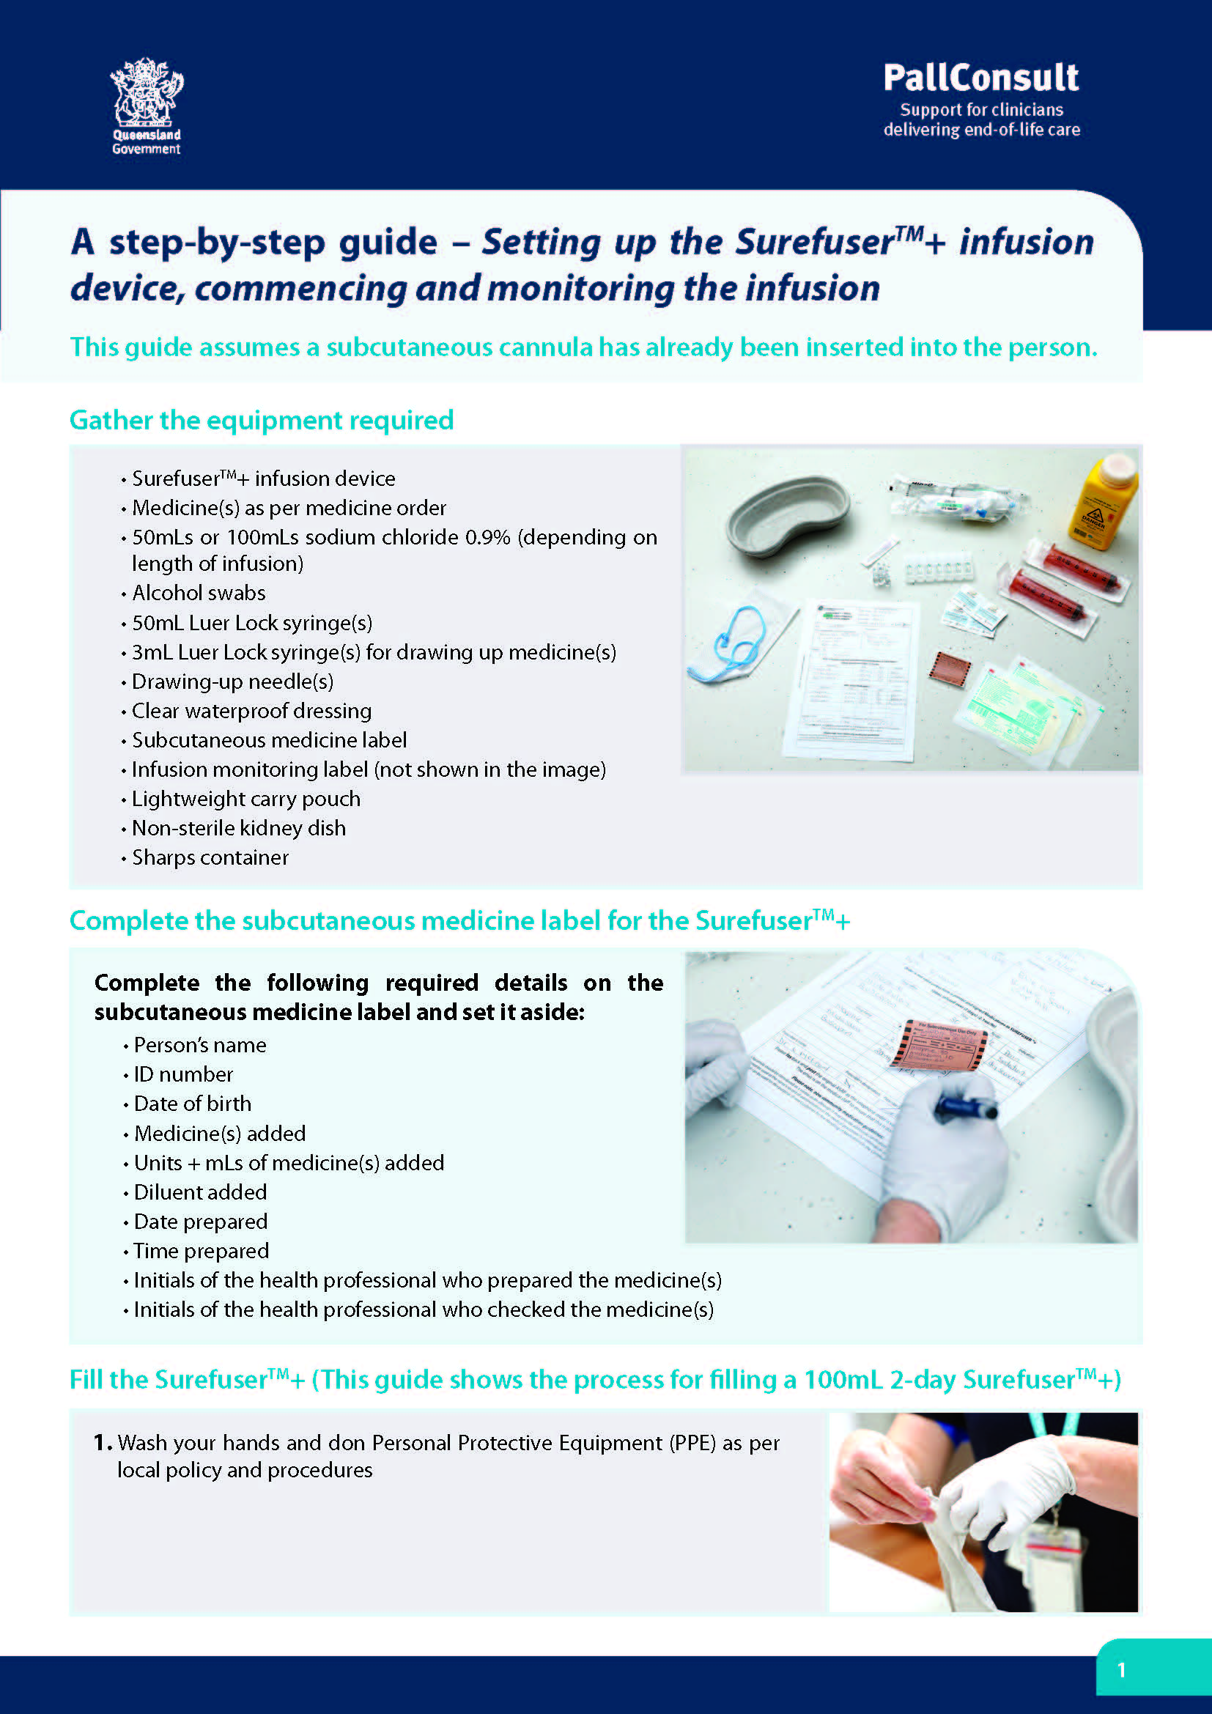
Step-by-step guide – Setting up the SurefuserTM+ infusion device, commencing and monitoring the infusion

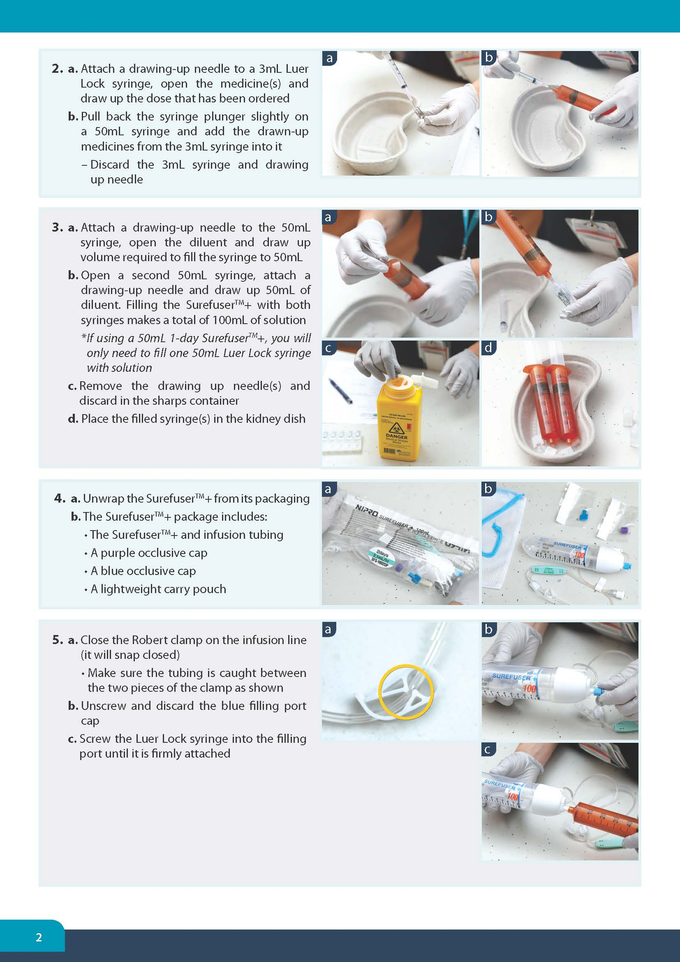
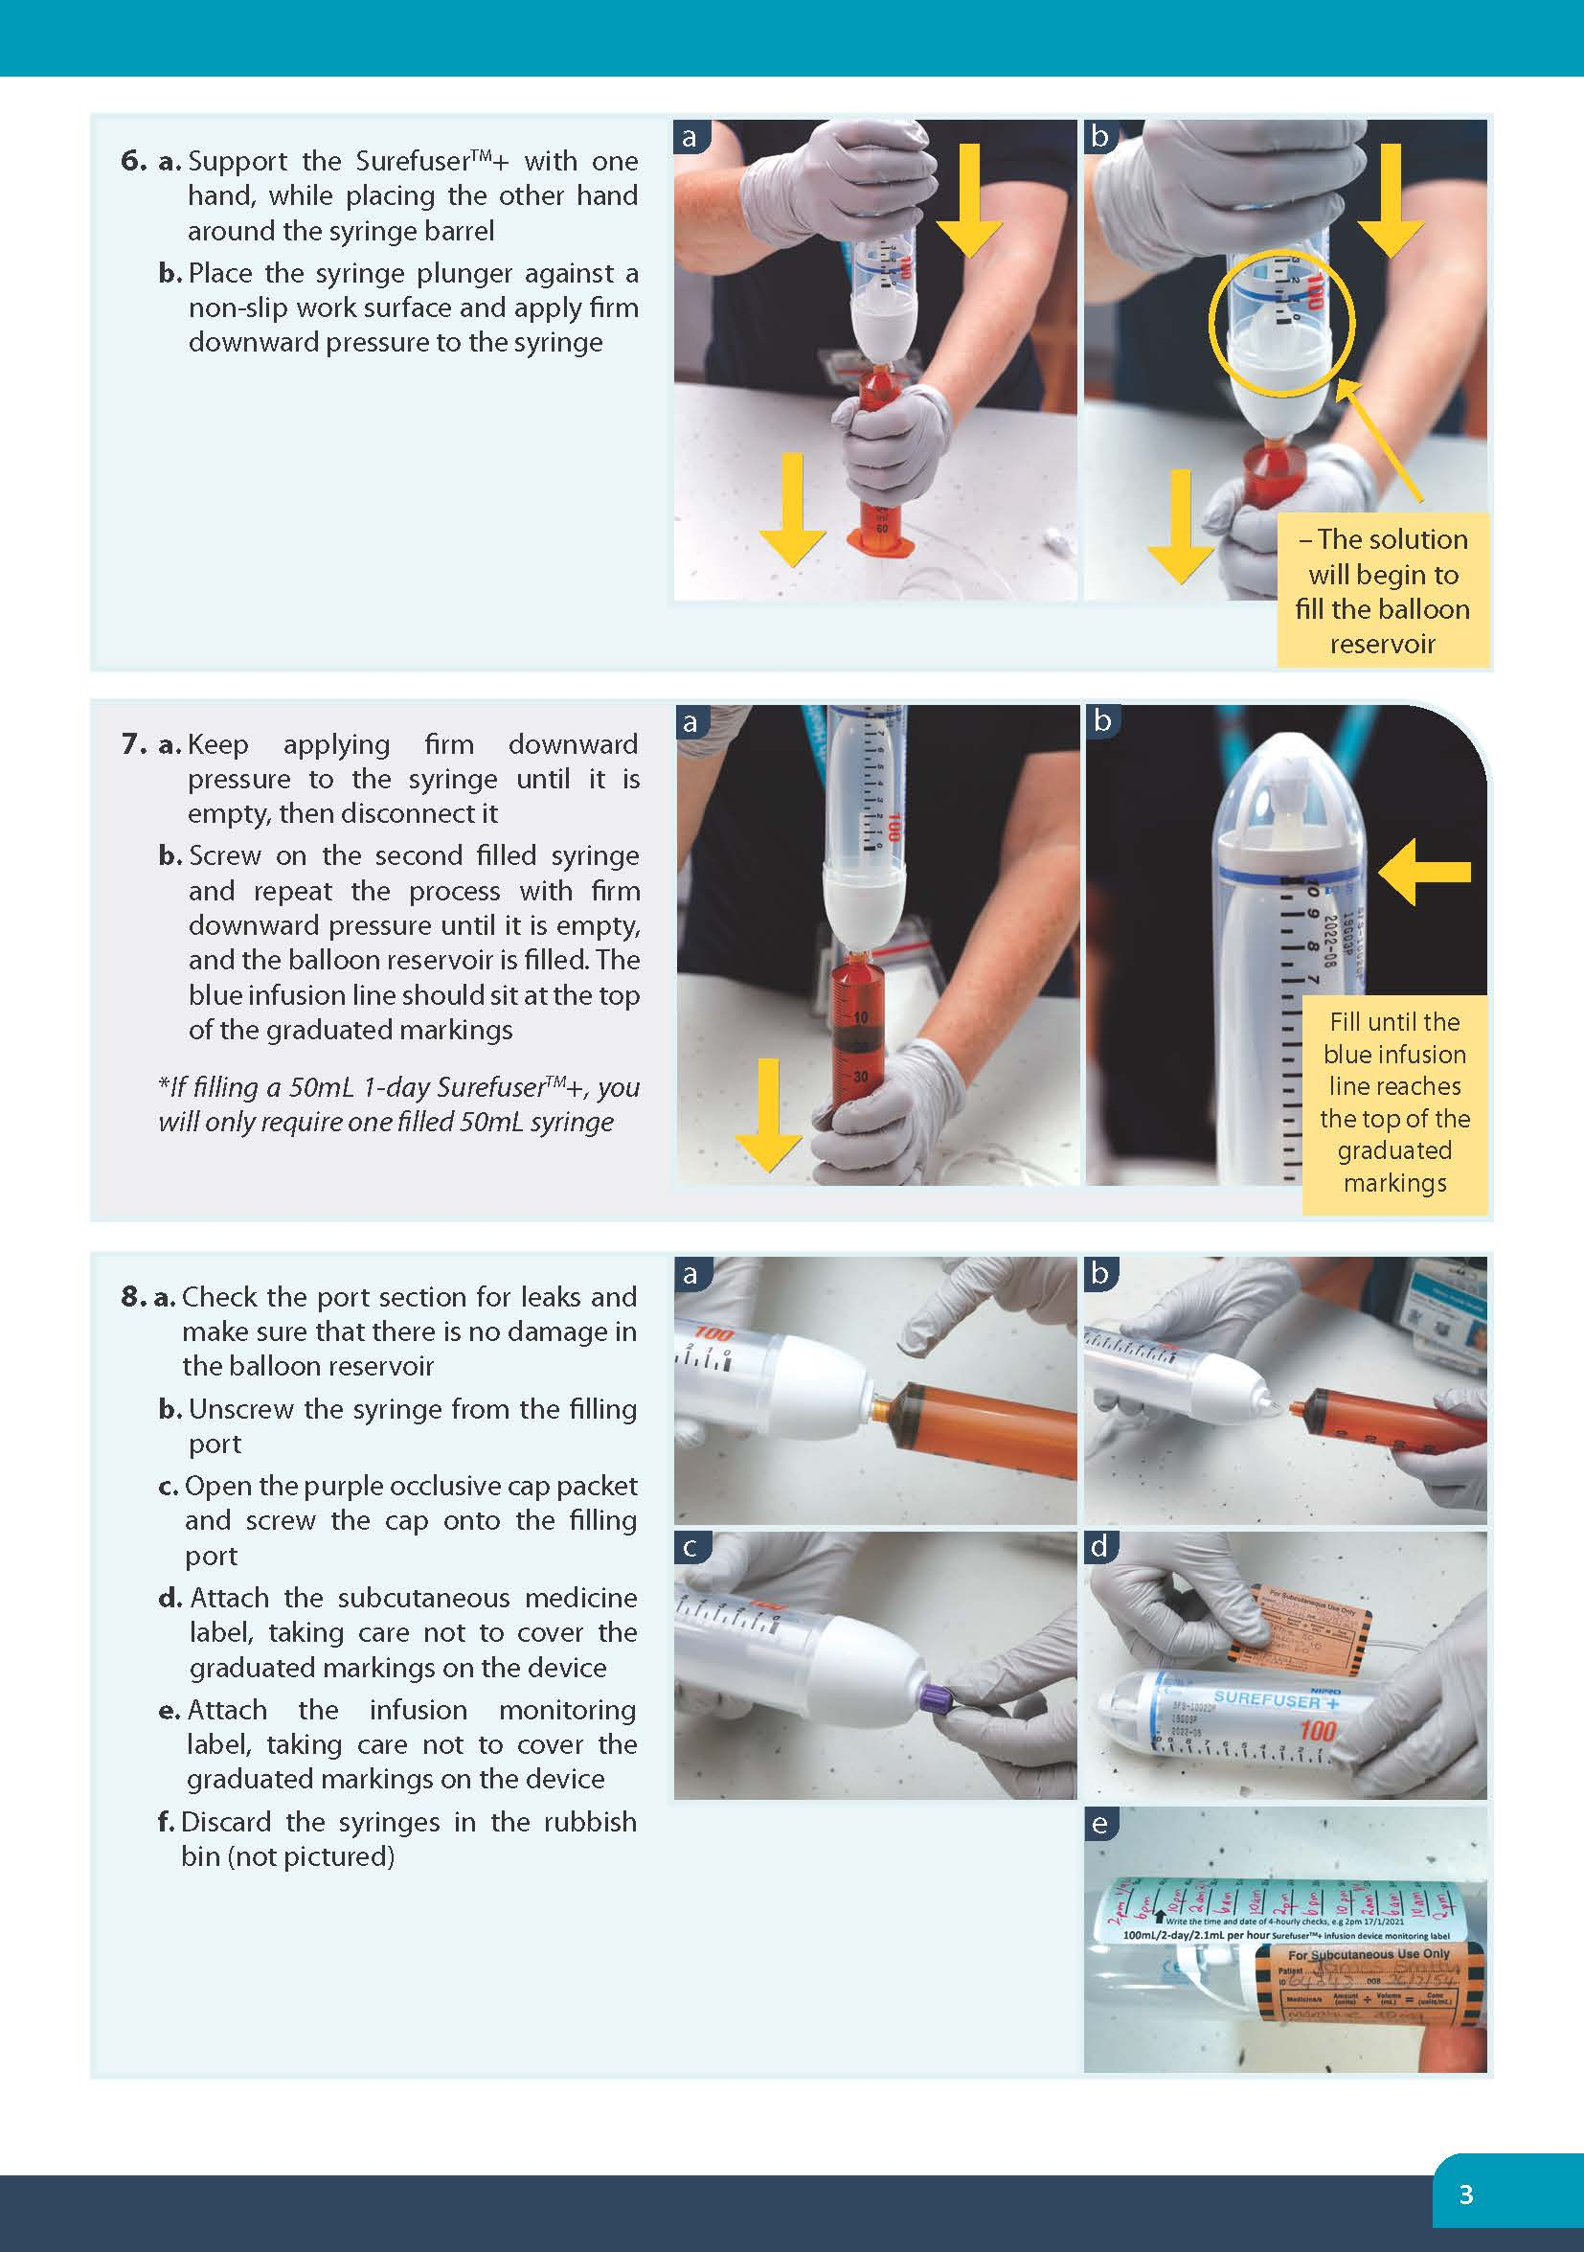
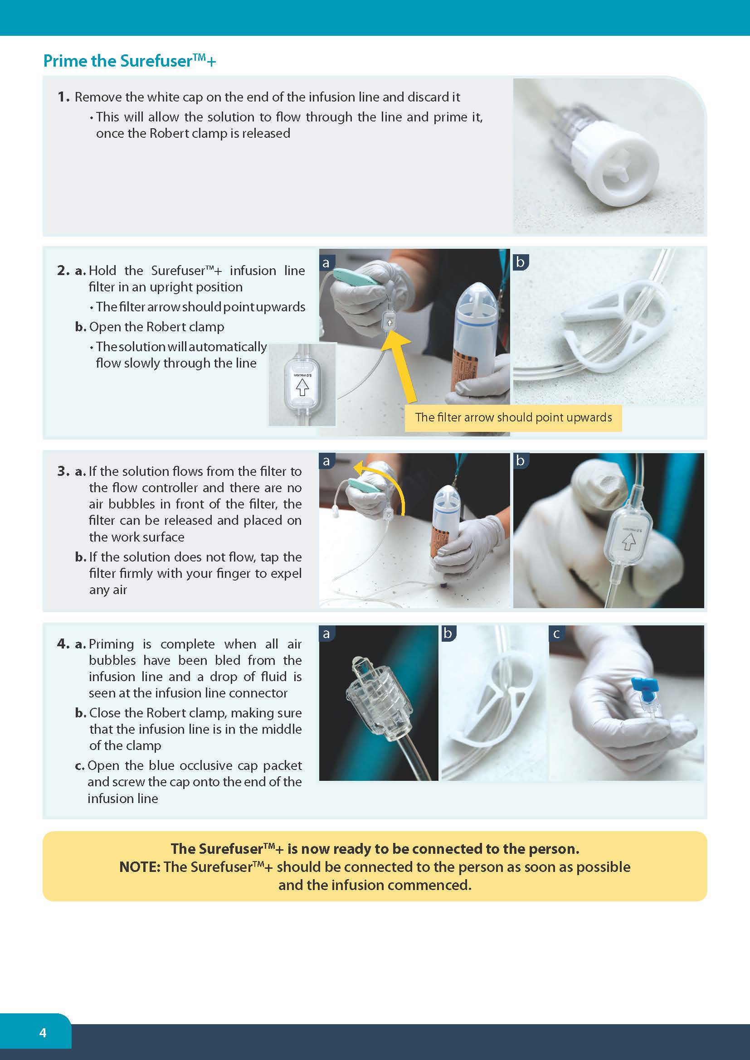
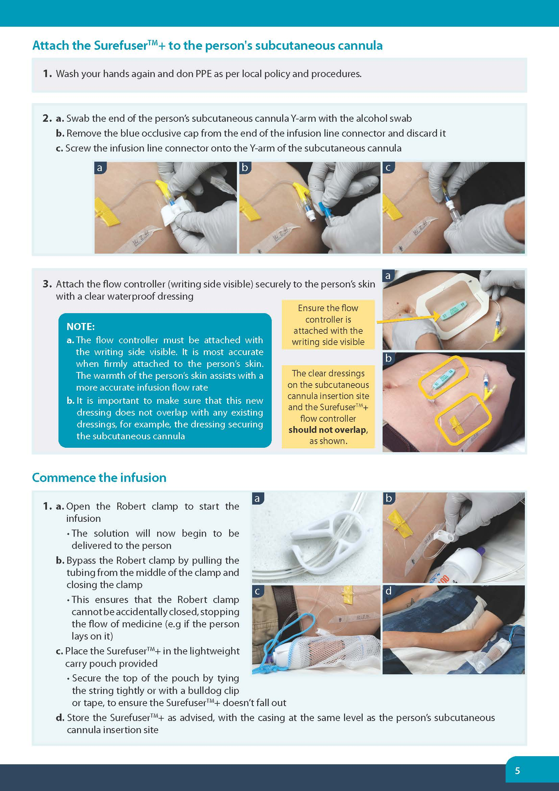
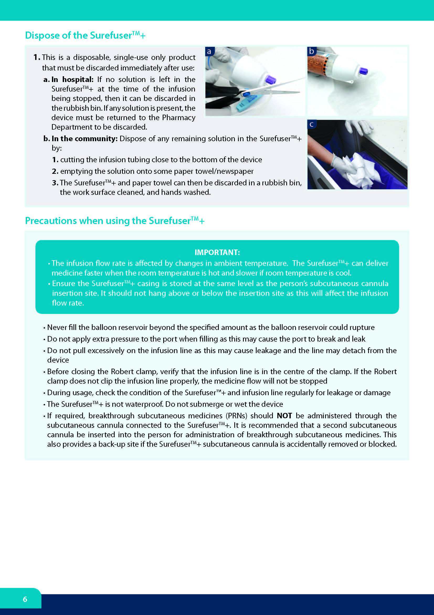

Monitoring the infusion over time

SurefuserTM+ infusion flow rates can be more variable that powered CSCI devices such as the NIKI T34TM syringe pump. The small variations in the infusion flow rate are unlikely to cause any clinically significant issues, though all people under care should have their symptoms monitored and reviewed regularly to ensure they are comfortable.
- The SurefuserTM+ operates silently. Regular monitoring is the only way to detect any issues with the device and the infusion. Therefore, monitoring every four hours is recommended.
- The SurefuserTM+ has graduated markings printed on the casing that are numbered in 10mL increments. The location of the blue infusion line on the graduated markings roughly corresponds to 10 x millilitres remaining to be infused.
This infusion (right) has approximately 50mL (5 x 10mL) of medicine remaining

Managing monitoring requirements
IMPORTANT: The infusion flow rate is affected by changes in ambient temperature, viscosity of the solution and gravity. The SurefuserTM+ can run 10-15% faster (or slower) when the room temperature is very warm (or very cold).⁷ This may result in the device completing the infusion up to a few hours earlier (or later) than expected (particularly with 2-day and 3-day infusions).
The health care team should take steps to ensure the person’s symptoms are well managed if the delivery of medicine finishes earlier or later than expected, including:
- Informing the family/carers of this variability
- Educating the family/carers and ensuring they are confident to monitor the SurefuserTM+ and symptoms and give anticipatory medicines if required
- Ensuring the person has anticipatory medicines prescribed and available for breakthrough symptoms
- Helping them plan what they should do to manage any symptoms that may occur, e.g. by using the caring@home package for carers.

Monitoring labels
The exact amount of solution infused by the SurefuserTM+ can sometimes be difficult to determine, particularly with the longer 100mL 2- and 3-day infusions.
Monitoring labels have been developed as a part of this package to assist families, carers and health professionals to:
• maintain the recommended regular four-hourly checks of the SurefuserTM+ and the subcutaneous cannula insertion site
• ensure the blue monitoring line is progressing at the correct infusion flow rate, and not running too fast or too slow.
The image (right) shows an example of a 100mL 2-day SurefuserTM+ monitoring label.¹¹
The labels can be attached to the SurefuserTM+ casing, ensuring that the graduated markings and the subcutaneous medicine label are not covered. The label colours correspond with the colour of the flow controller on the matching SurefuserTM+.
• The health professional should fill in the times and dates that the family and carers should check the SurefuserTM+ and the subcutaneous cannula insertion site.
• The family or carers should mark where the blue infusion line is at each four-hourly check to ensure the infusion flow rate is not too fast or too slow.
• Family or carers should refer to the SurefuserTM+ infusion device troubleshooting and monitoring guide for families or contact their health care team with any concerns.

In the hospital or residential aged care facility setting
- A 50mL 1-day infusion is recommended. The usual CSCI device four-hourly checks are the same. Both the Queensland Health Medicine Administration Record (MAR) and the Statewide Subcutaneous Medicine Infusion Chart can be used to record the routine checks
- Graduated markings on the SurefuserTM+ casing are numbered in 10mL increments. These are approximations only but can be used on the monitoring chart. Health professionals should record approximately what volume is left, based on where the blue infusion line is at each four-hourly check in the Volume Left(mL) column.

SurefuserTM+ checklist
Ensure:
- The blue line has moved down the scale towards zero. This indicates that the balloon is deflating as it delivers medicine to the person
- The infusion device is intact with no solution leakage
- The Robert clamp on the infusion line is open
- The tubing is not tangled, kinked or squashed and is securely connected to the subcutaneous cannula
- The subcutaneous site is not red or swollen and that the dressing is intact with no leakage
- The solution remains clear without discolouration, fogging or crystallisation
- That no more than three medicines are mixed in an infusion device, unless on the advice of a palliative medicine specialist.⁷
- Document all checks, and any remedial actions taken.

Precipitation
If a combination of medicines become cloudy, precipitates or crystallises in the device or tubing:
- Immediately stop administration of the medicines
- Contact the doctor or nurse practitioner
- Re-site the subcutaneous cannula
- Discard the device
- Prepare a new SurefuserTM+
- Document actions in the patient’s medical record and ensure that the incident is recorded in the organisation’s Incident Management System.

Subcutaneous cannula insertion site check
Subcutaneous cannula insertion site inspections at least four-hourly (in the community, family are not expected to check overnight) is integral to early identification and prevention of site-related complications and should be performed as part of routine care. Any site problems can potentially cause patient discomfort. They can also interfere with medicine absorption and compromise effective symptom control.
When inspecting the site, check for:
- Tenderness or hardness at the site
- Leakage at the insertion site
- Swelling
- Erythema (redness)
- Presence of blood in the tubing
- Displacement of the cannula.

Patient/family education related to the SurefuserTM+
Patients and family require clear and simple education about the reasons the SurefuserTM+ is being considered for symptom management. Time should be provided to discuss a patient’s or family member’s fears about the use of a SurefuserTM+.
Education in inpatient or residential aged care settings should include:
- Indication for a continuous subcutaneous infusion
- An explanation about what the SurefuserTM+ does, and how it works
- Safety aspects of the SurefuserTM+.

Education in the home setting should include:
Nursing staff must carefully assess the patient/family/carers for their willingness and ability to manage subcutaneous infusions in the home environment.
Education includes:
- Routine four-hourly checks of the SurefuserTM+, medicine volume remaining, infusion line and subcutaneous cannula insertion site during the day
- Description of factors that cause infusion rate variation and strategies to minimise them
- Troubleshooting tips
- Contact number(s) for support
- Providing written information to reinforce verbal education provided.
See:
- Information sheet for families - SurefuserTM+ infusion device and infusions
- SurefuserTM+ infusion device and infusions: troubleshooting and monitoring guide for families

Troubleshooting
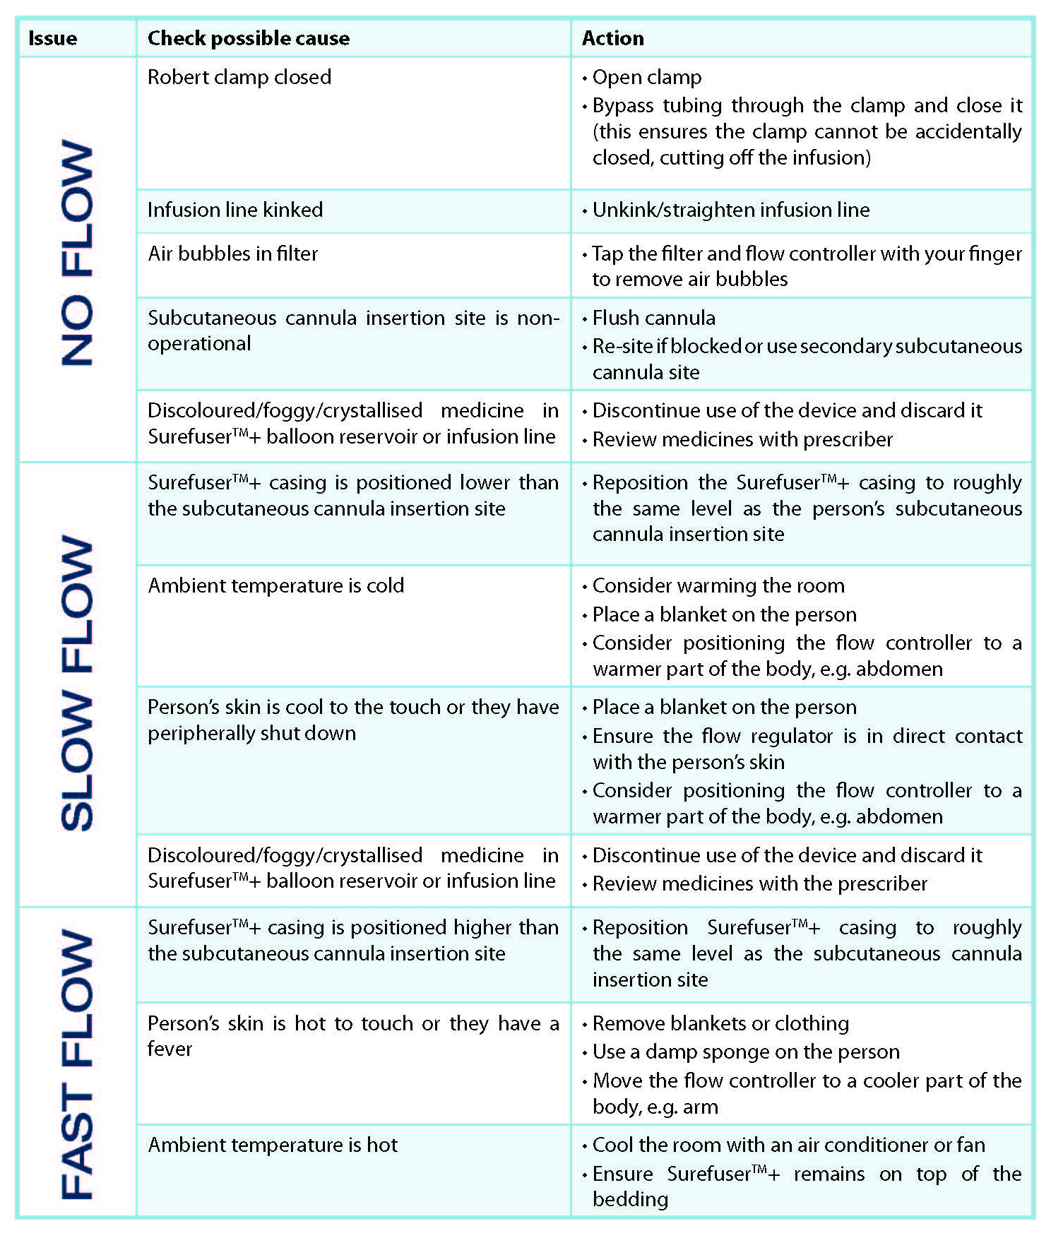
Health professionals can use the following table to troubleshoot common issues with the SurefuserTM+.

Quality improvement
As part of the continuous quality improvement process of a health care organisation, 12-monthly audits should be undertaken to monitor staff completion rates of the SurefuserTM+ competencies.
This includes:
- Review of A practical handbook for health professionals: How to safely set up a SurefuserTM+ infusion device, commence and monitor an infusion in a palliative care setting
- Completion of Competency checklist - How to safely set up a SurefuserTM+ infusion device, commence and monitor an infusion in a palliative care setting
A routine audit of the organisation’s incident and error register is a systematic way to review any potential issues with staff knowledge of policy and procedures relating to the SurefuserTM+.
Audits need to be directly relevant to the implementation of the PallConsult SurefuserTM+ resources.
Evaluation and monitoring should be simple, inexpensive and feasible. The processes should use routinely collected data and data linkage where possible.

SurefuserTM+ storage:
- Store boxes of SurefusersTM+ in a clean, dry place, such as a storeroom, at room temperature.
- The SurefuserTM+ is sealed in a sterile wrapper. Do not use the device if the wrapper is damaged.
- Each device has an expiry date. Do not use expired stock.

References
- Brisbane South Palliative Care Collaborative (BSPCC). A practical handbook for health professionals: How to safely set up, commence and provide necessary documentation for NIKI T34TM syringe pump (2nd and 3rd editions) infusions. Brisbane: BSPCC; 2020.
- State of Queensland (Queensland Health). Guidelines for Subcutaneous Infusion Device Management in Palliative Care. 2nd ed. Brisbane: Centre for Palliative Care Research and Education (CPCRE); 2010.
- State of Queensland (Queensland Health). Health (Drugs and Poisons) Regulation 1996. Brisbane: Queensland Government; 2020. Available from: https://www.legislation.qld.gov.au/view/html/inforce/current/sl-1996-0414 [Accessed 27 April 2021].
- Palliative Care Australia (PCA). National Palliative Care Standards 5th edn. Canberra: PCA; 2018.
- Queensland Government (Queensland Health). Palliative Care. Available from: https://www.qld.gov.au/health/support/end-of-life/care/palliative [Accessed 9 June 2021]
- Nursing and Midwifery Board of Australia. Professional Standards. Available from: https://www.nursingmidwiferyboard.gov.au/codes-guidelines-statements/professional-standards.aspx [Accessed 10 June 2021]
- State of Queensland (Queensland Health). Statewide strategy for end-of-life care. Brisbane: 2015.
- Safer Care Victoria. Syringe driver compatibility. Melbourne: State of Victoria, State Government: 2021. Available from: https://www.bettersafercare.vic.gov.au/clinical-guidance/palliative/syringe-driver-compatibility [Accessed 10 June 2021]
- Queensland Government (Centre for Palliative Care Research and Education). Syringe driver online learning package. CPCRE; 2015.
- Nipro Australia Pty Ltd. Step-by-step guide for filling and preparing Surfuser™+. Available from: http://cdn2.niproaustralia.com.au/wp-content/uploads/2012/10/Surefuser-Filling-Instructions.pdf [Accessed 9 June 2021]
- Australian Commission on Safety and Quality in Health Care. The National Safety and Quality Health Service (NSQHS) Standards. Australian Government; 2021. Available from: https://www.safetyandquality.gov.au/standards/nsqhs-standards [Accessed 9 June 2021]
- Dickman A, Schneider J. The Syringe Driver: Continuous subcutaneous infusions in palliative care (4th ed.). Oxford, New York: Oxford University Press; 2016.
- Palliative Care Expert Group. Therapeutic Guidelines: Palliative Care. Version 4. Melbourne: Therapeutic Guidelines Limited; 2016.
- Flowers C, McLeod F. Diluent choice for subcutaneous infusion: a survey of the literature and Australian practice. International Journal of Palliative Nursing. 2005;11(2):54-60.

We acknowledge and thank Nepean Blue Mountain Health Palliative Care Service for their development and sharing of the Surefuser - A nurse’s guide to using the SurefuserTM + infusion device in the palliative care setting https://vimeo. com/403504780

