Example Policy and Procedure
  - Implementation of Advance Care Planning in Residential Aged Care Facilities
Version 2.0 – April 2022

Published by the State of Queensland (Metro South Health), October 2021
This document is licensed under a Creative Commons Attribution 3.0 Australia licence.
To view a copy of this licence, visit creativecommons.org/licenses/by/3.0/au
© State of Queensland (Metro South Hospital and Health Service) 2021
You are free to copy, communicate and adapt the work, as long as you attribute the State of Queensland
(Metro South Hospital and Health Service).
For more information, contact:
Statewide Office of Advance Care Planning, Metro South Health, Eight Mile Plains Community Health, 51 McKechnie Drive, Eight Mile Plains Qld 4113, email acp@health.qld.gov.au, phone 1300 007 227.
An electronic version of this document is available at:
      - www.mycaremychoices.com.au
      - www.pallconsult.com.au
Disclaimer:
The content presented in this publication is distributed by the Queensland Government as an information source only. The State of Queensland makes no statements, representations or warranties about the accuracy, completeness or reliability of any information contained in this publication. The State of Queensland disclaims all responsibility and all liability (including without limitation for liability in negligence) for all expenses, losses, damages and costs you might incur as a result of the information being inaccurate or incomplete in any way, and for any reason reliance was placed on such information.

Contents
PART ONE: ABOUT THIS DOCUMENT 3
Purpose 3
What is ACP? 3
Why do you need an ACP policy and procedure? 3
How can you use the example ACP policy and procedure? 3
How was the example ACP policy and procedure developed? 4
Relevant standardised Queensland ACP documentation 5
Definition of terms 5
PART 2: ADVANCE CARE PLANNING (ACP) POLICY AND PROCEDURE 6
Statement 6
Purpose 6
Policy statement 6
Guiding principles 6
Procedure 7
1. Information provision and ACP conversations 7
2. Ongoing review 8
3. Clinical decision making 8
4. Training for staff 8
5. Quality improvement 8
6. Documentation 8
Relevant Queensland legislation 9
Related policies, documents and further assistance 9
APPENDIX 1: Definition of Terms 10
APPENDIX 2: RACF Steps for Completed Advance Care Planning Documents to Be Uploaded to The Viewer 11
APPENDIX 3: OACP Checklist for Statement of Choices Documents to Be Uploaded to The Viewer 12
APPENDIX 4: OACP Checklist for Enduring ACP Documents, Approved for Use Prior to 30 November 2020 to Be Uploaded to The Viewer 13
APPENDIX 5: OACP Checklist for Enduring ACP Documents, Approved for Use After 30 November 2020 to Be Uploaded to The Viewer 19
APPENDIX 6: Continuous Quality Improvement: After-Death Audit for Residential Aged Care Facilities 25

PART ONE: ABOUT THIS DOCUMENT

Purpose
This document provides an example advance care planning (ACP) policy and procedure that residential aged care facilities (RACFs) across Queensland may use to develop and/or review relevant ACP documentation and systems within their policies and procedures frameworks.

What is ACP?
Advance care planning refers to an ongoing, iterative process by way of conversations between a resident, their family and/or substitute decision maker(s) (SDMs) and health care professionals enabling the resident’s preferences for future health care to be known should they become unable to participate in decision making. Ideally these preferences will be documented on a Queensland standardised form designed for the purpose.
Advance care planning is an important component of quality person-centred end-of-life care and can improve resident and family satisfaction with care, reduce avoidable hospital transfers, reduce stress and anxiety for families and/or SDMs and improve staff satisfaction with the seamless care that can be provided for residents.

Why do you need an ACP policy and procedure?
Best practice principles for ACP in RACFs in Australia have been developed. They emphasise the importance of written policies and procedures about ACP that are readily accessible and establish ACP as a routine component of care. Appropriate documentation will support a coordinated, systematic, patient-centred approach to ACP that has been shown to support resident’s wishes (as expressed in their advance care plan) being respected.³

How can you use the example ACP policy and procedure?
The example ACP policy and procedure is a resource for RACFs to use in the development and/or review their own documentation to support the implementation of ACP in their facility. It is not meant to be prescriptive. Managers in RACFs can adapt the content of the example ACP policy and procedure to meet their own identified needs.
The example ACP policy and procedure is offered as an foundation component of a suite of documents developed to support RACFs to embed an evidence-based ACP program into their routine clinical care to support high quality end-of-life care for residents and their families.

How was the example ACP policy and procedure developed?
The example ACP policy and procedure was developed using:
- The best practice principles regarding ACP identified in the literature as:
Written policies about ACP should be readily accessible in every RACF. Policies should include the systems needed to establish ACP as a routine component of person-centred care and all aspects of documentation, including where the advance care plan is to be kept, and when it is to be reviewed.
Education about ACP should be regularly provided to all RACF staff, residents, families and/or SDMs ensuring all newcomers are well informed and their engagement encouraged. More experienced staff should be given opportunities to upskill for advanced practice.
Information about ACP is best provided to residents, families and/or SDMs before entry, followed by well-planned individual discussions as soon as practicable after entry; normally within 28 days unless there are unforeseen circumstances.
ACP should be incorporated into routine clinical decision making and care planning, and regularly reviewed, particularly when circumstances change (e.g. exacerbation of illness, health deterioration or hospital admission), or at least annually.
ACP involves open and comprehensive discussions with the resident, family and/or SDMs initiated by a health professional with relevant skills in this area.
The general practitioner (GP) should be included in ACP discussions.
ACP documents clearly specify (at a minimum): (a) an appointed SDM, and contact details where available; (b) current state of health; (c) values and beliefs (things that matter most in life); (d) future unacceptable health conditions; (e) the level of preferred future medical treatment; (f) specific wanted/unwanted treatments, where applicable; (g) goals for end-of- life care; (h) appropriate signatures (clear, complete, dated, and, if a legally binding document witnessed); and (i) evidence of GP review.
Facilities have effective information transfer systems in place to enable communication of resident ACP information across health transition points.
- The Queensland Health service provided by the Statewide Office of Advance Care Planning (OACP) has developed a meticulous standardised clinical approach to the secure access and sharing of residents’ ACP documents:
  - Copies of the Statement of Choices (SoC) Form A and Form B, Advance Health Directive (AHD), Enduring Power of Attorney (EPOA) long and short form documents, and Queensland Civil and Administrative Tribunal (QCAT) orders are reviewed by clinical staff of the OACP and, if they meet criteria, are uploaded to the person’s Queensland Health (QH) electronic health record via the ACP Tracker in The Viewer.
- The ACP Tracker (in The Viewer) is an electronic platform that allows authorised clinicians to directly read residents’ ACP documents and comments entered by Queensland Health staff, supporting continuity and progression of ACP across all healthcare settings and person-centred decision making.
- The Viewer is available to all AHPRA-registered doctors, nurses/midwives and paramedics through Health Provider Portal (HHP) which requires a QGov account and a 100-point ID check to register.
- Application of this embedded ACP process by RACFs, and uploading of ACP documents to The Viewer, provides the opportunity to implement a coordinated, seamless person-centred approach to quality end-of-life healthcare for their residents.

Relevant standardised Queensland ACP documentation
- Advance Health Directive (AHD)
About the AHD
The AHD form
- Enduring Power of Attorney (EPOA)
About the EPOA
The EPOA short form (the same attorney appointed for both financial and health matters)
The EPOA long form (different attorneys appointed for financial and personal matters)
Revocation of EPOA (Form 6)
- Statement of Choices (SoC)
About the SoC
The SoC Form A (to be completed by resident)
The SoC Form B (to be completed by SDMs)
- Translator/interpreter Statement (to be attached to AHD/EPOA documents for people who have had an interpreter or translator provide support to complete the form.
- Queensland Civil and Administrative Tribunal (QCAT) Decision
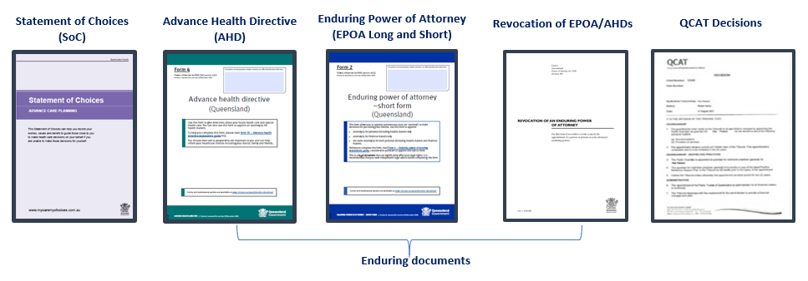

Definition of terms
See Appendix 1

PART 2: ADVANCE CARE PLANNING (ACP) POLICY AND PROCEDURE

Statement
NAME OF FACILITY is committed to offering all residents with/or their significant others the opportunity to participate in ACP discussions to ensure that the resident’s values, beliefs and preferences for future health and personal care are known in the event that they become incapable of participating in decision making.

Purpose
- To ensure that NAME OF THE FACILITY understands and considers the wishes of all residents concerning their future health care.

Policy statement
Advance care planning refers to an ongoing process of planning for future health and personal care whereby the person’s values, beliefs and preferences are made known and accessible to healthcare professionals and substitute decision maker(s) if that person loses capacity to make their own health care decisions. A series of conversations between a resident, their family and/or substitute decision maker(s) and health care professionals may be required to facilitate the process. Ideally these preferences will be documented on a standardised Queensland ACP form.

Guiding principles
- Residents have a right to be involved in their health care decisions, including agreeing to or refusing treatment.
- The values, beliefs and wishes of a resident should be known and respected by those providing health care to that individual.
- ACP discussions must involve open communication and respect a resident’s specific spiritual, religious, and cultural needs.
- Decision making capacity is assumed unless proven otherwise (refer Queensland Capacity Assessment Guidelines 2020). Residents with any impairment have the right to the support they need to participate in their ACP to the fullness of their potential.
- Offers to participate in ACP are made to all residents, families and/or SDMs. Participation in ACP is voluntary, and it is recognised that some individuals may decline to engage in these discussions.
- If a resident has capacity at the time of illness, the treatment decisions they make take precedence over any advance care plans developed. The written advance care plan is not required until the resident has lost capacity to make a decision.
- ACP provides opportunities for residents, families and/or SDMs to participate in planning for the resident’s preferred end-of-life care needs and conversations should include frank discussions about dying and death and the consequences of treatment choices.

Procedure

Information provision and ACP conversations

Pre-entry / initial contact with resident, family and/or SDM
- Include information about ACP e.g. a brochure in Welcome information packs
- If there have not been any prior conversations about ACP, introduce ACP and its benefits using a suitably trained staff member
- Request copies of existing ACP documentation e.g. AHD, EPOA
- If an SDM has not been legally appointed, discuss the benefits of identifying an SDM
- Document ACP conversation according to RACF policies and procedures.

On entry
- Confirm with the resident, family and/or SDMs their engagement in ACP discussions. If required, offer further conversations with a suitably trained member of staff e.g. the ACP Champion. ACP conversations are voluntary, and if declined at this time, document according to RACF policies and procedures.
- Ensure that:
  - certified copies of existing enduring ACP documents e.g. the AHD, EPOA are kept in the resident’s file in a readily accessible designated area.
  - copies of other existing ACP documentation e.g. the SoC, are kept in the resident’s file in a readily accessible designated area.
  - copies of all standardised ACP documents are sent to the Statewide Office of Advance Care Planning (OACP) for review and upload to The Viewer.
  - contact details of the SDMs and the method by which they are appointed (Tribunal-appointed Guardian, SDMs appointed in EPOA or AHD) are current and readily accessible.

Within four to six weeks post-entry
- Undertake ACP conversations with the resident, their family and/or SDMs who agree to participate. Remember ACP is an entirely voluntary process.
- If not already completed, support residents and/or SDMs to document their wishes on the (standardised Queensland) ACP form according to the resident’s expressed needs and the completion criteria of the statutory authority and the OACP. (Appendices 3,4,5)
- For the SoC, ensure that all essential fields in the document(s) are completed. For completion of SoCs see OACP Checklist for Statement of Choices Documents to be Uploaded to The Viewer. (Appendix 3)
- If residents and/or SDMs do not wish to complete standardised documents, record conversation outcomes and health care preferences according to RACF policies and procedures.
- Engage and support GPs in the ACP process to contribute, review, and sign completed documents as required
- Send a copy of the completed ACP document(s) to the OACP for uploading to The Viewer (refer to Appendix 2: Steps for a Completed Advance Care Planning documents to be Uploaded to The Viewer) and to relevant parties, and place the documents in a designated place within the resident’s file.
- Place alerts to identify to all staff that current ACP document(s) are in place
- Inform resident and/or SDMs that reviews are undertaken at regular intervals (e.g. annually) or when health status changes.

Ongoing review
- Encourage ongoing conversations and discussions regarding ACP with resident and/or SDMs
- Review ACP documents no less frequently than annually, or as clinically required. Timing of review should be guided by clinical prompts e.g. deterioration/functional decline, observed social withdrawal social, increasing symptom burden, declining effect of usual treatment; or a resident’s request for change in wishes or preferences.
- If substantial changes are required to a current ACP document, a new document will need to be completed, and a copy sent to the OACP so that current documents are accessible at all times. A more recent document supersedes a previous version of the document.

Clinical decision making
- Completed ACP documentation is used to guide decision making by RACF staff, the GP, other clinicians, and the SDMs if the resident does not have capacity to participate in decision making. This facilitates care provision in accordance with the resident’s values, beliefs and wishes.

Training for staff
- ACP induction and a sustainable, ongoing staff training program is implemented to ensure all staff have an awareness of the principles and importance of ACP for all residents in their care and the knowledge skills and confidence to participate according to the expected standard for their role.
- A cohort of motivated nursing staff are offered additional training to enable high levels of communication skills and expertise to guide ACP discussions with residents, families and/or SDMs.

Quality improvement
- After-death audits are undertaken as part of a continuous quality improvement process to monitor congruence between residents’ recorded wishes and care outcomes. (Appendix 6)

Documentation
- Establish a designated place within residents’ files for all ACP documentation
- Establish alerts to identify to all staff that current ACP documents have been completed.

Relevant Queensland legislation
- Powers of Attorney Act 1998 (legislation.qld.gov.au)
- Guardianship and Administration Act 2000 (legislation.qld.gov.au)
- Public Guardian Act 2014 (legislation.qld.gov.au)

Related policies, documents and further assistance
- Facility specific
- Office of Public Guardian (OPG):
The OPG is an independent statutory office established to protect the rights, interests and wellbeing of adults with impaired decision-making capacity.
For adults with impaired decision-making capacity the OPG can:
  - makes personal and health decisions if the Public Guardian is their guardian or attorney
  - investigates allegations of abuse, neglect or exploitation
  - advocates and mediates on behalf of adults with impaired decision-making capacity
  - educates the public on the guardianship and attorney systems.
When appointed by the Queensland Civil and Administrative Tribunal (QCAT) as guardian, the Public Guardian routinely makes complex and delicate decisions on health care and accommodation, and guides adults through legal proceedings in the criminal, child protection and family law jurisdictions.
  - General enquiries: 1300 653 187
  - Health care decisions: 1300 753 624
- Statewide Office of Advance Care Planning (OACP):
The OACP is a free service funded by the Queensland Department of Health that helps Queenslander’s plan and share their health care wishes. The OACP can:
  - provide information and resources about advance care planning
  - receive copies of advance care planning documents (advance health directive, enduring power of attorney, revocation documents, QCAT Decisions and Statement of Choices), review them, and if effective, upload them to the person’s Queensland Health electronic hospital record.
For more information, please contact the OACP via:
  - Phone: 1300 007 227
  - Email: acp@health.qld.gov.au
  - Or visit: www.mycaremychoices.com.au

APPENDIX 1: Definition of Terms
- Advance Health Directive (AHD): This is a legally binding document that can be used in certain circumstances to provide directions about future health care and to appoint an attorney for health matters. A Doctor or Nurse Practitioner is required to complete the certificate stating the person has capacity to make the document. To be complete, an AHD must also be witnessed by an eligible witness (Justice of the Peace, Commissioner for Declarations, a lawyer or notary public).
- Capacity: This legal term refers to a person’s ability to make a specific decision in a particular area of their life such as healthcare choices, support services they may need, where they live and how they manage their finances. A person has capacity for health care decisions when they can understand the information provided about their health and treatment options and are able to make a decision regarding their care. The person also needs to be able to communicate their decision in some way and the decision must also be made of the person’s own free will. Capacity can change or fluctuate and can be influenced by the complexity of the decision, support available to the person and the time the decision is made. It is presumed that every adult has capacity to make all decisions until proven otherwise. For more information visit: http://www.qld.gov.au/law/legal-mediation-and-justice-of-the-peace/power-of-attorney-and-making-decisions-for-others/capacity-guidelines
- Enduring Power of Attorney (EPOA): An EPOA allows a person to legally appoint attorney(s) substitute decision-maker(s) and set out terms for how and when the power operates. These documents must be witnessed by an eligible witness (Justice of the Peace, Commissioner for Declarations, a lawyer or notary public).
- Statement of Choices (SoC): This is a values-based document that records a person’s wishes and preferences for their health care into the future. It is not legally binding and does not provide consent to health care in advance. A doctor or nurse practitioner signs and dates the form, but it does not require witnessing. Its purpose is to guide or inform those who need to make health care decisions for a person who is unable to make those decisions for themselves.
- Statutory Health Attorney (SHA): This term refers to someone with automatic authority to make health care decisions on your behalf if you are an adult whose capacity to make health care decisions is permanently or temporarily impaired. A person acts in the role of SHA because of their relationship with the impaired adult. By law, this attorney is the first available, culturally appropriate adult from the following:
  - A spouse or de facto partner (as long as the relationship is close and continuing)
  - A person who is responsible for the adult’s primary care but isn’t the adult’s health provider, a service provider for a residential service where the adult is a resident, or a paid carer (although they can be receiving a carer’s pension)
  - A friend or relative in a close personal relationship with the adult. Relation can also include a person who under Aboriginal tradition or Torres Strait Islander custom is regarded as a relation
  - If there is no-one suitable or available, the Public Guardian acts as the SHA of last resort.
- Substitute Decision Maker (SDM): This term describes someone who has legal power to make decisions on behalf of an adult when that person is no longer able to make their own decisions. This may be a person appointed in an Enduring Power of Attorney or Advance Health Directive, a tribunal- appointed guardian or a statutory health attorney.

APPENDIX 2: RACF Steps for Completed Advance Care Planning Documents to Be Uploaded to The Viewer
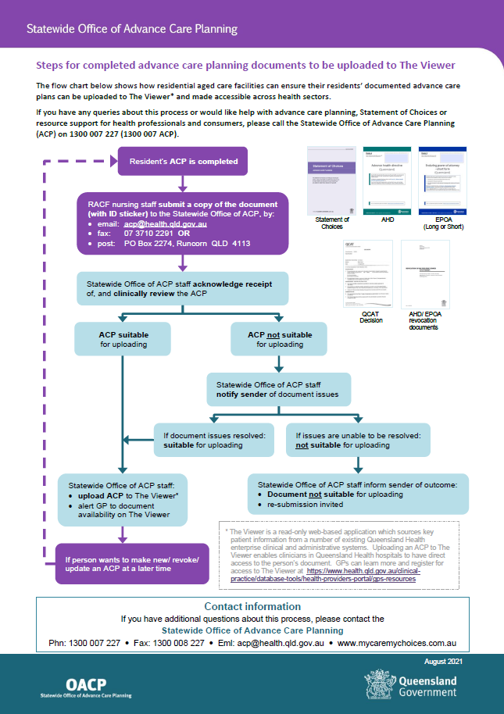

APPENDIX 3: OACP Checklist for Statement of Choices Documents to Be Uploaded to The Viewer
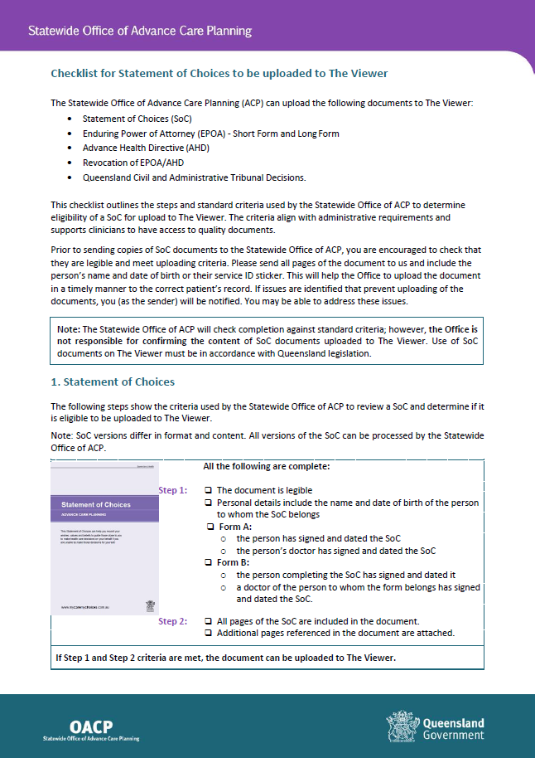

APPENDIX 4: OACP Checklist for Enduring ACP Documents, Approved for Use Prior to 30 November 2020 to Be Uploaded to The Viewer
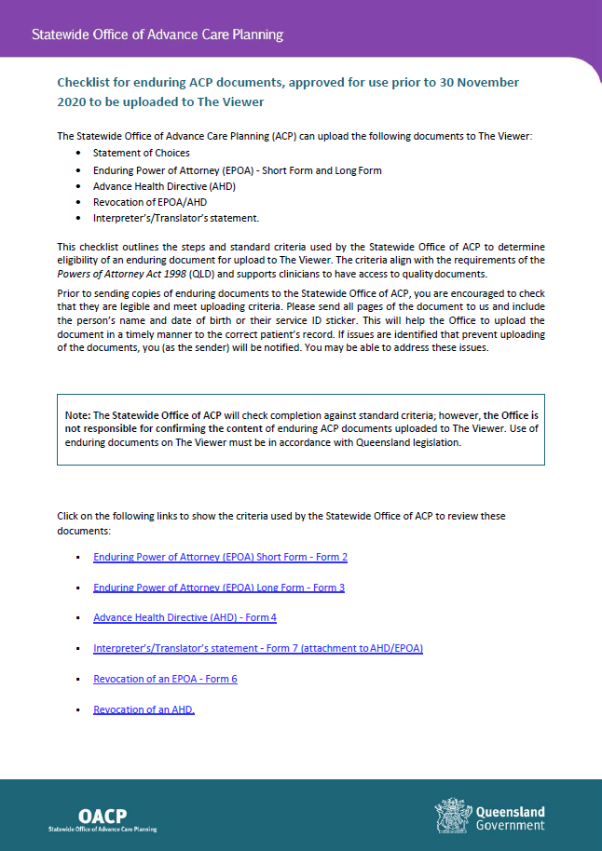

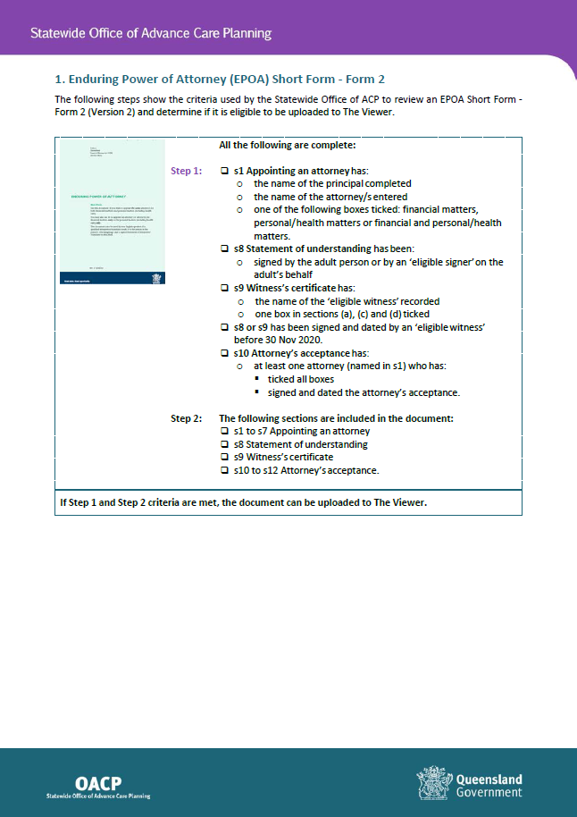

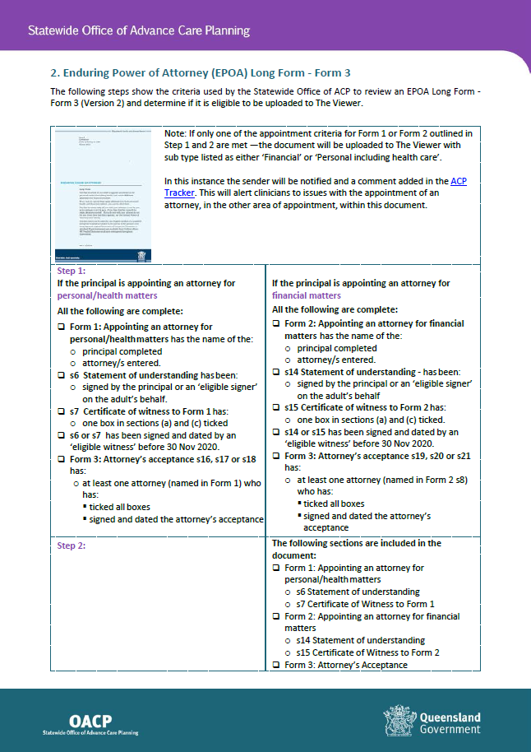

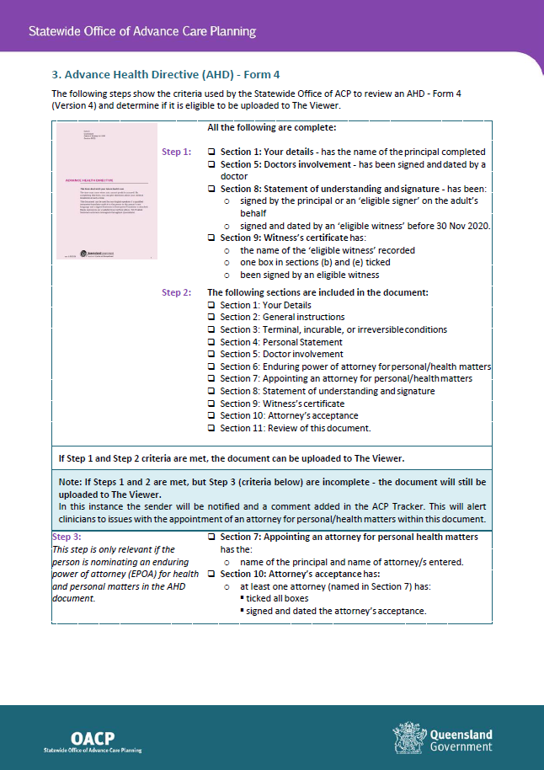

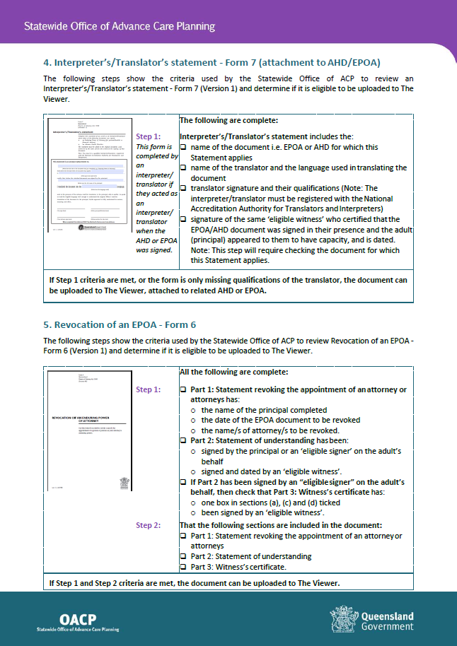

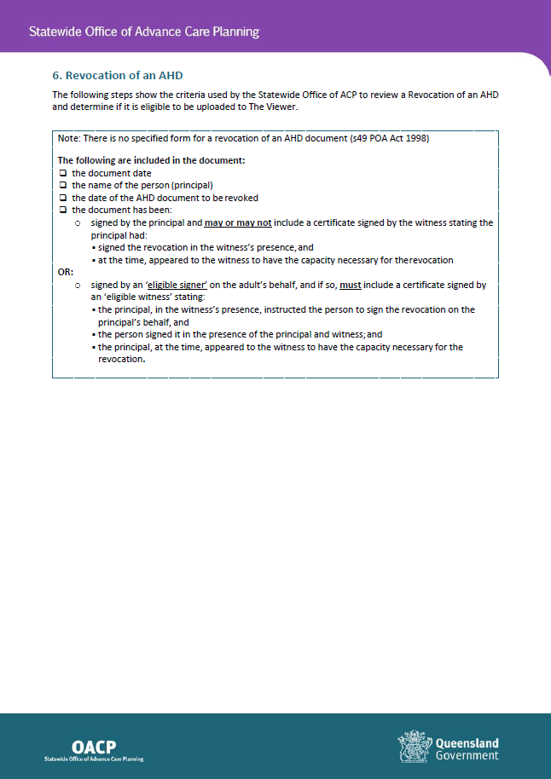

APPENDIX 5: OACP Checklist for Enduring ACP Documents, Approved for Use After 30 November 2020 to Be Uploaded to The Viewer
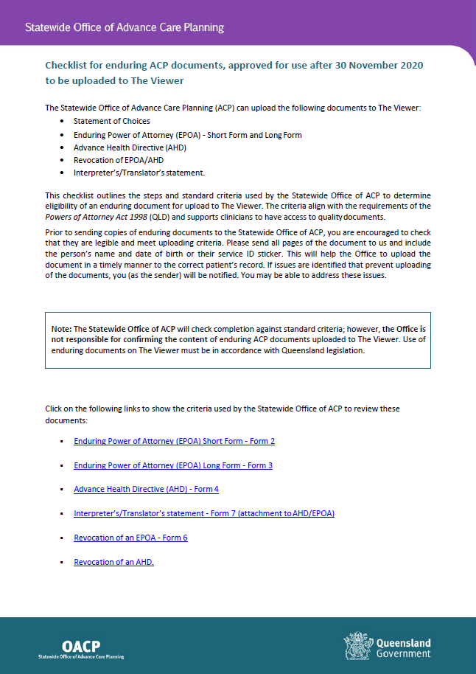

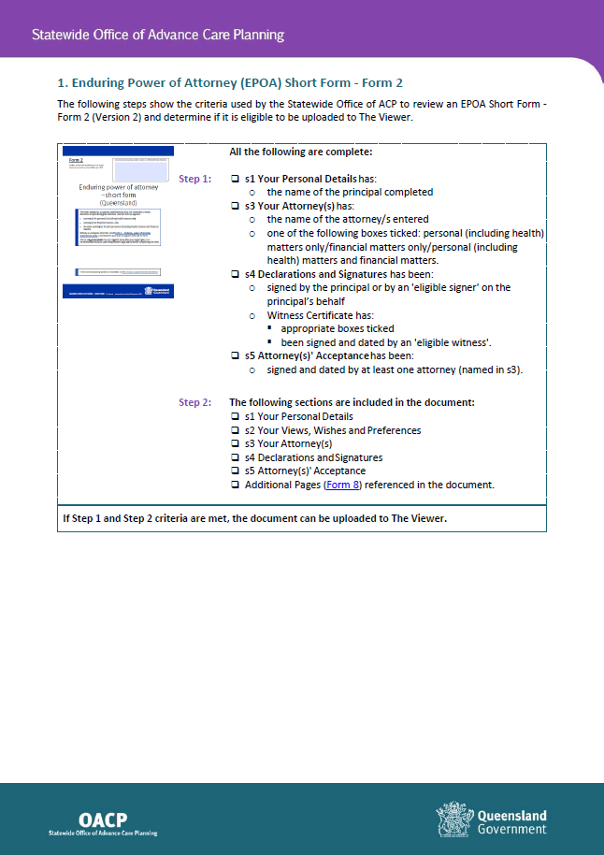

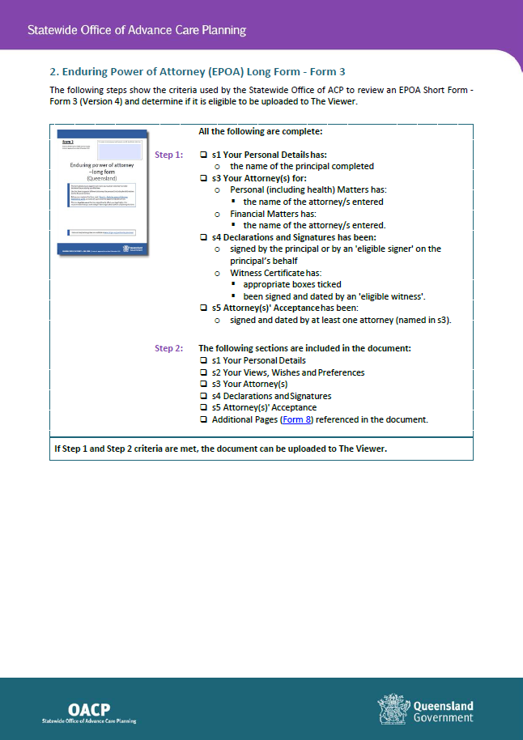

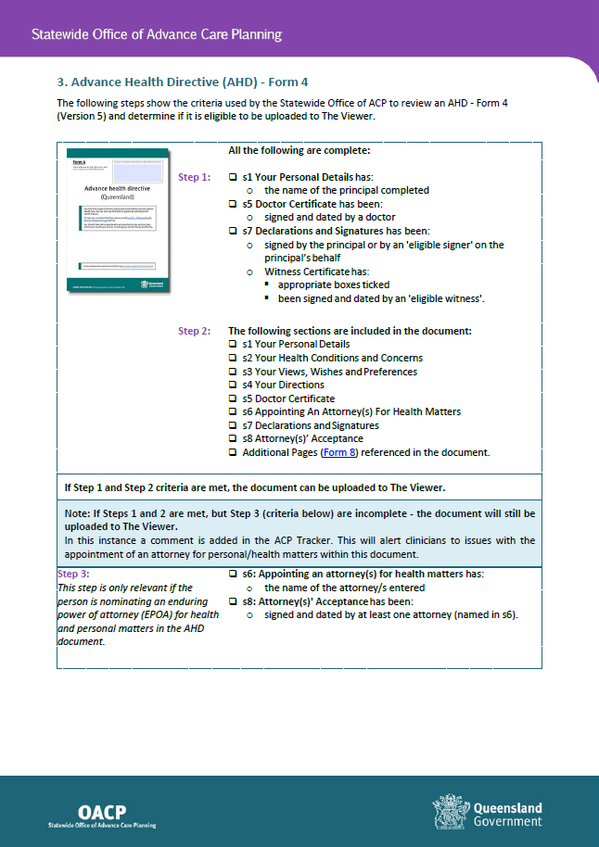

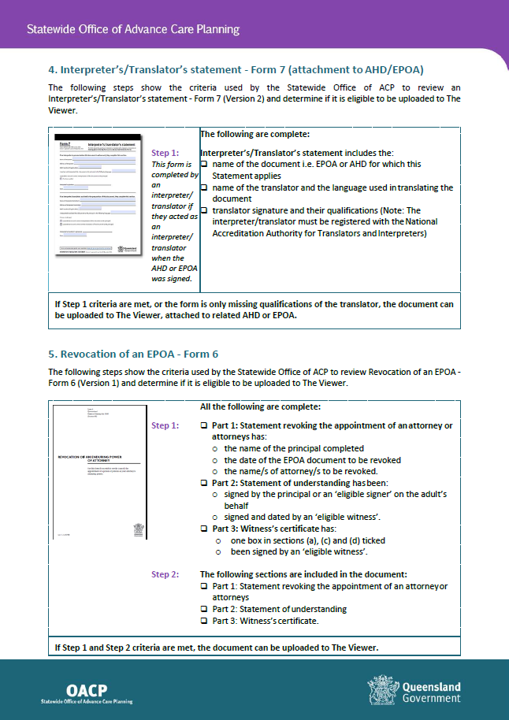

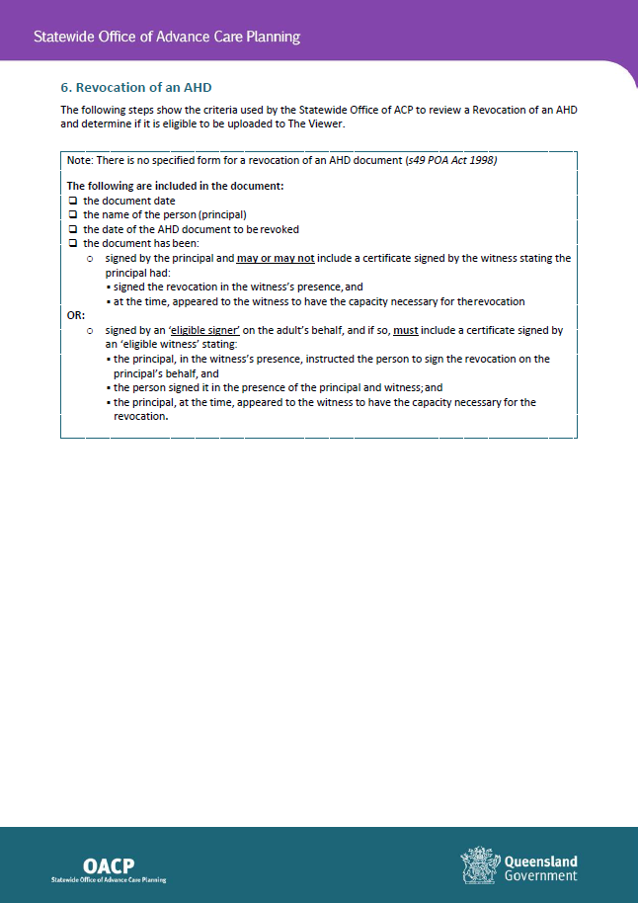

APPENDIX 6: Continuous Quality Improvement: After-Death Audit for Residential Aged Care Facilities
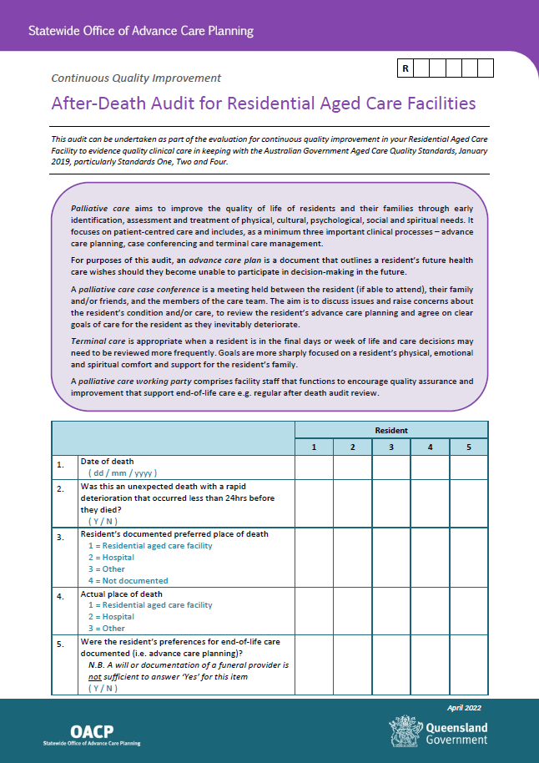

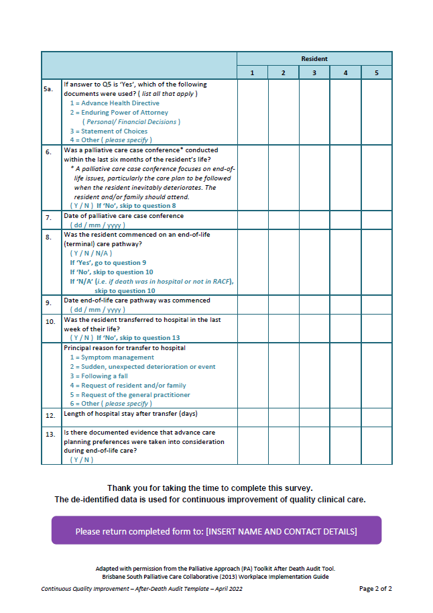

Nolte L and Macleod A. 2020. Guidance and resources for aged care providers to support implementation of advance care planning and advance care directives. Advance Care Planning Australia, Austin Health, Melbourne.
2 Wright AA, Zhang B, Ray A et al. Associations between end-of-life discussions, patient mental health, medical care near death, and caregiver bereavement adjustments. JAMA 2008. 300:1665-73
3 Detering KM, Hancock AD, Reade MC et al. The impact of advance care planning on end of life care in elderly patients: randomised controlled trial. BMJ 2010. 340:1345
4 Silvester W, Fullam RS, Parslow RA et al. Quality of advance care planning policy and practice in residential aged care facilities in Australia. BMJ Supportive & Palliative Care 2012. 00 1-7
Silvester W, Fullam RS, Parslow RA et al. Quality of advance care planning policy and practice in residential aged care facilities in Australia. BMJ Supportive & Palliative Care 2012. 00 1-7
Silvester W, Parslow RA, Lewis VJ et al. Development and evaluation of an aged care specific Advance Care Plan. BMJ Supportive & Palliative Care 2013. 0 1-8
Dellit J. Advance care planning policy and procedure example for residential aged care. 2014. Available at: http://www.nwcscnsenate.nhs.uk/files/3714/6589/6314/Sample-of-ACP-Policy-Aged-Care.pdf
Nolte, L and Macleod, A. 2020. Guidance and resources for aged care providers to support implementation of advance care planning and advance care directives. Advance Care Planning Australia, Austin Health, Melbourne.
Statement of Choices Form. Available at https://metrosouth.health.qld.gov.au/acp/statement-of-choices-form

